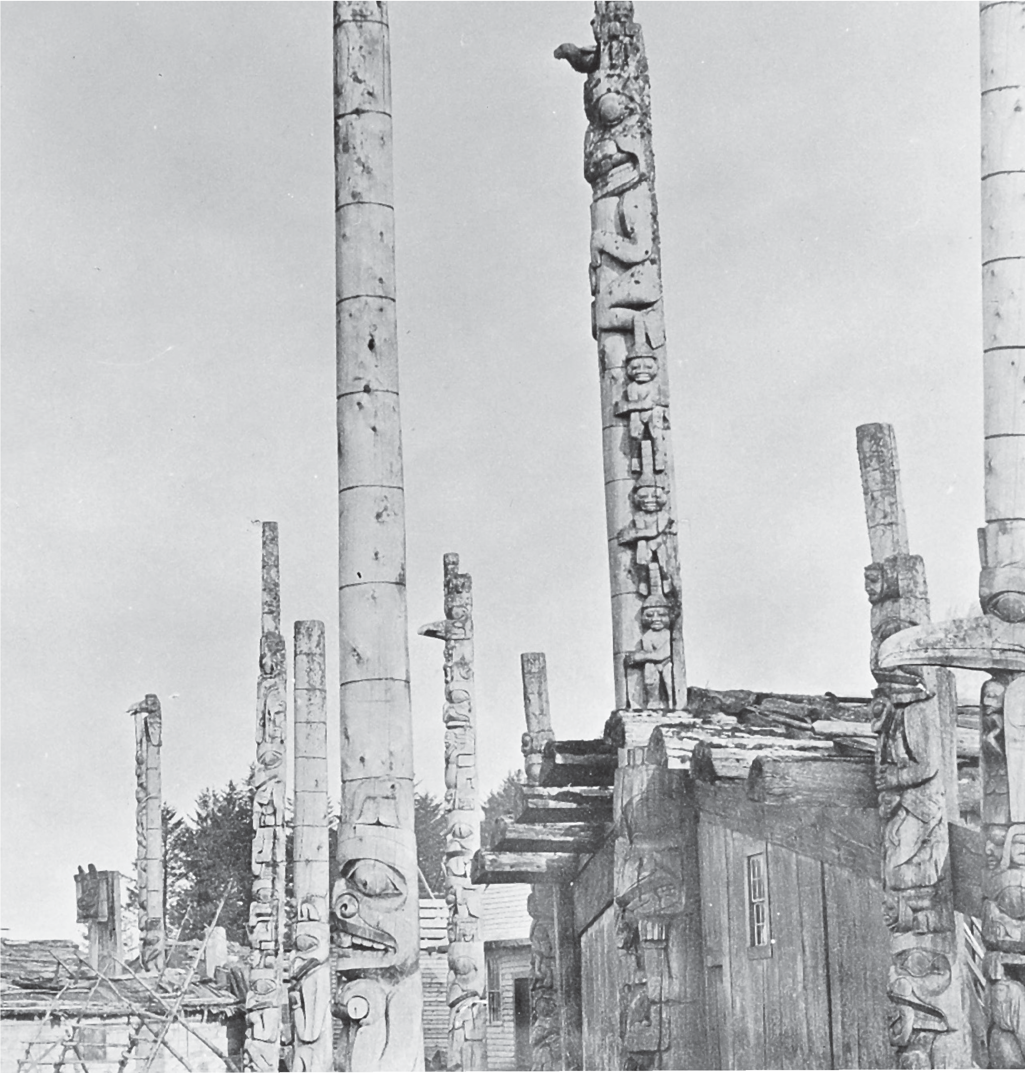

Great Bear Rainforest

The Voice of the Land is Our Language

The Voice of the Land is Our Language
By Carrie J. Reid
First Nations people in British Columbia have enduring values and beliefs that are as relevant today as they were in the past. We have a great responsibility to protect not only our families, but also the land in which we live. Families are responsible for maintaining a connection to the land, to honour and respect the way we live today, and to remember our past. First Nations’ histories impart a sense of belonging and a way of holding on to the values that sustain us. Instilled within our languages are the ties to land, family, community, and the great respect and honour we have for all nations. Every culture has a world view that determines a people’s basic beliefs of how to act in society. These beliefs are so fundamental that people usually
do not realize that they have them because they form a piece of who they are. Traditional First Nations view the world as an integrated whole, balancing physical, emotional, mental, and spiritual health. These beliefs make up who a person is and how he or she functions in society and within the environment. The life forces that exist in mountains, rivers, plants, animals, people, and spiritual beings are all interrelated. First Nations civilizations recognize the importance of community—of people working together for the common good.
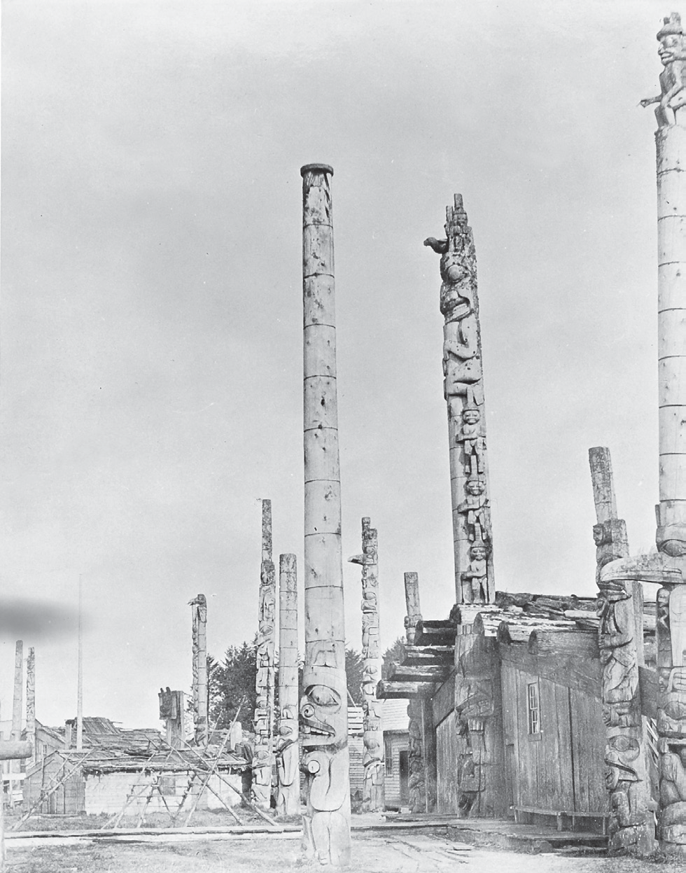
The group is emphasized over the individual. Our people live in an oral culture. Our histories are contained within the oral traditions of our stories and songs. Our recorded history exists through our crests, house posts, petroglyphs, baskets, blankets, and paintings. Children are taught at a very young age to listen. They are taught to listen to stories as they weave, carve, and knit, and as they dance. The whole being of the child is involved in hearing the story. Stories are the primary teaching tool in our cultures. The stories have been told for generations and continue to be told today.
There are many significant pieces to oral traditions. While there is

sometimes room for innovation and creativity, it is important that the people trained to carry the stories retell them accurately, in order to
Haida poles proclaim the importance of family histories. Photo RBCM PN 5599 courtesy of the Royal BC Museum and Archives.

pass down the histories, traditions, laws, and the various technologies to future generations. The stories are not just stories. They are our foundation, our identity, and our culture. Oral history requires a total commitment to culture.
First Nations people have always existed on this land. Creation stories often speak of a being that combined both human and supernatural characteristics to bring order to the world and knowledge to the people.

First Nations Voices
Agnes Edgar, Nuxalk
Now I want to talk about the creation. In the beginning there was an ocean covering the entire [Bella Coola] valley. This was as Alquntam had planned it. But Raven didn’t like it that way, so he changed it around so people could get around in the valley. You can still see mussels upriver at Stuie. The ocean that used to cover the valley left them there. This place was ready for human beings after Raven changed it around. The river flowed then and Raven came poling upriver in his canoe. He put a good sign on Nuxalk. After he was done, he came drifting downriver playing with his pole. He was pretending to let the pole slide alongside of the canoe. When he got to the mouth of the river he threw his canoe pole at the mountain. It’s the upper part of that mountain that is still now called “used to be a canoe pole.” (skukutll)

Governance
All First Nations cultures have organized governments with different governing systems, some hereditary and some appointed. In these systems, a leader is recognized for his or her ability to take care of the people through the stewardship of the land and its resources. The sharing of accumulated wealth raises the es- teem of a leader and his or her group. Every First Nations culture has a word that describes its own laws, and these words are generally complex, encompassing more than one concept. In Nisga’a, for example, the word is Ayuuk, and it refers to the system of justice that people must follow from birth to death. Within these legal dictates there is a constant goal of balance and harmony within the community. This is governance.

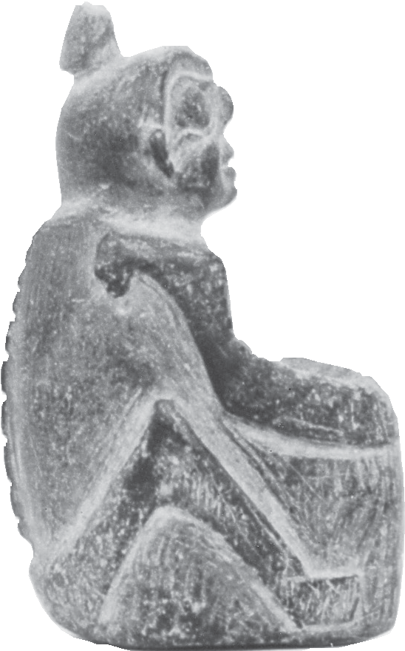
Ancient stone carvings were created many centuries ago. Photo RBCM PN 4546 courtesy of the Royal BC Museum and Archives.

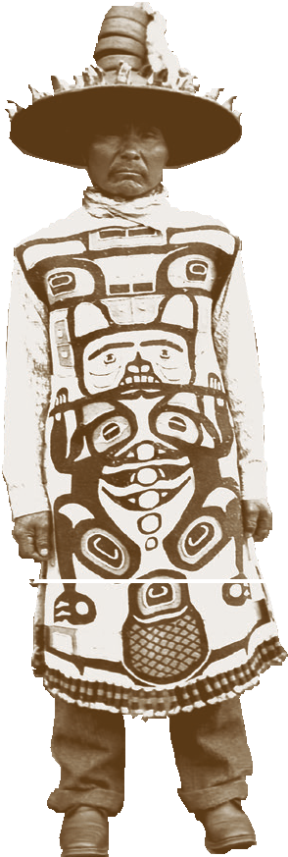
A hat with potlatch rings and a crest- bearing Chilkat robe signify hereditary rights. Photo RBCM PN 1544 courtesy of the Royal BC -Museum and Archives.

Spirituality
First Nations have an important tie to the land that goes beyond the need for food and shelter. The land and its forces contain the belief systems and world views of First Nations cultures. The relationship between the living world and the spirit world is vital in First Nations cultures.
Spirituality exists in every aspect of life—from stewardship to everyday practical matters.
Prayer is not something one does at a certain time or that one needs to stop one’s job to do. The concept of spirituality is to be always mindful and grateful for life and what it
provides.

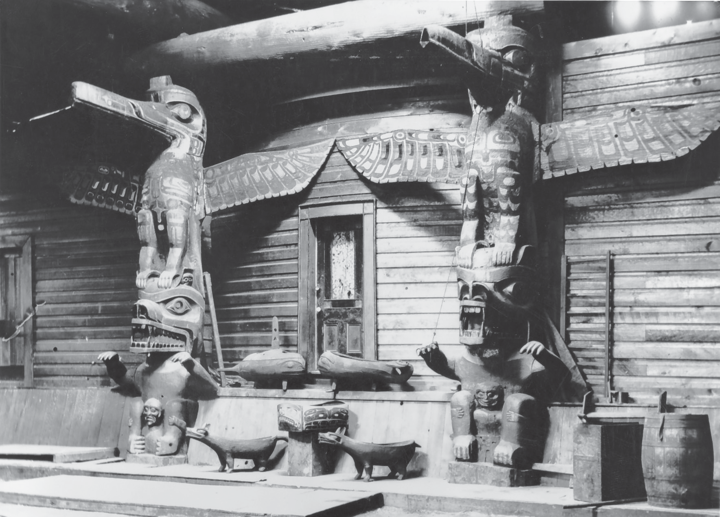
Feasting and extreme physical challenges accompanied by sacred rituals provide methods of connecting to the spirit world. These rituals are not taken lightly; specialists are trained in these fields from birth. First Nations cultures acknowledge that individuals can be trained to receive special power from animals, plants, the spiritual world, or other life forces.
In many First Nations traditions, dreaming is a connection to the
other world. In Tahltan culture, for example, hunters often dream into the future in order to discover things about their next hunt. Dreams can contain messages from late ancestors, provide teachings, warn of danger, and bring together the many psychic realms of our
existence.
Inside the walls of the longhouse, our crests record our stories. Photo RBCM PN 29 courtesy of the Royal BC Museum and Archives.

Cross-Cultural Protocols
Individual nations do not live in isolation. First Nations trade with neighbouring villages as well as with more distant nations. They trade surplus food and materials for items that cannot be locally obtained and also harvest goods specifically for trading purposes. Relationships extend beyond simple trade to social interactions. First Nations people gather together for family meetings, winter dances, feasts, and potlatches. Sometimes they will gather at central locations to pick berries, gather wool, or to fish. Gatherings are greatly anticipated throughout the year and often bring together people from different nations for social or political reasons.
Gatherings often involve political resolutions or decisions regarding the environment. Other gatherings are based on enjoyment, where competitions are held and there is much laughter. Competitions may include races, challenges of physical strength, or gambling. In times past, lahal, also known as slahal, the bone game, or the stick game, was widely used for gambling. Even today, lahal is almost universal among First Nations cultures, and is used for gambling and for fun.
The concept of family that is central to First Nations people extends beyond the nuclear family and, in many cases, transcends nations. A family is composed
of sons, daughters, mother, father, grandmothers, grandfathers, aunts, uncles, cousins, all the people who live in your house and all the people who are in your clan, in your nation, and in other nations. There is a sense of responsibility to everyone in the community and towards allied communities. When people from different villages come together it is a time to reconnect with loved ones. People also interact culturally with their trading partners, exchanging songs, knowledge, expertise, recipes, and stories. Trading relationships can be strengthened through marriage, and gatherings provide an opportunity to determine potential matches.
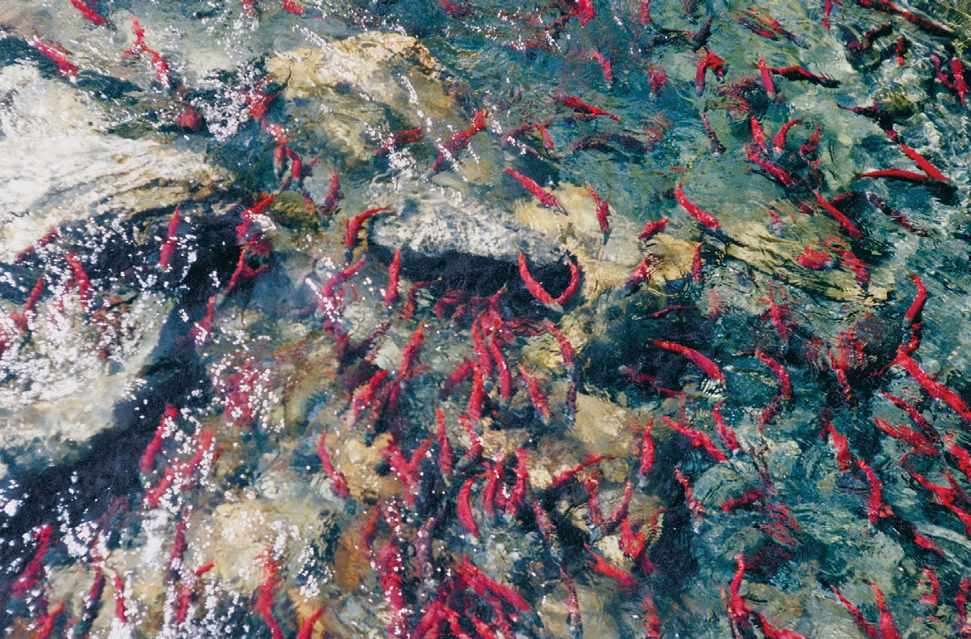
If we respect it, the salmon returns year after year. Photo by Ross Taylor, Courtesy Museum of Anthropology / University of British Columbia

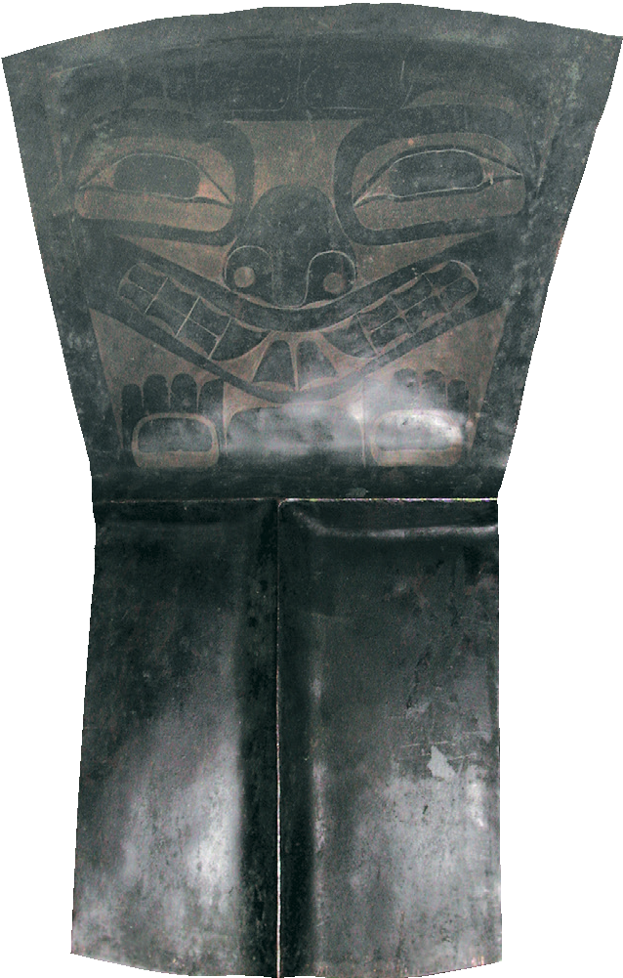First Nations people believe in the individual’s right and responsibility to make his or her own choices according to what will allow each person to function as a human being within society. Direction may be given but answers come from inside, not from someone on the outside.
Knowledge is gained by example. In this way, protocols exist to ensure that people meet together in an acceptable and positive manner.

The copper is a symbol of wealth and power. Photo B. McLennan

First Nations Voices
Chief Walter Wright of Kitselas
Excitement swept the men who stood on the shore. Was all well, or was this a ruse?
But from the canoes came the assurance. “It is well. We come as friends. As friends we wish to stay and be your guests.”
Dressed in his Cape of Ceremony, shaking his rattles, dancing his greeting, Loot-Quitz- Ampty-Wich – Lightning – Head Chief of the Eagle Totem, came to meet his guests.
And here, as his honoured friends, the Kitselas and Tsimpseans stayed for ten days.
Feasts, ceremonies, and dancing filled the days as the Eagles and the Crows lavished entertainment on their guests.
As the days sped a great friendship sprang up between the Eagle Chief and Neas Hiwas. 3

Conflict Resolution
While trade is important, conflict is an inevitable part of life. In First Nations communities, each nation has its own way of dealing with conflict. The following is a common practice among the Tahltan.
During parts of the year many people may live in the same dwelling, requiring them to find ways to get along and deal in healthy ways with disagreements so as to live in harmony with others. It is very disrespectful to disagree with someone else’s point of view. To disagree is to tell them your view is better, devaluing the other person.
When there is potential for confrontation, people try to be passive in outward actions and inward feelings. They do not respond in anger. If they respond in anger they are not being respectful to themselves or to others. To show anger is to show immaturity. The ability to be calm and not get angry is an important quality in many First Nations communities. Elders go to great lengths to teach youth not to respond in anger because it is believed that when one is angry one will hurt the spirit of another being.
Should someone say something disrespectful, the person who receives the disrespectful comments cannot respond. If he responds, he is being more disrespectful than the person who made the comment and is carrying on a second disrespectful action. If an Elder or someone else is present, it is their responsibility to politely stop the rude behaviour. If no one is present to stop the speaker, the person must politely listen, without commenting in a negative manner. The person may pray to the Creator for guidance on how to help heal the anger being displayed towards him, and it becomes his responsibility to establish harmony between them.
If one person is upset with the conduct of another, that person may talk about the second person to a third person. His “talking about” has clearly defined boundaries. The person doing the talking must do so in a culturally appropriate way. For example, if a man is upset about the conduct of a younger man, the older man may talk to friends about the young man’s conduct, taking care that the discussion is not malicious or negative. The intent is to send a message to the young man that his behaviour is unacceptable and he needs to change to fit in with the expectations of the community. A good friend of the young man will relay the message to him and it now becomes his responsibility to respond appropriately.
If the advice is not taken, then one or more Elders from the community may visit and tell him stories, not directly telling him he is doing something wrong. They will tell him stories about similar cases and what the consequences were. It then becomes the young man’s responsibility to listen to the stories and deduce the
lesson to be learned. If the young man listens and changes, then harmony has been established.

Should the young man not listen, the Elders need to make a decision. If the actions of the young man are not going to hurt the village they will let him learn from his experiences. If the young man’s actions will cause harm, then the Elders have a range of options from which to choose. They could ostracize the young man so that no one is allowed to speak his name. When he is encountered in the village people will look the other way and he will become a non-person. This puts a considerable amount of pressure on him to conform to the expectations of the society in which he lives. If this does not work, he could be banished from the community. He will either starve or have to travel to another community and hope that they will accept him.
Elder
A person whose wisdom about spirituality, culture, and life is recognized. First Nations people and communities seek the advice and assistance of Elders in various areas of traditional as well as contemporary issues. As a sign of respect for First Nations Elders, the term is often capitalized.

Stewardship of the Land
The land is a provider, sustaining life in its many forms; as such, it must be treated with the utmost respect. Many ceremonies, cultural values, and economic activities pay tribute to the land and ensure that people will not jeopardize the availability of the resources for the future. The concept of sustainability was, and continues to be, a characteristic of First Nations cultures. There is a sense that all life is equal. There is a sense of humility and appreciation for a land that is bigger than we are. There is a sense of wonder, humour, and history.
When First Nations people say land, we mean nature: rivers, oceans, mountains, valleys, and all the life that inhabits them. In the First Nations world view, people are integrated with the natural world, not separate from it.
First Nations view the environment as a holistic natural phenomenon, where any action has an accompanying reaction. This principle underlies all physical and spiritual matters. Through having an understanding of one’s environment, rules and patterns are established for living in a manner that best suits one’s needs. This ensures that the bountiful harvest of the land remains intact for future generations, and all life will continue to live in harmony. The values and beliefs that emerge
from this perspective guide the behaviour of the community in relation to the surrounding environment and in relation to each other.
Despite cultural differences within various First Nations, there is one principle that unites all people: a respect for the surrounding environment, from the land to the sky with its heavenly bodies, to the waters with their many creatures.
Respect, created and maintained by social customs, rules, and beliefs, is prevalent throughout First Nations cultures.

Everything is connected and nothing exists in isolation. Consider, for example, gathering mountain goat wool. For it to be collected at the right time of the year, there must be a thorough understanding of ecosystems. If there isn’t, then blankets aren’t woven and people are cold. If people are cold, more wood must be cut. If more wood needs to be cut, more tools are needed. To build new tools takes time and resources… and on it goes.
Knowledge of natural resources involves more than simply understanding a single piece of information. It is necessary to understand the whole and the interrelatedness of the parts. It is necessary to understand that all work is
important and to trust that the community will come together for the greater good.

Looking Back, Looking Forward
Can you think back to an earlier time in our world? Can you think back far enough to imagine the lushness of the land, uninterrupted by highways and buildings? Can you imagine the silence that was possible? Do you think, that, even for a minute, when Maquinna met Cook, he thought that their values would be so different? Can you understand that First Nations people could not even conceptualize that “giving is wealth” was not a universal concept?
What happened next in our world has taken our people to places that were unexpected and at times unbelievable. The balance of this book will take you from our past into the present. Our history is ancient, abounding, and real. We have complex, dynamic, and evolving cultures that have adapted to changing world events and environments. We face new and varying conditions and circumstances yet retain key values and beliefs within our cultures. Our values and beliefs are diverse, durable, and relevant. They are eloquently expressed in our languages and through our ties to the land.
Carrie J. Reid is mostly Salish and works as a private contractor, primarily in the fields of justice and education. She lives with her son Xwulq’sheynum on lands reserved for Indians in Qualicum Bay.

Sources and Credits
- Agnes Edgar quoted in Bella Coola Texts. Victoria: B.C. Provincial Museum, 1980.
- Aku quoted in Robin Ridington, Trail to Heaven: Knowledge and Narrative in a Northern Community. Iowa: University of Iowa Press, 1988, p. 291.
- Chief Walter Wright quoted in Walter Wright, Men of Medeek. Kitimat: Northern Sentinel Press, 1962.
- The section on Talhtan justice is based on material provided by David Rattray

