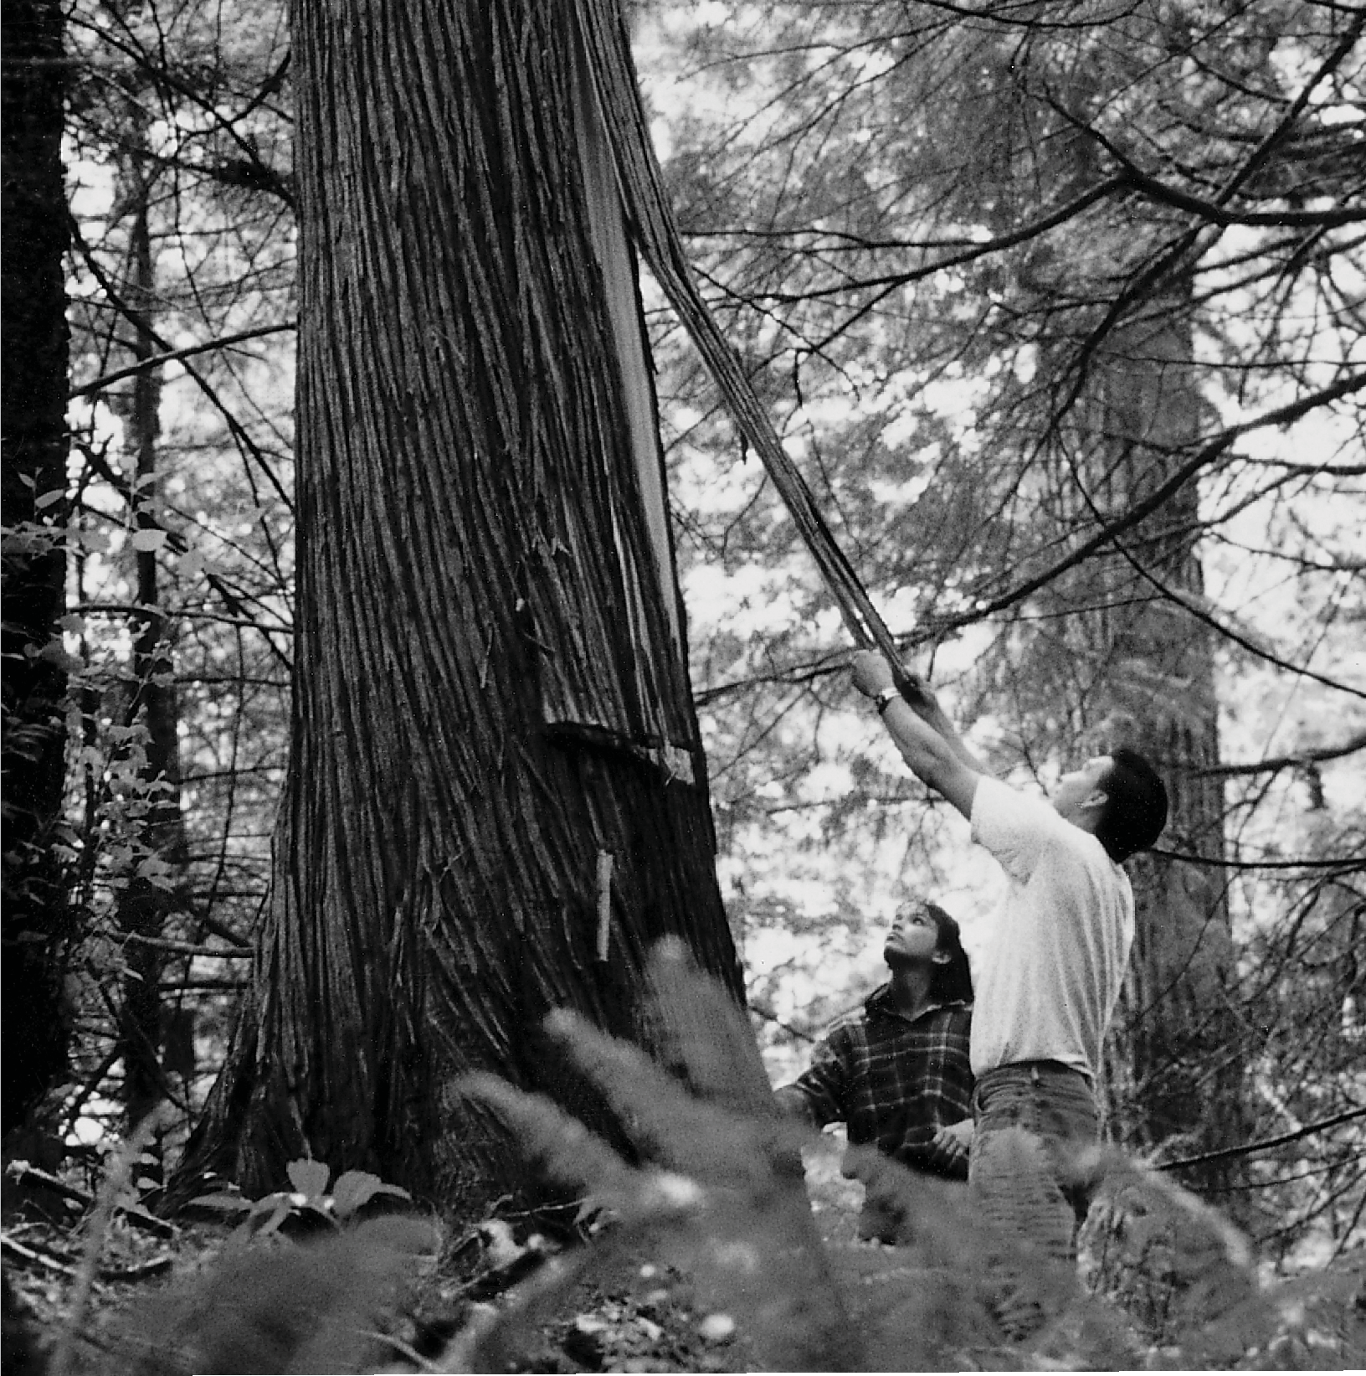

Great Bear Rainforest

Relationships to the Land

Relationships to the Land
In the First Nations world view, people are integrated with the natural world, not separate from it. The land has great variety, and so the people are very diverse, for the land has shaped the people. It determines where and how they live.
The history of the First Nations people in British Columbia is as rooted in the land as are the great trees of the forests. Although the First Nations of the province are many and diverse, they have at least one thing in common: they have an enduring relationship with the land, a bond so strong that it defines who they are.
In general, Western society views the ownership of land and resources as an individual right. Property or land ownership is based on the right to purchase land, holding it in what is termed fee simple, that is, owning land that can be sold or passed on to inheritors. In practice, some individuals or corporations own land, while others who are landless pay land owners for the right to live on or use the land. In the traditional First Nations view, ownership of land is interpreted in a very different way. It is the extended family, the group, or the community that holds rights to the land, not individuals. There are no landless people in this system, as every member of the community shares in the rights and responsibilities of using and taking care of the land.
Through more than two hundred years of European contact and colonization, the differences in these two views have caused tension and conflict between First Nations people and colonists from other lands. The forces of colonization have threatened the integrated relationship the First Nations have with the land.
The First Nations of British Columbia have seen their people marginalized and discriminated against; they have seen oppressive laws attempt to assimilate them; and they have seen their land taken away from them without battle or treaty.
Together they have worked to have their title to the land recognized and the loss of the lands compensated for.
Today there are more than two hundred First Nations bands in British Columbia. The continuity of their relationship with their traditional territories has not been broken, despite the pressures put on them. Their oral traditions—the important narratives passed on from generation to generation—reinforce and remind
First Nations people of their connection with the land. Today, this connection is still strong, and all across the province, First Nations people return to the land to harvest the same resources as did their ancestors. Of course, some of these resources no longer exist or have been depleted, some of the technologies of production have changed, and now people may travel by speedboat or skidoo to

reach their territories. What have not changed are the ties to the land expressed in the oral tradition and verified by modern experiences.
First Nation
A community of Aboriginal people who identify themselves as a distinct cultural group and who are the descendants of the original inhabitants of the land that is now known as British Columbia. Each First Nation has a name for itself, such as the Stó:lō Nation.

The Shape of the Land
The place that today we call British Columbia is a land of many different climates and habitats, but there is one constant: this is a province of mountains. The land is dominated by a series of mountain chains running roughly north-south, from the Coast Mountains in the west to the Rocky Mountains in the east. Between the
mountain ranges lie valleys and plateau regions such as the Cariboo, the Okanagan Valley, and the Rocky Mountain trench. On the coast, the would-be valleys are flooded by the sea, forming islands and fjords.
If British Columbia is a place of mountains, it is also a place of water—of rivers, lakes, channels, and inlets. These waterways, formed by the mountains, define the land and its people. A large part of B.C. is drained by four major river systems: the Fraser, Skeena, Columbia, and Peace. These rivers and their valleys provide living space, transportation routes, and habitat for fish.
Many of the abundant resources found in the province come from the mountains, including forests, food plants, minerals, game, and fur-bearing animals. The waters are equally rich, especially with fish like the Pacific salmon and oolichan. The ocean provides a wide array of food sources, from large sea mammals to small molluscs. Rivers and lakes, too, offer a variety of foods, including fish.
This land and its resources shape the lives of the people who have lived here for thousands of years. The mountains create barriers for people, but they also act as landmarks and natural boundaries. Their peaks and ranges enclose many river systems, both large and small, and these watersheds are a logical way of defining
territories. The territories of many First Nations of B.C. are based on the boundaries formed by watersheds.
For thousands of years, First Nations people have inhabited the valleys, plateaus, and coastline of this mountainous land, and they have adapted to the variations in climate, topography, and resources in different ways, resulting in a wide variety of societies. Distinct groups speak separate First Nations languages. Of the sixty First Nations languages in Canada, half are found in British Columbia.

First Nations Voices
Chief James Wallas, Kwakwaka’wakw
The Transformer started off again down the coast and had not gone far when he met a man standing all alone on a beach. He asked the man, “What do you want to do with your life? What do you want to be?”
“I want to be something to help my people,” answered the man.
“Then how would you like to be a big cedar tree? Your people could weave mats and clothing from your bark and use your wood for their lodges.”
“No, I don’t want to just stand there. I want to help my people in another way.” “Would you like to be a big boulder?” asked the Transformer.
“No! That’s worse than a tree and doesn’t help my people much.”
“How would you like to be a big salmon in the bay that your tribe could catch and eat?” “No, I do not wish to be a salmon.”
“How about a river? Then the salmon would swim up the river and your people could catch them easily and live on them.”
“Yes, that would be fine,” said the man. “I would like to be a big river.” The man suddenly found himself falling backwards. The Transformer had put his hand on the man’s forehead and given him a little push. When he hit the ground he became a mighty river—the Nimpkish.
The people were really happy then, because every summer lots of fish came up the river to spawn—
Sockeye, Cohoe, Spring—all the best salmon. Later on there was a large camp located at that spot.1

The people of the coast have many different characteristics, but they share some common features which people who study cultures call the Northwest Coast culture. These societies had strict social codes to follow, with a rigid hierarchy whereby chiefs were ranked in importance, and a class system was made up of chiefs, nobles, commoners, and slaves.

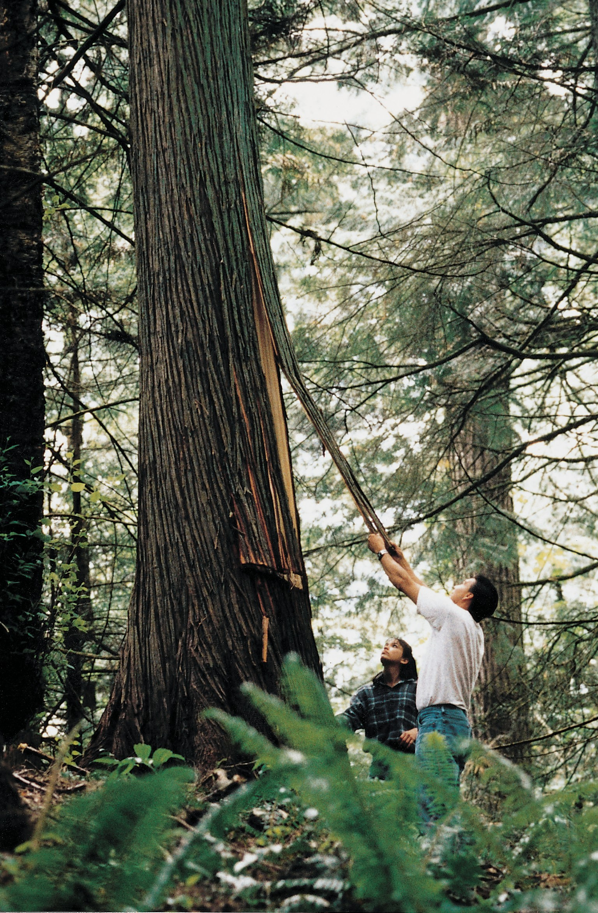

Skill, knowledge, and respect are required to harvest cedar bark from the coastal rainforests. Photo courtesy of Stó:lō Nation

The Regions of B.C.
Many factors influence how people adapt to living in their chosen territories. The latitude, physical geography, climate, and altitude all affect the types of animal and plant resources found in a specific area. They also determine how people will harvest and use these resources. The relationship of the people with their natural world determines where they choose to live and affects how they organize their societies. B.C. can be divided into four broad geographical regions: the coast, the southern interior, the northeast, and the northern interior.

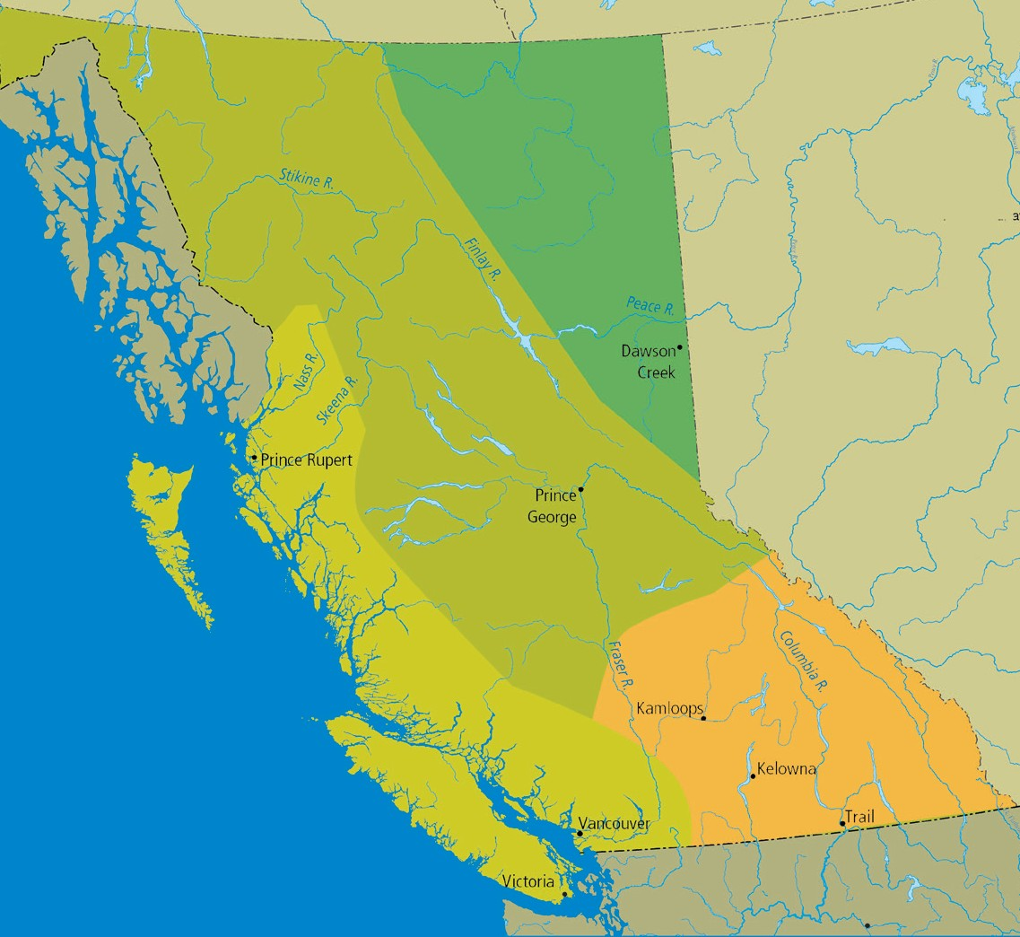The Coast
Northern Interior
Northeast
ALBERTA
Coast
Southern Interior
Pacific Ocean
0
200 km
0
200 miles
United States
Geographic Regions of B.C.
The First Nations people who live on the coast of British Columbia have adapted to a wet, mild climate influenced by the Pacific Ocean. The
temperature usually stays above freezing in the winter and below 20° C in the summer. The annual rainfall in some locations is more than 400 cm a year. This results in many cloudy days, and fog often blankets the mountains.

This climate creates ideal conditions for the temperate rainforests which cover the mountain slopes, providing lush vegetation dominated by coniferous trees. The greatest of these trees, the western red cedar, is considered a special gift from nature by First Nations. Its characteristics make it one of the most useful materials available. Bill Reid, the renowned Haida artist, once wrote about the cedar:

If mankind in his infancy had prayed for the perfect substance for all material and aesthetic needs, an indulgent God could have provided nothing better.2

On most of the coast, the mountains rise out of the ocean, creating intricate waterways that form a maze of channels, bays, and inlets. Hundreds of islands, from tiny rock outcroppings to giant Vancouver Island, provide protection from the ocean winds.
As well, thousands of rivers and streams rush down the mountains, flowing into the ocean directly, or combining into major rivers such as the Nass, Skeena, Kitimat, Kitlope, Dean, Bella Coola, Klinaklini, Homathko, and Squamish. These and other rivers empty into the ocean at the heads of long, narrow inlets or fjords. Most of these fjords have steep sides with little shoreline, but the head of the inlet flattens out to a floodplain built up of silt carried by the river. The estuaries formed at the juncture of fjord and river create rich habitats for a great deal of wildlife as well as living space for people.
The southern coast, the region that surrounds Georgia Strait, has a different climate and therefore a unique environment. This area lies in the rain shadow of Vancouver Island, including southeast Vancouver Island, the Gulf Islands, and the Fraser
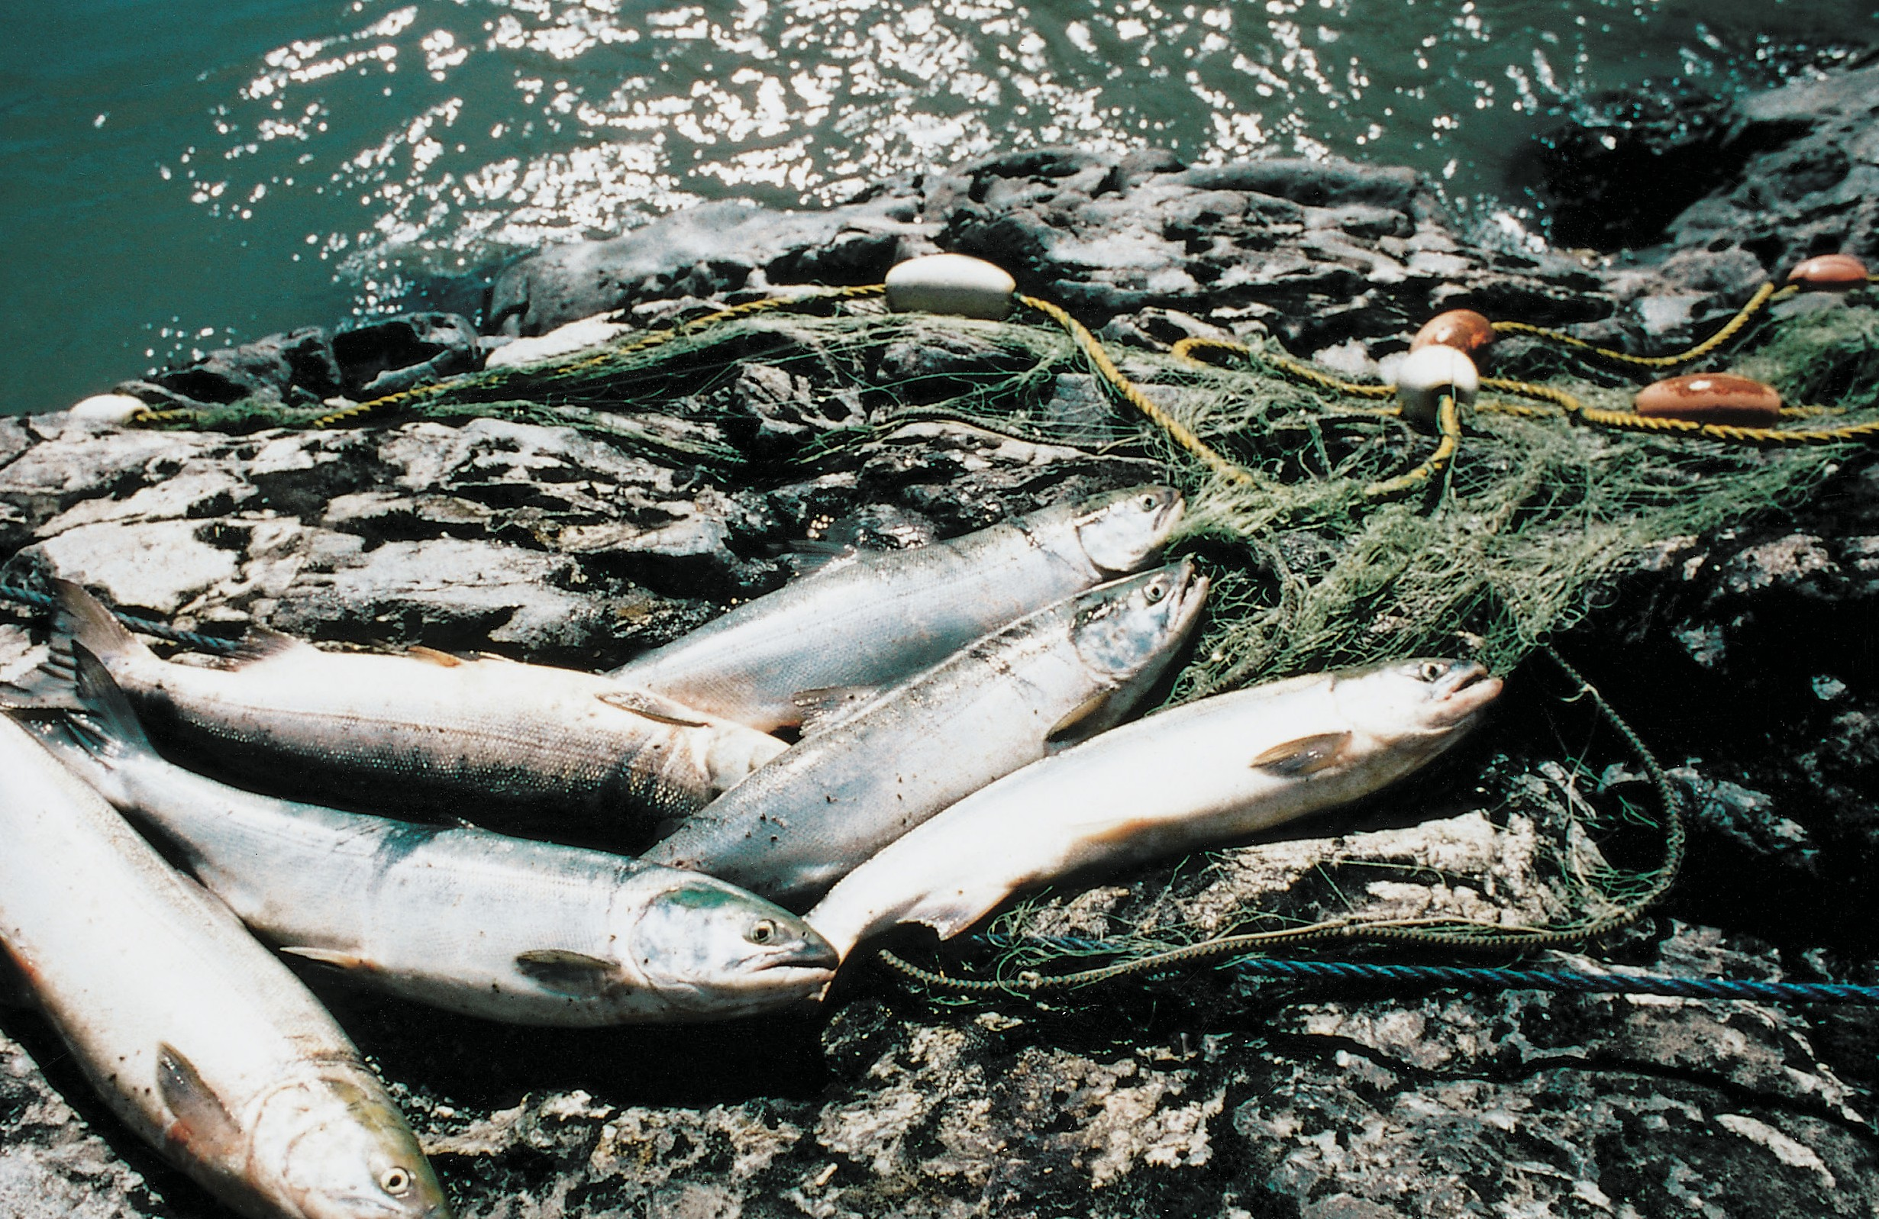
Valley. Generally it has flatter land and a drier climate, and, consequently, different vegetation.
The Pacific salmon is a key resource in British Columbia. There are five species: sockeye, coho, spring, chum, and pink. The salmon is hatched in the freshwater rivers and streams of the province, makes its way to the ocean where it spends its adult life, then returns to the fresh water to spawn, and complete the cycle.
Photo courtesy of Stó:lō Nation

Resources on the Coast
The principal resources on the coast have already been mentioned: from the forest, the cedar, and from the ocean, the salmon and the oolichan. However, there is a great wealth of other resources available in the coastal environment. In the ocean are deep sea fish such as halibut, sole, cod, and red snapper. Herring spawn near the shore in spring, and their roe is considered a delicacy. Along the intertidal zone are shellfish, cockles, clams, mussels, oysters, and abalone. A dark green seaweed growing on exposed rocky shores, known to scientists as porphyra, is another important resource for harvesting. Crab, octopus, and sea cucumber add to the list of foods from the sea. The thick bushes and shrubs that grow beneath the giant conifers offer a variety of plants, including berries like huckleberry, salal, and salmonberry. A wide range of medicinal plants come from the rainforest, from the licorice fern whose roots are chewed to soothe coughs to the formidable devil’s club, which was used to cleanse and purify the body and soul.
The underbrush of the rainforest is an ideal home for fur-bearing mammals and deer. Their meat is a source of food, while their furs, hides, and bones are useful for clothing and tools. Most common are the black bear and the black-tailed deer. Smaller mammals such as river otter, mink, wolverine, and marten also inhabit the forest.
Oolichan
The oolichan (also spelled eulachon) is a small fish important for its oil. It spends adulthood in the ocean and returns to freshwater to spawn in the early spring. It was the first harvest of the year for the First Nations after the winter supplies had been exhausted.
Intertidal zone
An area which is under water at high tide and exposed at low tide.

People of the Coast
The coast has the greatest number of distinct First Nations in Canada. Nine different First Nations live along the north and central coasts and on the west coast of Vancouver Island: Haida, Tsimshian, Nisga’a, Haisla, Xai-Xais (Hai-Hais), Heiltsuk, Kwakwaka’wakw, Nuxalk, and Nuu-chah-nulth. Along Georgia Strait, on Vancouver Island’s east coast and the opposite mainland, including the Fraser Valley, seventeen different First Nations live. All are members of the Coast Salish language group.
The abundant resources available to the First Nations of the coast and the mild coastal climate resulted in the development of highly structured societies. People had time away from resource gathering to develop complex social and artistic customs.

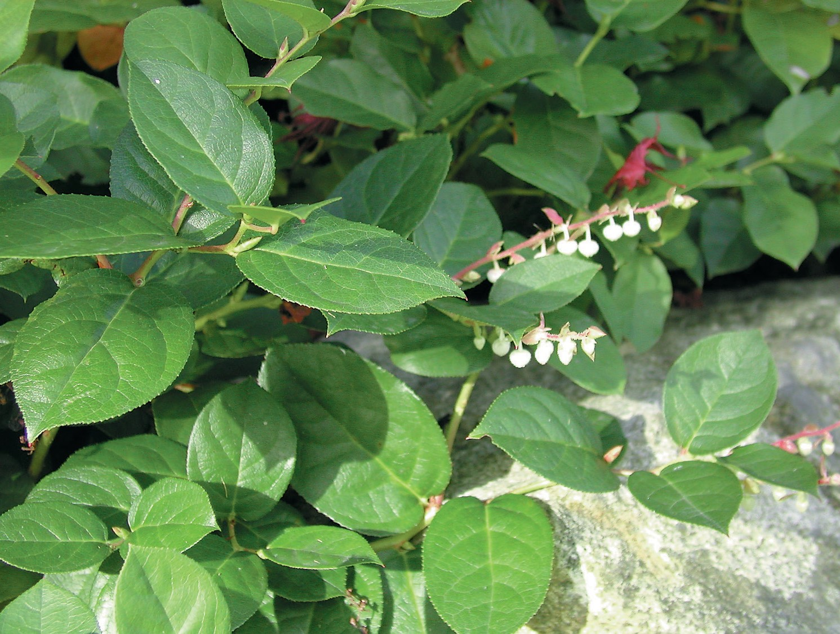
Salal, a member of the heather family, is one of the most common shrubs in B.C.’s coastal forests, in places forming a dense ground cover. It has evergreen leathery leaves and pinkish bell-shaped flowers followed by deep blue berries. First Nations people eat the berries fresh, boil them into a syrup, or dry them into cakes. Photo courtesy of Stó:lō Nation
The First Nations of the coast adapted to their ocean-front environment by organizing in resource use units, generally composed of extended families. Also known as a house group, each resource-use unit had a number of territories that provided resources throughout the year, including salmon fishing grounds, hunting territories, and berry harvesting grounds. Some groups also had oolichan camps, which were usually shared by a number of families. These seasonal territories were usually close together, depending on local conditions. Each group had a hereditary chief who was responsible for his people and the appropriate use of their territories and resources. A number of these groups were aligned together in collectives often referred to in English as “tribes.” They lived together in one large winter village under the leadership of a head or village chief.

Extended family
The term extended family usually refers to a large family group of several generations who live and work together. Often it will include several siblings and their families living with parents and perhaps grandparents.
Resource-use unit
The resource-use unit is the basic group which has stewardship over the resources in a particular territory. First Nations express this in different ways. For some it may be a family grouping; for others it may be a broader social organization such as a house group.

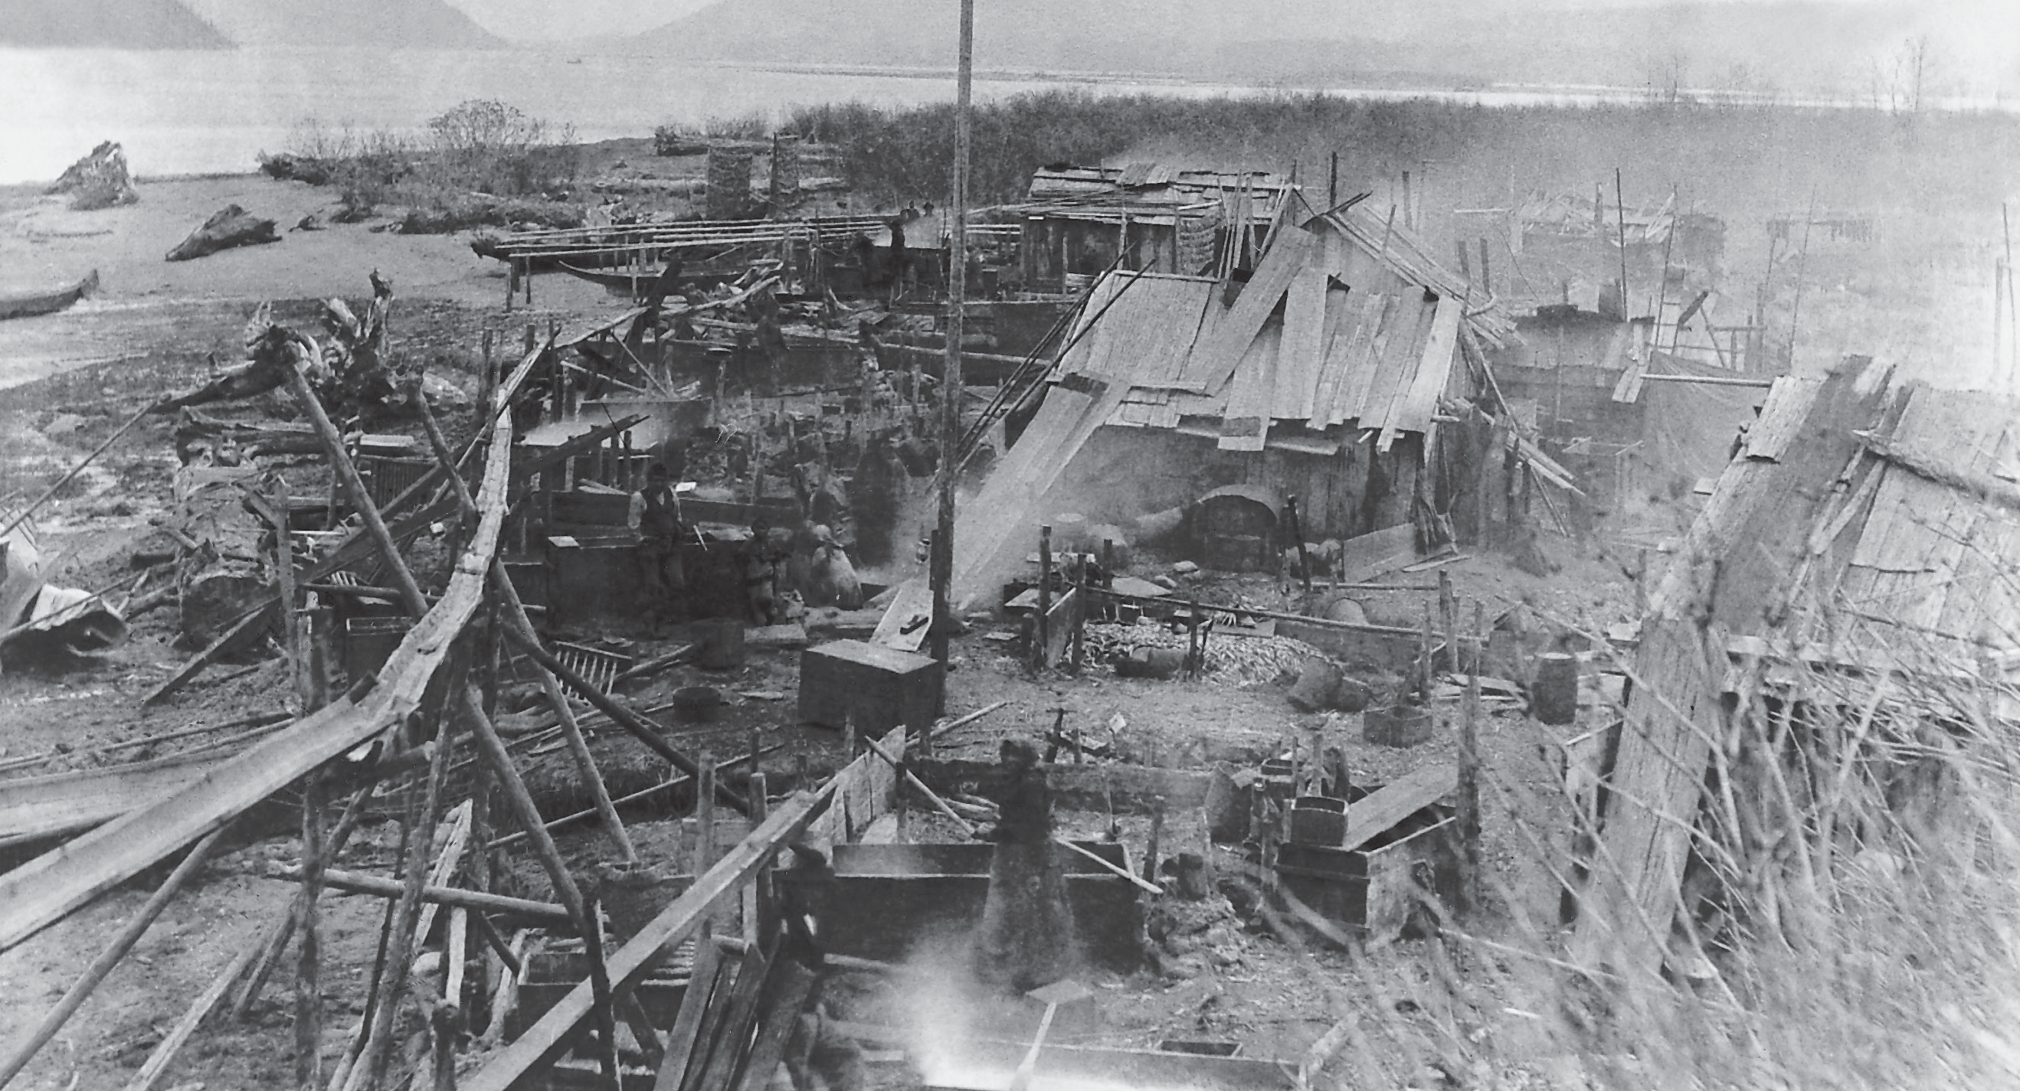

Oolichan processing at Fishery Bay, near the mouth of the Nass River. Thousands of people gathered here in February and March to make the valuable oolichan grease. Oolichan was known as the “saviour fish,”
because it saved people from starvation. Its rich oil or grease is extremely nutritious and valuable; it is eaten as an accompaniment to many foods, and used as a medicine and preservative.
Photo RBCM PN 1449, courtesy of the Royal BC Museum and Archives
Most First Nations on the coast followed similar seasonal patterns, or seasonal rounds, when they moved from location to location as the resources became available. Winters were spent in large villages of as many as thirty cedar longhouses lined up in one or two rows facing the ocean. Feasts, potlatches, and winter ceremonials occupied much of the time spent here.
As spring approached, people moved to various spring resource camps. For many people, this meant congregating in large groups at oolichan processing camps.
Many tribes gathered at the mouths of the major oolichan rivers, the Nass, Kemano, Bella Coola, Klinaklini (Knight Inlet), and Fraser. Major trading routes extended from these gathering sites across mountain passes into the interior. As well as oolichan camps, some people went to halibut and seaweed camps or seal camps. By June, the salmon were returning, so people spread out to their individual salmon camps. These were at the mouth of a river or sometimes on a lake. People remained at salmon camps until fall. Eventually the cycle was completed as everyone moved back to the winter villages.
This generalized outline of the seasonal rounds varied depending on the resources a group had within its territories. For instance, whale hunting was central to the Nuu-chah-nulth living along the west coast of Vancouver Island. The importance of this resource resulted in cultural patterns, seasonal rounds, and spiritual practices that were different in many ways from other coastal First Nations.

The ownership of each territory was inherited not by individuals but by the extended family group that formed the resource-use unit. Transferring the inherited territorial rights from one generation to the next was the principal purpose of the potlatch. This all-important public ceremony, which combined dances, songs, crest masks, and great quantities of food and many gifts, was the ultimate expression of the coastal people’s relationship with the land.
Seasonal round
Also known as the annual round, this term refers to the pattern of movement from one resource-gathering area to another in a cycle that was followed each year. Spring, summer, and fall saw the people moving to a variety of resource areas while during the harsher winters they gathered in winter villages. The abundance of resources also determined how often people moved. In areas that had a greater abundance and variety, people could stay in one location for longer than in areas where resources were scarcer.

Case Study: How the Kwakwaka’wakw Adapted to their Environment
The Kwakwaka’wakw of northern Vancouver Island and the nearby mainland coast live in a rugged landscape of islands and channels, mountains and inlets. The climate here, like on the rest of the coast, is mild and wet. By looking at the way the Kwakwaka’wakw settled and used their territories, we can see how they adapted to their environment.
Kwakwaka’wakw people in the past did not need to travel great distances to obtain most of the food and materials they required. The mountains made it difficult to travel by land, so cedar canoes were the mainstay of life on the coast.
A wealth of resources from the land and the sea was concentrated in their territories. This region had beaches where shellfish, crab, seaweed, and other intertidal resources thrived. Seals, sea lions, and deep-water fish abounded in the ocean. Along the shore a wide range of trees, bushes, and plants offered wood, berries, shoots, and roots.
More than any other resource, however, salmon were the principal resource for the Kwakwaka’wakw people. Salmon runs in this region were prodigious. Half a million salmon spawned on Gilford Island alone. The Nimpkish River had runs of over a million sockeye and 300,000 coho. In most years people could harvest more than they required for basic subsistence.
They stored food for over the winter and still had a surplus to trade. The readily available supply of resources was able to support a relatively high population. As well, it gave the Kwakwaka’wakw, like other First Nations of the coast, the precious commodity of time, which gave rise to highly-evolved technologies and complex social structures.

Kwakwaka’wakw people living before Europeans arrived had strict laws to follow. First there were the laws of nature, which dictated the way they interacted with their land.
Most of the resources became available at specific times of the year, so the Kwakwaka’wakw people adapted their lifestyle by moving to different sites depending on the season. Their settlement patterns included a variety of resource gathering sites which they returned to year after year.
The other set of laws was their social organization, which developed as an efficient way to manage the resources. Before European contact there were thirty tribes
in the Kwakwaka’wakw Nation. Each tribe was made up of a number of resource groups called numaym, meaning “one kind.” The numaym is the central unit of Kwakwaka’wakw society, each with its own resource camps and hunting territories within the tribal territory. As well, each numaym has hereditary rights to its
own crests and its own narratives, songs, and dances, which are performed at potlatches.
The organizational structure of the numaym allowed the resources to be harvested in an efficient manner. Tribal territories were divided into individual areas for each numaym. Most of the sites were concentrated within a relatively small range. For example, the Mamalilikulla tribe has traditional territories at the mouth of Knight Inlet, including a number of small islands, sections of larger islands such as Turnour and Gilford, and the northern shore of Knight Inlet. From east to west this is a distance of about 70 kilometres. Within this territory were a variety of resource sites: halibut fishing grounds, salmon rivers, berry grounds, clam beds, and hunting and trapping areas. The Mamalilikulla tribe was made up of eight different numaym.
The Kwakwaka’wakw seasonal round had three major periods. First was the winter ceremonial season. About the end of November, members of a tribe’s numaym gathered together in the tribal winter village. For the Mamalilikulla, this was on Village Island. Great cedar longhouses with painted house fronts and totems standing before them displayed the crests of the chiefs of each numaym. Each numaym had its own property within the village. At the centre stood the largest house, which belonged to the head chief of the tribe. These massive buildings provided both living space and the arena where potlatches were held. As well as participating in potlatches, people spent part of the winter months creating the many items that were needed both for the coming year’s resource gathering and for potlatches. This was the time for weaving cedar mats or crafting bentwood boxes.
Canoes could be finished and totem poles or masks carved.

Spring arrived, bringing the second period of the seasonal cycle.
Most Kwakwaka’wakw people moved to oolichan fishing camps at the head of Kingcome Inlet or Knight Inlet. The Mamalilikulla travelled up Knight Inlet along with members of eight other tribes. They all lived in close quarters along the river banks where they trapped or dip-netted the tiny rich fish. Although the Klinaklini River is in the territory of one tribe, the Tenaktak, it was shared during oolichan season by the others.
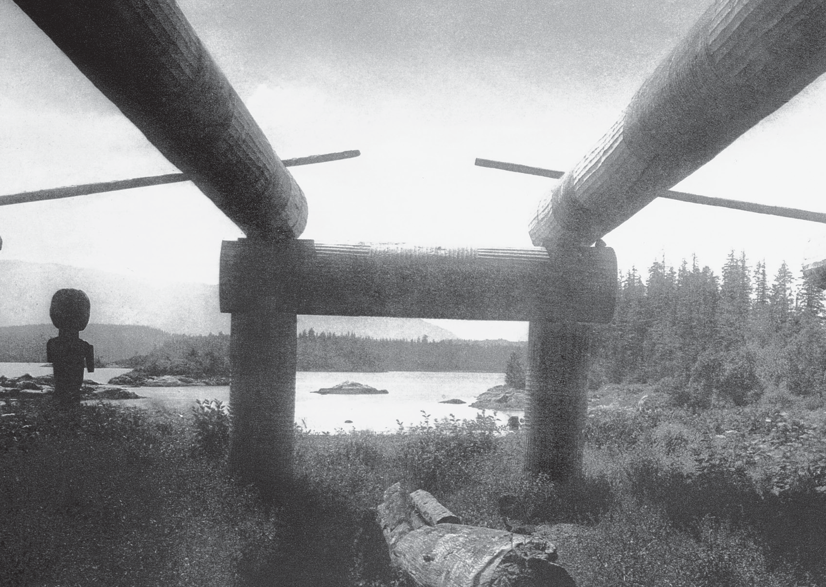
The distinctive house frame of the Kwakwaka’wakw people at Mamalilikulla. Photo BCA D-08290, courtesy of the Royal BC Museum and Archives

People spent the greater part of the year at their individual camps to catch and process salmon. From spring until late fall, the salmon dictated where the people lived. Usually this was at the mouth of a salmon river, where salmon could be trapped in intertidal stone traps or in wooden traps placed across the river. Other activities accompanied this major occupation. Food such as berries and roots could be gathered from areas near the salmon camps as they ripened. Fall activities included hunting and trapping. Much trapping was done along the shore and river banks, while hunting more often took men to the mountains for deer and mountain goat.

You can see how the environment shaped the lives of the Kwakwaka’wakw.
The abundance of salmon and cedar supported a large population. The coastal geography dictated a canoe-based society, allowing people to be highly mobile on the water. The seasonal availability of foods meant people travelled to different sites throughout the year.
To efficiently manage the resources, a highly structured political system developed, with the potlatch at its core. This system, hand in hand with the extra time allowed by the abundance of resources, created an artistic tradition that today is one of the most highly regarded in the world.

Summary
The great diversity in the geography of what we know today as British Columbia led to an equally great diversity of First Nations societies, each with a unique identity and relationship to the land. The province can be divided into four regions according to the topography, climate, and vegetation: coast, southern interior,
northern interior, and northeast. The coast, with its mild climate, is characterized by many inlets and passages bounded by steep mountains and valleys blanketed with lush temperate rainforest.
The resources of these regions vary, but in all except the northeast, the Pacific salmon is a key resource. People adapted their settlement patterns and the structure of their societies according to the places they lived. Coastal nations, who primarily depended on the salmon resource, developed highly structured political and social systems.

Sources and Credits
- Told by Chief James Wallas in James Wallas and Pamela Whitaker, Kwakiutl Legends. Surrey: Hancock House, 1981. Used with permission of Hancock House Publishers.
- William Reid, Out of the Silence. New York: Harper & Row, 1971, p. 55. Used with permission of Martine Reid of William Reid Ltd.

