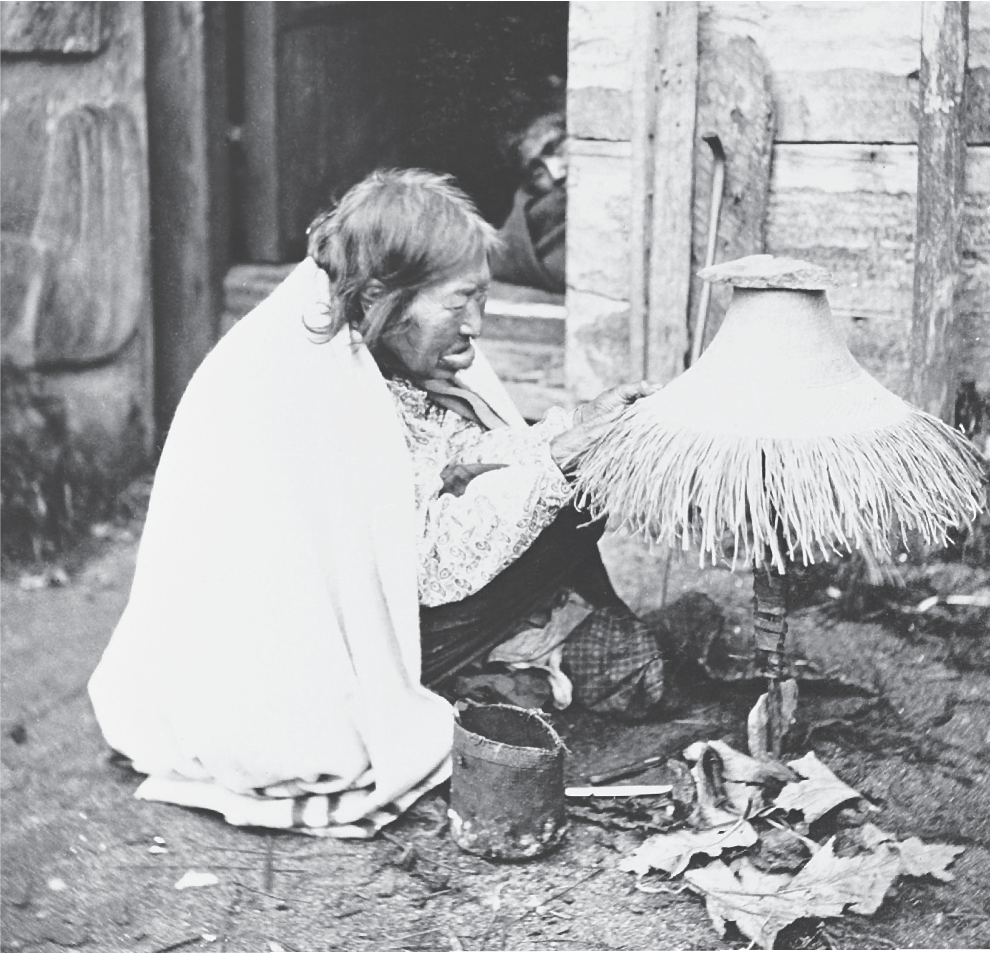

Great Bear Rainforest

Living on the Land

Living on the Land
Although varied living environments created different settlement and lifestyle patterns, there are some aspects of traditional culture that are shared by all First Nations. Every group has a rich oral history that explains the origins of the people and their spiritual relationship to the land, which includes the responsibility of stewardship of the resources. Governing systems developed, which ensured the stewardship was maintained from generation to generation.
First Nations people respect and co-exist with nature. The resources from the land and the sea that they use are more than just food or materials; they are viewed as gifts from the natural or supernatural realms. As a result, if you travel to any First Nations community, you are likely to find Elders who still do as their ancestors did, thanking the animals or plants for sharing their gifts with people. This is a different world view from that typical in western European cultures.
The First Nations of British Columbia have always had a close and special relationship with the land, which is marked by respect. It reflects a different world view from that of western European cultures, one that sees the natural world and human experience as integrated and unified.
The material cultures of the First Nations of the province reveal a multitude of technologies developed to efficiently and effectively harvest and process the plants and animals, which made up the natural resources. A high degree of skill was required to make and utilize the varied technologies. The way that people managed their resources influenced their social organization. Interior people, on the whole, had relatively large and open areas within their territories, and travelled extensively to reach different sites. Their social organization was flexible and democratic, without a pronounced hierarchy or rank.
Coastal people, however, divided their territories into smaller units, which required less travel. Their seasonal rounds followed a strict pattern and a corresponding structured social organization was the result.
As a result of land claims and a number of landmark court cases dealing with Aboriginal rights and resource base issues, today First Nations are reclaiming their roles as stewards of their territories.
The backgrounders examine how First Nations people harvested resources, the technologies they developed for preserving and using the resources, and how resource management was conducted.
Stewardship
Stewardship is the care and management of the local resources. It implies a responsibility to respect and protect the resources in return for using them.
Material culture
Material culture refers to objects that are made and used by a group of people. As a field of study, it includes the techniques for making objects, how they were used, and how they connected with the daily lives and beliefs of the people.

Harvesting Resources
With such a diversity of people using an abundance of different resources throughout British Columbia, a wide variety of technologies were developed and used for harvesting and processing the resources. The rich and varied material cultures of the First Nations of B.C. show the high degree of skill the people had to effectively use the natural resources at hand.

Gathering Plants
Plants were an important raw material for many aspects of First Nations’ daily, ceremonial, and spiritual life. Hundreds of different plants provided food, as well as materials for medicine, tools, dyes, containers of all sorts, fuel, and fibre.
Most plants could be easily harvested by hand or with simple tools. Berries were picked and placed in woven baskets. Digging sticks were made to collect root vegetables and trees were felled by chopping with adzes or controlled burning around the base. In some areas, plants were tended to ensure a better crop; for example, on southern Vancouver Island, where camas fields were maintained by controlled burning.
Sometimes materials were harvested from living trees. One cedar plank might be split off a standing tree. Barks were gathered in the spring when the sap was
running, making it easier to separate bark from wood. Cedar bark was pulled off in long, narrow, vertical strips, and in the interior, the bark of trees such as birch and pine was cut off in sheets. Long roots were dug and pulled from the ground.
Harvesting certain plants was often a group activity, especially when they had to be picked in the short period when they were ripe, or were collected in large quantities.
The harvesting of plants usually involved a spiritual element. Many groups celebrated a First Fruit ceremony in which the first berry of the year was welcomed and thanked in a ritual. Whenever they took a resource, First Nations people thanked the plant for giving of its bounty. Today many First Nations people continue this practice when they gather plant materials.

Adze
A tool for cutting away the surface of wood, like an axe with an arched blade at right angles to the handle.

Fishing Techniques
Many skills were required to catch and preserve a good supply of salmon, whether they were caught in the ocean, at a river’s mouth, or in the fast-moving waters
of a river canyon far inland. Usually catching the fish was a cooperative effort involving a family group operating a fish trap. People needed to have an intimate understanding of the ways of the water, to be able to read the tides and winds on the ocean or the currents and eddies on the river so they could successfully harvest the salmon.
Some salmon were caught in the open ocean using trolling hooks or nets, but most were caught in the tidal waters near the shore. Beach seines were large nets set out parallel to the shore from a canoe. When enough fish had congregated between the net and the shore, men on the beach hauled in the net, pulling the fish onto
the shore, where they could be gathered. In Coast Salish territory, off the shores of southern Vancouver Island, a reef net was suspended between two canoes with stone anchors holding it in place on the ocean bottom. At the right moment it was hauled up to the surface and the trapped fish were removed.
At river mouths and estuaries, where salmon wait before heading upstream, people used the tide to their advantage by building stone traps. At high tide, the salmon could swim over the circular stone walls, but as the tide went out, they were stranded and could be gathered by hand. The tidal flats or rocky shores at the mouths of most salmon rivers along the coast had such stone traps, and the remains of some of them are still visible today.
Different techniques were used once the salmon entered the rivers. Groups worked together to build and use weirs, fence-like structures which allowed water to flow through but blocked salmon on their relentless journey upstream. Weirs could
be built across a small river to stop the salmon, which could then be gathered by spears or dip nets.
More elaborate structures could guide the fish into traps. Basket traps were large, circular traps placed in the water that funnelled the salmon into the tapered end. More solitary methods using dip nets and spears were often used in faster water.
Platforms and stages were built out over the river on rocky promontories. Still in use today, these are usually built in precarious spots where it would be too
dangerous simply to fish from the shore. Gill nets, which catch the gills of fish in the mesh of the net as they attempt to swim through, also remain in use today at age- old fishing sites on rivers.
Another method involved fishing at night from canoes using torch lights to attract the fish. One person held a burning torch over the water, while another speared the salmon or trout.

Many technologies were used for catching other varieties of fish. Oolichan arrived in rivers in such large quantities that they could be caught in long, funnel-shaped nets, in dip nets, or with rakes. These rakes were also used for herring. Halibut, which live on the ocean bottom, were caught with highly specialized hooks that were anchored in groups near the ocean floor. Two different styles of halibut hook were developed. On the south and central coasts, they were made of one piece of hard wood, usually yew bent with steam to form a U shape. On the north coast, two pieces of wood were lashed together to form a V shape. One of these pieces had an elaborate carving.
Freshwater fish were caught with similar methods to those used in the salmon fishery: hooks, spears, and gill nets. Ice fishing was common in the interior during winter, when fine fishing lines of sinew were dropped through a hole in the ice with a baited stone or bone hook attached. When a fish was caught it was hauled through the hole, or if it was large, speared first. The largest fish in B.C.’s rivers, the sturgeon, grows up to six metres in length and can weigh as much as 600 kg. Sturgeon were usually fished from canoes. Sometimes they were speared with large, double-headed harpoons and sometimes trapped in a large trawl net.

Hunting
Moose, caribou and deer were the primary sources of meat for many interior people. Hunters required highly developed tracking skills, as well as an intimate knowledge of the vast territories where the animals travelled. They needed to understand animal behaviour so they could attract the animals using sounds that mimic those made by the deer or moose.
Sometimes individuals hunted these animals using bows and arrows, but more often, people worked together to hunt whole herds of caribou or deer. Some groups worked in hunting teams, where a line of men would close ranks and encircle the deer, allowing the best archers to shoot them. Some groups used fences or corrals. Fences were built along travel routes in the mountains, while corrals were built at small lakes, either in the water or on the shore where the deer would come out of the lake.
Deadfalls were used to trap other mammals, from large game like bears to mink and otter. These are traps which drop a heavy log when triggered by animals entering them. Some people dug pits along the animals’ paths, covering the holes with light vegetation. The unsuspecting animal would break through the covering and be trapped in the pit.

Preserving and Using Resources
First Nations people developed highly efficient and sometimes quite sophisticated technologies to process the resources they harvested. Much of their labour was spent preparing stores of food for the winter. Many of the tasks requiring time to create a product, such as weaving a basket, making clothing or carving a mask, were done in the long winter months.

Preserving Food
In the past, the most common way used to preserve the large stock of food needed to last through the winter was drying. Sometimes meat was dried by wind or sun, and sometimes by the heat and smoke from fires. The meat, whether it was from salmon, deer, or other animals, had to be expertly cleaned and prepared for drying.
Usually some kind of structure was built to dry or smoke the meat. In the Fraser Canyon, you can still see dozens of open air racks along the shores where salmon are hung to let the dry, hot summer winds remove the moisture. In most First Nations communities throughout the province you will find smokehouses, small structures used generation after generation to hang salmon or meat over a fire. From community to community methods of cutting and drying differ, with a variety of finished products. Sometimes salmon is dried completely, resulting in a light, nutritious food that is easy to store and to pack when travelling. At other times, it may be half-dried, letting the smoke do most of the curing.
People on the coast stored food in bentwood boxes beneath the raised floors around the sides of their longhouses. In the interior, where people were more mobile, raised caches were built. These were small storehouses built high above the ground so that animals could not invade them. In other interior villages, where people lived in pit houses for the winter, dried salmon, deer, and other foods were kept in underground pits.

Hides
The hides of animals such as deer, moose, and elk were valuable for clothing and footwear and were also used to make shelters such as tipis. Sometimes the raw hide was used, such as for making cord and drums, but frequently the skins needed to be tanned. Tanning was a complex technology, requiring a great deal of skill and knowledge. First, it was essential to skin the animal and scrape the hair and fat off without making any cuts or tears, and secondly, knowledge of the chemical process of tanning, as well as the critical timing of all the steps was necessary. A common tanning solution was made from the brains of the deer or moose, which were boiled with bones and marrow. Part of the processing of hides could also include hanging them over smouldering fires to smoke them.

Making Textiles and Baskets
Plant fibres were woven into clothing, mats, and baskets, and used in twine and rope. Women usually had the role of gathering and processing the necessary plants. They had specialized knowledge of where and how to gather the plant materials, and the skills to process them and create a finished product.
For example, making traps or nets for fishing took considerable time—sometimes as much as a whole winter—as well as resources. On the coast, the most common plant used to make nets was the stinging nettle; in the interior it was “Indian hemp” (Apocynum cannabinum). The strong fibres were removed from the stems of these plants and twisted into twine.
Other products made from plants required similarly sophisticated technology. Baskets woven from cedar bark, spruce roots, reeds or grasses came in many different styles depending on their purpose. Some were made watertight for carrying liquids, usually by weaving them very tightly, or sometimes by applying a sealant such as resin. Others were loosely woven to allow water to drain
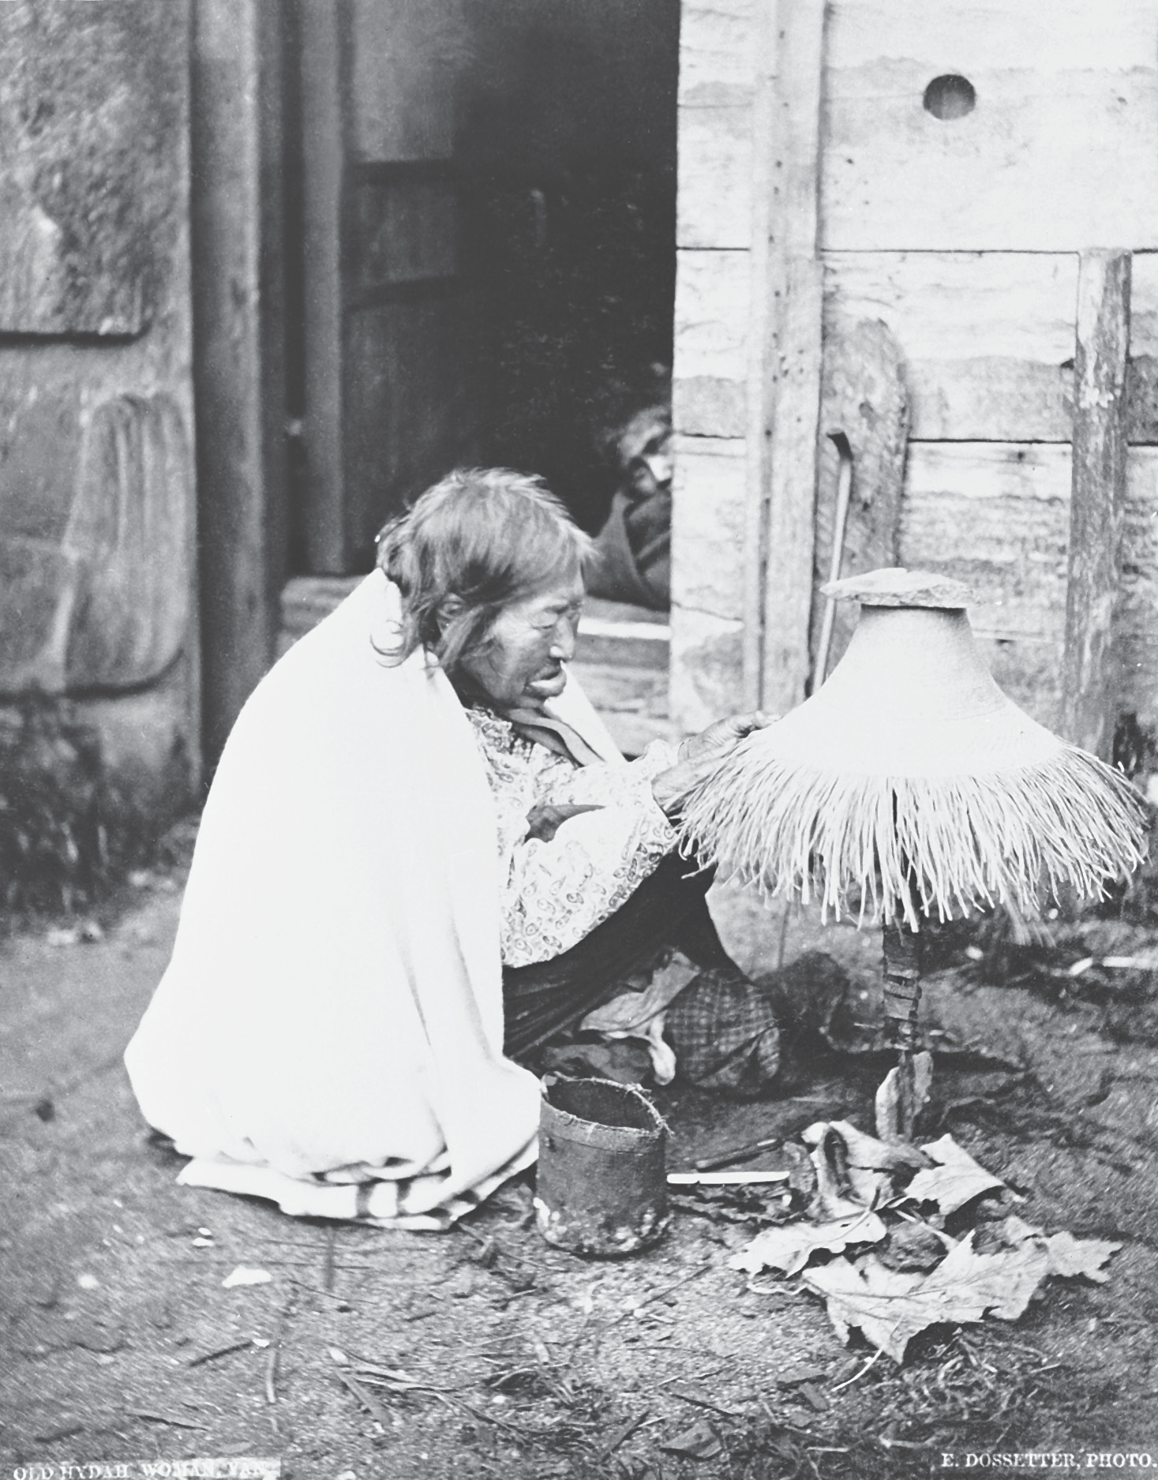
out. Throughout much of the province, birch bark baskets were common. The waterproof and rot-resistant bark was sewn with spruce roots to form watertight containers.

A Haida woman making a spruce root hat, using techniques that are still practised today. In her lower lip she is wearing a decorative ornament known as a labret, a sign of prestige among many Northwest Coast First Nations. Photo BCA B-3592, courtesy of the Royal BC Museum and Archives.

Weaving and basket-making were developed into complex and highly sought-after arts, almost always carried out by women. As well as making utilitarian objects, women created fine textiles from both plants and animal hair spun into thread.
These were most often made into robes that signified great power and social status, or had spiritual significance.
The expertise of Coast Salish women in creating valuable textiles was highly regarded. They raised a breed of dog especially for its soft hair, which was spun using a spindle whorl, a unique tool which helped the spinning process. The thread was woven using a special type of loom with free-floating roller bars.
Mountain goat wool was also widely used in weaving blankets. Because it was relatively rare and difficult to obtain, it was reserved for ceremonial robes of high- ranking people. On the northern coast, two types of ceremonial robes known as the Raven’s tail blanket and the Chilkat blanket were created using complex weaving processes. The Coast Salish wove their own style of blanket from mountain goat hair.

Making Tools and Household Goods
Winter offered an opportunity to replenish the tools that would be needed for the coming year. Usually everybody knew how to make the tools they would require, and men and women were responsible for making the implements they used. In some cases experts might be called upon to make very sophisticated items.
Nothing was wasted: people made use of practically every part of the resources they harvested. For example, when a moose was killed, those parts that were not used for food could be used in other ways. The skin, of course, was tanned for many uses. The antlers were used as moose calls, imitating the sound of a moose rubbing its antlers against the trunk of a tree. They were also shaped to make knives and scrapers. Other bones were fashioned into tools such as awls and needles. Sinew from the muscles made a tough thread, while the stomach was cleaned and used as a bag.
A hunter’s most important equipment was his bow and arrows, and the skill with which he could make them determined, to a degree, the success of the hunt. Bows were made from a strong supple hardwood such as yew or maple, while the string might be made from sinew or the fibre from Indian hemp. The construction of arrows varied according to their purpose. One type might simply have the shaft sharpened to a fine point for small prey like birds, while others had large detachable stone points for killing large game.

Great expertise was required in using the materials. For instance, it isn’t a simple matter to shape a stone into a projectile such as a spearhead or sculpted form like an anchor. To make a sharp projectile, you must understand the structure of the stone and know how shards will flake off when you strike it a certain way. To sculpt the stone, you must have the knowledge and the patience to grind, pierce, and smooth the material, creating a tool of great utility as well as beauty.
Woodworking, too, required great skill, and often men specialized in building large items such as canoes. One of the most useful household items made on the coast, but also traded into the interior, was the cedar bentwood box (sometimes known as a kerfed box). Highly sophisticated techniques enabled the woodworker to make
the sides of a box out of one piece of wood, using steam to bend the wood after the corners had been carefully notched or kerfed. The bent wood was joined with pegs or lashing and a tight-fitting lid and bottom were added to make a tightly sealed container. These boxes were made in many sizes and used to store any manner
of goods, from foods such as dried salmon and oolichan grease, to fishing gear, to chiefs’ ceremonial objects. They were also used for seating.

Creating Shelter
Most First Nations used different architecture for summer shelter than they did for winter. Many houses were light and portable, as people moved to different resource sites in the summer. In some areas, such as the northeast, tipis were the principal type of shelter, as they were on the Prairies. These tall conical tents covered with moose or caribou hides were light and easily transported.
The people of the southern interior developed a unique winter home that is usually called a pit house because a pit was excavated in the ground to create a living space. They were usually circular with a conical roof built of beams and posts.
People entered through the central smokehole, which held a ladder made from a log. As many as thirty people lived in these structures over the winter. The earth acted as insulation, and the houses were comfortable and easy to heat.
Coastal people constructed a different type of house that suited their climate and social organization. They used the readily available cedar trees to construct large plank houses known as longhouses or big houses. Distinct architectural styles were used in different regions of the coast. Haida houses had six beams which projected out from the roof, while most other types used two roofbeams. In the north, the cedar planks forming the wall were placed vertically in grooves. The Coast Salish houses used planks set horizontally. This construction made it possible to add extensions, and some Coast Salish houses truly were long, reaching lengths of 450 metres. The planks of the longhouse could be removed and transported by canoe to be used in the buildings at seasonal camps.

The longhouse was an important cultural entity. It was a part of the Northwest Coast social organization, and longhouses were named and decorated with crests. As well as providing daily living space, they were used for all the important events such as potlatches.

Transportation
Throughout the interior, people usually walked as their main mode of transportation, until the arrival of the horse in the early 1700s. They developed extensive and well-maintained networks of trails. Where trails needed to cross rivers, people built bridges, usually simple log structures. However, the Gitxsan developed a unique technology for constructing cantilevered bridges over deep river canyons. During the winter, people used snowshoes to travel between villages or to work their traplines.
On the coast, transportation was mainly by canoe. Cedar was used almost exclusively, except for some small river canoes which might be made of birch or spruce. The cedar canoes, which reached a size of eighteen metres, had a
remarkable streamlined design, were able to travel great distances on stormy seas, and could carry a large cargo or as many as twenty passengers. Each one was made from a hollowed out tree that was steamed to stretch the gunwales to a broader shape.
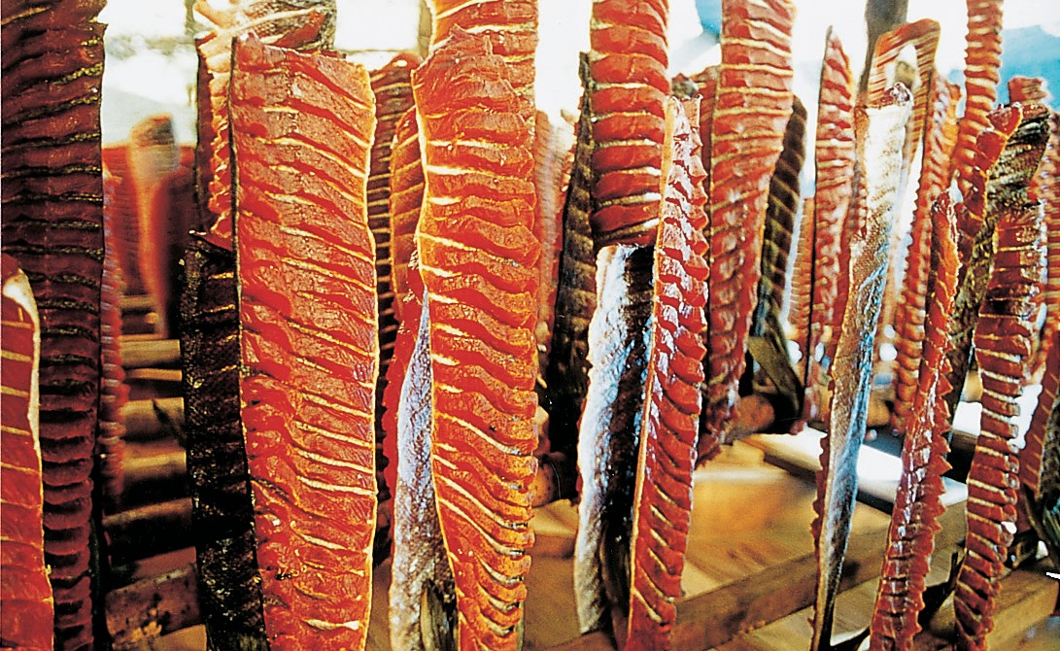
Because of the importance of salmon as a food source, the beginning of the salmon season has traditionally been celebrated by many First Nations. Photo courtesy of the Stó:lō Nation
Cantilevered
A cantilevered bridge is built with beams projecting out from the banks and supported by girders.
Gunwale
The upper edge of the side of a boat or ship. The name comes from when guns were supported there.

Managing the Resources
First Nations people’s traditional way of life integrated social, economic, and spiritual elements, and the natural world and the human world were all one. It is important to understand what is meant by the spiritual to realize its significance in First Nations’ relationship with the land and their views about resource management. The 1996 Report of the Royal Commission on Aboriginal Peoples defined it clearly:

Spirituality, in Aboriginal discourse, is not a system of beliefs that can be defined like a religion; it is a way of life in which people acknowledge that every element of the material world is in some sense infused with spirit, and all human behavior is affected by, and in turn has an effect in, a
non-material, spiritual realm.1
One example of this view of nature is in First Nations’ celebrations of the earth’s annual rebirth. People showed their respect and appreciation for the new season by addressing plants and animals as living entities. They thanked them for sharing themselves, and also explained to them in what ways the people would make use of them. Further respect was shown for the resources, especially the major meat sources such as salmon or moose, by following certain rituals when disposing of the unused portions. Often bones and guts were burned or placed in water so scavenging animals could not eat them.
Almost every First Nation named the months after the major seasonal activity that was carried out during that time, or the actual resource gathered. For instance, the Tsimshian call June “Salmonberry Month” and July “Sockeye Month.”
Special spiritual ceremonies often celebrated the arrival of key resources. These included First Salmon, First Fruit, and First Root ceremonies. Some were quite simple, showing reverence and thanks, while others were complex. For instance, the First Salmon ceremony of the St’at’imc people began when a special man, the seer, received the first sockeye from the fisherman who caught it.
The seer and another Elder set the salmon on a bed of boughs, and they presented to it a series of wooden rods which were individually marked and decorated. These rods represented the Elders of the village, and through the rods, each Elder was introduced to the salmon. Having been welcomed, the salmon was boiled and shared among the whole community. Everyone who took part in the ceremony later gave one salmon to the seer. These were all cooked and eaten by everyone during a feast that included dancing led by the seer.

The ways that resources were administered varied from place to place. Generally a band would hold certain territories in common, but other bands were permitted to share these areas. For instance, among the St’at’imc a family held rights to specific fishing spots, but once they had caught all the fish they needed, others were permitted to use the same places. Hereditary chiefs were responsible for the prosperity and safety of their groups. They organized their group’s economic
activities, maintained its prestige and social position through feasts and potlatches, and acted as leaders of spiritual pursuits. However, they required the support of the resource-use unit’s members. Decisions were made by consensus through a council of Elders and chiefs. All members of the group gave some of their labour and food and materials for the common good of the group, and the chief used this wealth in his potlatch. Thus it was required of everyone in the resource-use unit to manage the land and resources of their particular territories.

Summary
The First Nations of British Columbia have always had a close and special relationship with the land, which is marked by respect. It reflects a different world view from that of western European cultures, one that sees the natural world and human experience as integrated and unified.
The material cultures of the First Nations of the province reveal a multitude of technologies developed to efficiently and effectively harvest and process the plants and animals which made up the natural resources. A high degree of skill was required to make and utilize the varied technologies.
The way that people managed their resources influenced their social organization.
Interior people, on the whole, had relatively large and open areas within their territories, and travelled extensively to reach different sites. Their social
organization was flexible and democratic, without a pronounced hierarchy or rank. Coastal people, however, divided their territories into smaller units which required less travel. Their seasonal rounds followed a strict pattern and a corresponding structured social organization was the result.
As a result of land claims and a number of landmark court cases dealing with Aboriginal rights and resource base issues, today First Nations are reclaiming their roles as stewards of their territories.

Sources and Credits
1. Report of the Royal Commission on Aboriginal Peoples, Vol. 1, ch. 15, sec. 1, p. 617.

