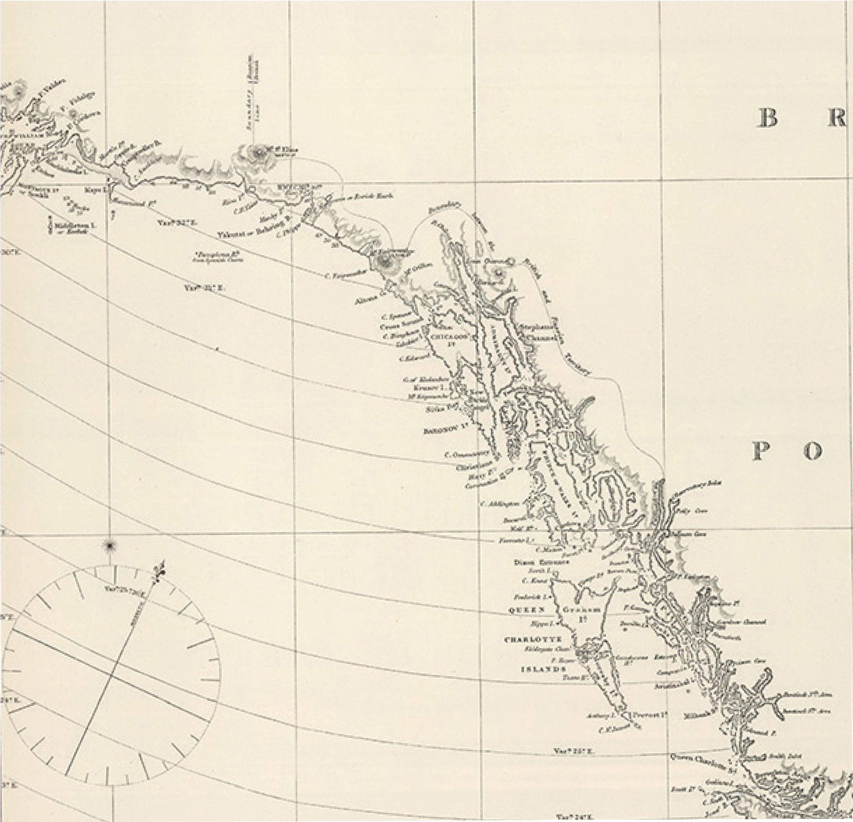

Great Bear Rainforest

The Colonial Era, 1849-1871

The Colonial Era, 1849-1871
The fur traders who lived at the trading posts had a significant impact economically and socially on the lives of First Nations people, but they did not attempt to govern the land and impose their own laws and regulations. Their concern was business. In the 1840s, however, the British government began to exert more direct control over the former fur-trading territories.
This section looks at the transition from the fur trade monopoly of the Hudson’s Bay Company to a colonial government which directed the settlement of the territory and began to put controls on the lives and lands of First Nations people in
B.C. You will see how two different men administered policies regarding Aboriginal people, first James Douglas, governor of the colonial government, and following his retirement, Joseph Trutch. Between them they laid the foundation for the
relationship between British Columbia and First Nations people for the next century and a half. This section also discusses the importance the Fraser River gold rush had in opening up the country, advancing formal colonization, and increasing tension between First Nations and Euro-Canadians.

Colonial Precedents
The development of colonial government in British Columbia occurred rather late in the history of the British Empire, and there were precedents which could have been followed in developing a relationship with First Nations people. British Columbia, however, pursued its own unique course.
In eastern North America the competing imperial powers of Great Britain and France had long since established colonies to defend their territorial expansion into what they called the “New World.” In 1759 the battle for control of North America came to an end at the Plains of Abraham and Britain claimed the continent. Their hegemony was to be short-lived, however, as the colonies on the eastern seaboard south of the St. Lawrence River rebelled against the laws imposed on them by the British government, culminating in the American War of Independence. A period
of struggle over sovereignty between Britain and the United States ensued, until finally, in 1846, the border stretched across the continent, following the forty-ninth parallel of latitude for most of its length in western Canada.

Colony
A colony is a country or territory occupied and ruled by another country. A colony has an elected local government but is subject to the laws of the parent country.

Precedent
A precedent is a similar event or action that occurred earlier; a previous case or legal decision taken as a guide for subsequent cases or as a justification for subsequent situations.
Hegemony
The predominant influence of one group or power over others, especially when it involves coercion, as in colonialism. The beliefs and values of the dominant group appear to be universal.

Following its victory in 1759, the British government consolidated its policies relating to the administration of the colonies in a document known today as the Royal Proclamation of 1763. Among other things, this proclamation contained Britain’s general policies for dealing with First Nations people in its North American colonies. Based on the premise that the Aboriginal people and the British colonizers had a nation-to-nation relationship, settlers and colonial governments were instructed not to settle on Aboriginal lands until agreements had been reached between the First Nations and Britain transferring ownership of the land. The Royal Proclamation set out the guiding principles for making treaties, based on the premise that the lands belonged to First Nations people. In eastern Canada the intent of the Royal Proclamation was adhered to, in that treaties were made with most First Nations.
That was not the case in British Columbia.

Colonial Timeline
1843 | 1846 | 1849 | 1858 | 1866 | 1871
Fort Victoria | Oregon Treaty | Colony of | Colony of | Both colonies | Confederation
established | defines border | Vancouver | British | united as | within
on Vancouver Island |  | Island created | Columbia created | Colony of British Columbia | Canada

From Fur Trade to Gold Rush
For decades First Nations people had incorporated the fur-trade economy into their societies, but soon a new economic force—the gold rush—was to bring about a greater transformation in their lives.
In the 1840s, westward expansion of the United States forced the Hudson’s Bay Company to move its Pacific headquarters at Fort Vancouver on the Columbia River because this was now American territory. To replace Fort Vancouver, Fort Victoria was established in 1843 at the southern tip of Vancouver Island. The site was chosen because of its large harbour and the rich agricultural land nearby.
Meanwhile, hoping to forestall the advancing Americans, the British parliament decided to create an official colony to establish its sovereignty on the coast. In 1849, Fort Victoria became the capital of a new colony of Vancouver Island. The colonial office in London leased the colony to the Hudson’s Bay Company for ten years,
with the understanding that the HBC would administer the colony in addition to its fur-trading activities. The first British governor was Blanshard, but he was soon replaced by long-time HBC employee James Douglas, who continued to work for the HBC as well as acting as governor. It was Douglas who established the first government policies that had such an enormous impact on First Nations people.
The colony of Vancouver Island was established without negotiation with, or even consideration of, First Nations governments. The presence of First Nations people was simply irrelevant to the Europeans intent on carving up North America.

Furs continued to be the prime economic resource of the colony, but some First Nations people recognized that the Europeans were also keen to trade in minerals, particularly coal and gold. The Kwakwaka’wakw and the Snuneymuxw had both traded small amounts of coal to the HBC, and pointed out the sources of these minerals within their territories. Rather than trading with these First Nations, however, the HBC started a mining division and built mining camps at two new posts, Fort Rupert and Nanaimo. These were small-scale developments compared to events that occurred when gold was discovered on the Fraser River.
Through the 1850s, First Nations people along the Fraser River had traded small amounts of gold with the Hudson’s Bay Company. The company encouraged First Nations to search for other sources by paying for their prospecting equipment.
Douglas tried to keep the discovery of gold secret because he was familiar with the destructive lawlessness that occurred when gold fever infected California in 1849. The news leaked out in spite of his efforts and in 1858 thousands of miners, mostly American, flooded into Victoria, crossed the Strait of Georgia, and headed up the Fraser River. The book You Are Asked to Witness, published by the Stó:lø Nation, describes how First Nations people perceived the gold miners:
“In the Halq’eméylem language the word for people of European descent is Xwelítem. Stó:lø Elders explain that Xwelítem translates as ‘hungry people’ or ‘starving people’. No one remembers exactly when the Stó:lø adopted this term to describe the immigrants who came to their land, but Elder Dan Milo was of the opinion that it dates back at least as far as the 1858 gold rush when thousands of poorly provisioned miners arrived in Stó:lø territory.” 1
In the decades that followed, the gold rush moved from places near the coast like Hope and Yale up into the Cariboo to Barkerville. As the gold was exhausted in one area, the miners moved on. Thousands of men and women journeyed along the gold rush trails, trying to make their fortunes. In their hunger for gold, they
frequently ignored traditional First Nations use of the rivers and valleys they passed through. They disturbed the environment with their mining activities and with the communities they built to meet their needs, in most cases showing no respect for the First Nations.
First Nations people became miners too, sometimes working alongside miners from other countries. At one spot on the Fraser called Hill’s Bar, for example, five hundred First Nations people and seventy foreigners mined the river banks for gold. However, most foreign miners opposed the participation of Aboriginal people, because they viewed them as competitors for the gold.
Douglas and the colonial office were determined that the lawlessness which characterized the American frontier would not be copied in British territories, so in 1858 the British government decreed the formation of an additional colony on the mainland. It was named British Columbia, and its headquarters were established at New Westminster.

During the gold rush era, both colonies were opened up to newcomers as never before. The influx of miners caused the creation of transportation routes that enabled them to participate in the gold rush. Prospectors spread out from the Fraser River and Cariboo gold fields, exploring nearly every part of the province. Smaller scale gold rushes occurred, including on the Stikine, the Omineca, and the Peace Rivers, as well as at Kamloops and on the Leech River near Victoria.
Once a viable mining region had been established, roads had to be built for easy access. The age-old transportation routes of the First Nations and the fur traders were no longer sufficient, especially on the Fraser River route where the Cariboo Wagon Road crossed the interior plateaus to Barkerville. Other people dreamed up alternative schemes to reach the gold fields; for example, Alfred Waddington led forays from the coast at Bute Inlet into the Chilcotin region, resulting in what is sometimes called the Chilcotin War. The British felt that it was imperative for British justice to prevail in these colonies. The chief agent of the justice system in
the colonial era and after, was Chief Justice Matthew Baillie Begbie who, through his judgements on a number of early cases, played an important role in administering colonial policies involving First Nations people.
James Douglas continued to administer both colonies until 1864. By that time, running two colonies was becoming too expensive, so they were joined, in 1886, under the name British Columbia, with the capital at Victoria.

Colonial Policies
As chief factor of the Hudson’s Bay Company in British Columbia, and as colonial governor from 1851 to 1864, James Douglas had immense power over the lives and lands of First Nations people. When he took control, he was given clear instructions to follow British colonial policy, which was to recognize Aboriginal title to the land and to negotiate a treaty or settlement to purchase land required for settlement. In the early years of his administration, Douglas followed these instructions. He negotiated what are known as the Douglas Treaties. Between 1850 and 1854 he signed fourteen treaties, covering approximately 927 km2 (580 square miles) of land around Victoria, Saanich, Sooke, Nanaimo, and Port Hardy. In each treaty, First Nations land was surrendered “entirely and forever” in exchange for cash, clothing, or blankets. The chiefs and their descendants kept existing village sites and fields for their use, the “liberty to hunt over unoccupied lands,” and the right to “carry on their fisheries as formerly.”
Treaty
A treaty is a formal agreement between two groups, usually sovereign bodies or nations. Treaties with First Nations in Canada were agreements between the government and the First Nations to clear land of Aboriginal title so the land could be used for settlement, resource extraction, or transportation routes like railways. Certain payments and benefits were traded in exchange for clear title to the lands. In negotiating treaties, the government acknowledges the title of First Nations to their lands.

James Douglas did not negotiate any treaties after 1854. His views on Aboriginal residents seem to have changed, due in part to changing policy in London. Earl Grey, colonial secretary until 1852, believed it was important to protect Aboriginal rights in the colonies, but his successor, Sir Edward Lytton, seemed more intent on creating model communities fashioned after English country villages, with a church at the centre and farms surrounding it. Douglas heartily agreed with Lytton’s vision, and instead of making treaties, he began creating “Indian reserves” and developed a “system” that he believed would help the survival of the First Nations people.
Under the Douglas system, First Nations groups would be given parcels of land reserved for them, but owned by the Crown. Most of the reserves created under the colonial government were in more populated regions, especially where settlers were moving in to take up farming, such as in the Fraser Valley, the Thompson
and Okanagan, and Vancouver Island. First Nations people were encouraged to
pre-empt land, just as the incoming foreigners did. In this way, they could build communities based on the English countryside ideal. However, this policy caused an outcry from European and American settlers, who were, at this time, outnumbered by First Nations people. They feared that all the best land would be taken up by the First Nations, who would then have an economic advantage over them.
Douglas fought hard to defend land rights for First Nations people, although it was from a colonial perspective based on the assumption that First Nations people would quickly become assimilated into mainstream society. He saw the Aboriginal people in the same light as he saw British immigrants. He believed they had rights similar to those held by British settlers, and enacted laws allowing them to pre- empt land and to vote in elections.
Some of his policies left a legacy that would define the relationship of the future province with First Nations people until the end of the twentieth century. He ignored the important idea of Aboriginal title in his plans, leaving his successors with the impression that Aboriginal title did not exist. He also left the impression that the government had a policy of allotting only ten acres for each family on reserves. Although much larger allotments were often made under his government, in a speech made just before he retired, he suggested that reserves should be ten acres a family. Later he tried to clarify this statement, but the damage had been done.
Pre-empt
To pre-empt land (known elsewhere as homesteading) was the main form of land settlement by immigrants in North America. In Canada, British subjects were given 160 acres of land free, as long as they cleared the land and started farming on it. During the Douglas administration, First Nations people were encouraged to pre-empt land, but after Douglas left, the laws were changed to forbid them from pre-empting.

6

Joseph Trutch succeeded Douglas as the administrator of First Nations policies. He stated his belief in no uncertain terms that the First Nations of B.C. had never owned the land. “The title of the Indians in the fee of the public lands, or any portion thereof,” he said, “has never been acknowledged by Government, but, on the contrary, is distinctly denied.” This statement contradicted the earlier Royal Proclamation of 1763, the policy of the British government, and the intent of the Douglas Treaties that had already been signed. It was, however, consistent with the general feeling held by the British settlers that the land was “empty” and free for the taking. By accepting the belief that the land had been empty before they
arrived, the colonists could say Aboriginal title never existed and that treaties were irrelevant. In fact, even the act of making reserves was thought by government to be a generous gift.
One of the first things the united colony did was to remove the right of First Nations people to pre-empt land. Reserves were strictly limited to ten acres a family.
Inequality became a part of First Nations policy in the colony.

Original Documents
Instructions to Governor Douglas
The colonial office’s letter of instructions to James Douglas clearly acknowledges that the First Nations were considered to be the rightful possessors of the land. However, the British only regarded land that was cultivated or that had permanent buildings standing on it to be owned by First Nations people. They had no understanding of the complex systems of land use and ownership that had existed for thousands of years.
With respect to the rights of the natives, you will have to confer with the chief of the tribes on that subject, and in your negotiations with them you are to consider the natives as the rightful possessors of such lands only as they are occupied by cultivation, or had houses built on, at the time when the Island came under the undivided sovereignty of Great Britain in 1846. All other land is to be regarded as waste, and applicable to the purposes of colonization . . . The right of fishing and hunting will be continued to [the natives], and when their lands are registered, and
they conform to the same conditions with which other settlers are required to comply, they will enjoy the same rights and privileges.

Gunboat “Justice”
Violence and the threat of violence were commonly used to keep order on the coast during the 1800s. The might of the British Empire was imposed throughout the world by the Royal Navy, and the Northwest Coast was no different. At its base at Esquimalt, near Victoria, the Royal Navy stationed “gunboats”—sailing ships and steamships armed with cannons, with names like Forward, Grappler, and
Devastation. Whenever a First Nations person committed a breach of British justice, there was a public cry of “Send out the gunboats!”
The crime that usually warranted sending out the gunboats was murder. Murders occurred for a number of reasons. Some followed patterns of inter-tribal warfare that were traditionally a feature of some First Nations societies, but more often they were the result of conflict between First Nations and new settlers moving onto their traditional territories. Some were acts of protest.
The settlers and their governments feared that a murder meant much more than a specific act growing out of local circumstances. It was regarded as a threat, a form of lawlessness that would grow if it were not stopped with a great show of force. From 1849, when Vancouver Island became a colony, until 1910 when the
Canadian navy took over, Britain’s Royal Navy provided that force. It was believed by government leaders and military commanders that brute force was the only form of justice First Nations people understood.
When the navy was first sent out to the scene of the crime, the commander anchored his ship, often called a “man-of-war,” directly in front of the village. He attempted to arrest the accused person or persons. If he faced resistance, he sent in the marines to take hostages, who were usually chiefs or their relatives. If the suspects still failed to turn themselves in, the commander threatened to destroy the whole village, and often fired the ship’s cannons to demonstrate their power. Sometimes he seized canoes to prevent escape.
Finally, the threat was carried out, and the whole village was blasted and destroyed, along with the canoes and any people who remained behind.
During the time that gunboats were used to bring “justice,” there were at least fourteen major incidents where the Royal Navy threatened a community or groups of communities. Eight of these resulted in the villages being destroyed. The most disastrous campaign involved a number of Nuu-chah-nulth groups on the west coast of Vancouver Island in 1864. Nine villages between Barkley Sound and Clayoquot Sound were destroyed, as well as sixty-four canoes. The last such incident was the destruction of Kimsquit in 1877, but the threat of gunboats was used as late as 1888 on the Skeena River.

When suspects were finally captured, they were hanged, sometimes on the spot in front of their com- munity, sometimes in Victoria or New Westminster. This heavy- handed form of justice left the whole tribe with a sentence of its own. With their houses destroyed, they were forced to disperse, often to live with relatives in other villages. Without canoes, they could not harvest the food and other resources they needed for survival.

Summary
During much of the fur trade era, First Nations people had to deal with just one corporate entity, the Hudson’s Bay Company, but the discovery of gold brought tens of thousands of newcomers into British Columbia, each concerned only with his own wealth. The British government, to protect its sovereignty on the Pacific coast, created the colony of Vancouver Island in 1849. A second colony called British Columbia was established in response to the influx of miners, and the two were joined in 1864. James Douglas, at first chief factor of the HBC on the Pacific coast and later governor of both colonies, forged the future relationships that would exist between First Nations and the newcomers. He abandoned the notion of treaties in favour of Indian reserves, which were designed to assimilate First Nations people into the immigrant society. His successor, Joseph Trutch, denied that First Nations people had Aboriginal title to the land. He determined that reserves would be limited to only ten acres per family. The British Empire imposed its con- troll, often using the Royal Navy to dispense gunboat “justice.”

Sources and Credits
1. Keith Thor Carlson, You Are Asked To Witness: The Stó:lō in Canada’s Pacific Coast History. Chilliwack: Stó:lø Heritage Trust, 1997, p. 54. Used with permission of the Stó:lō Nation.

9

