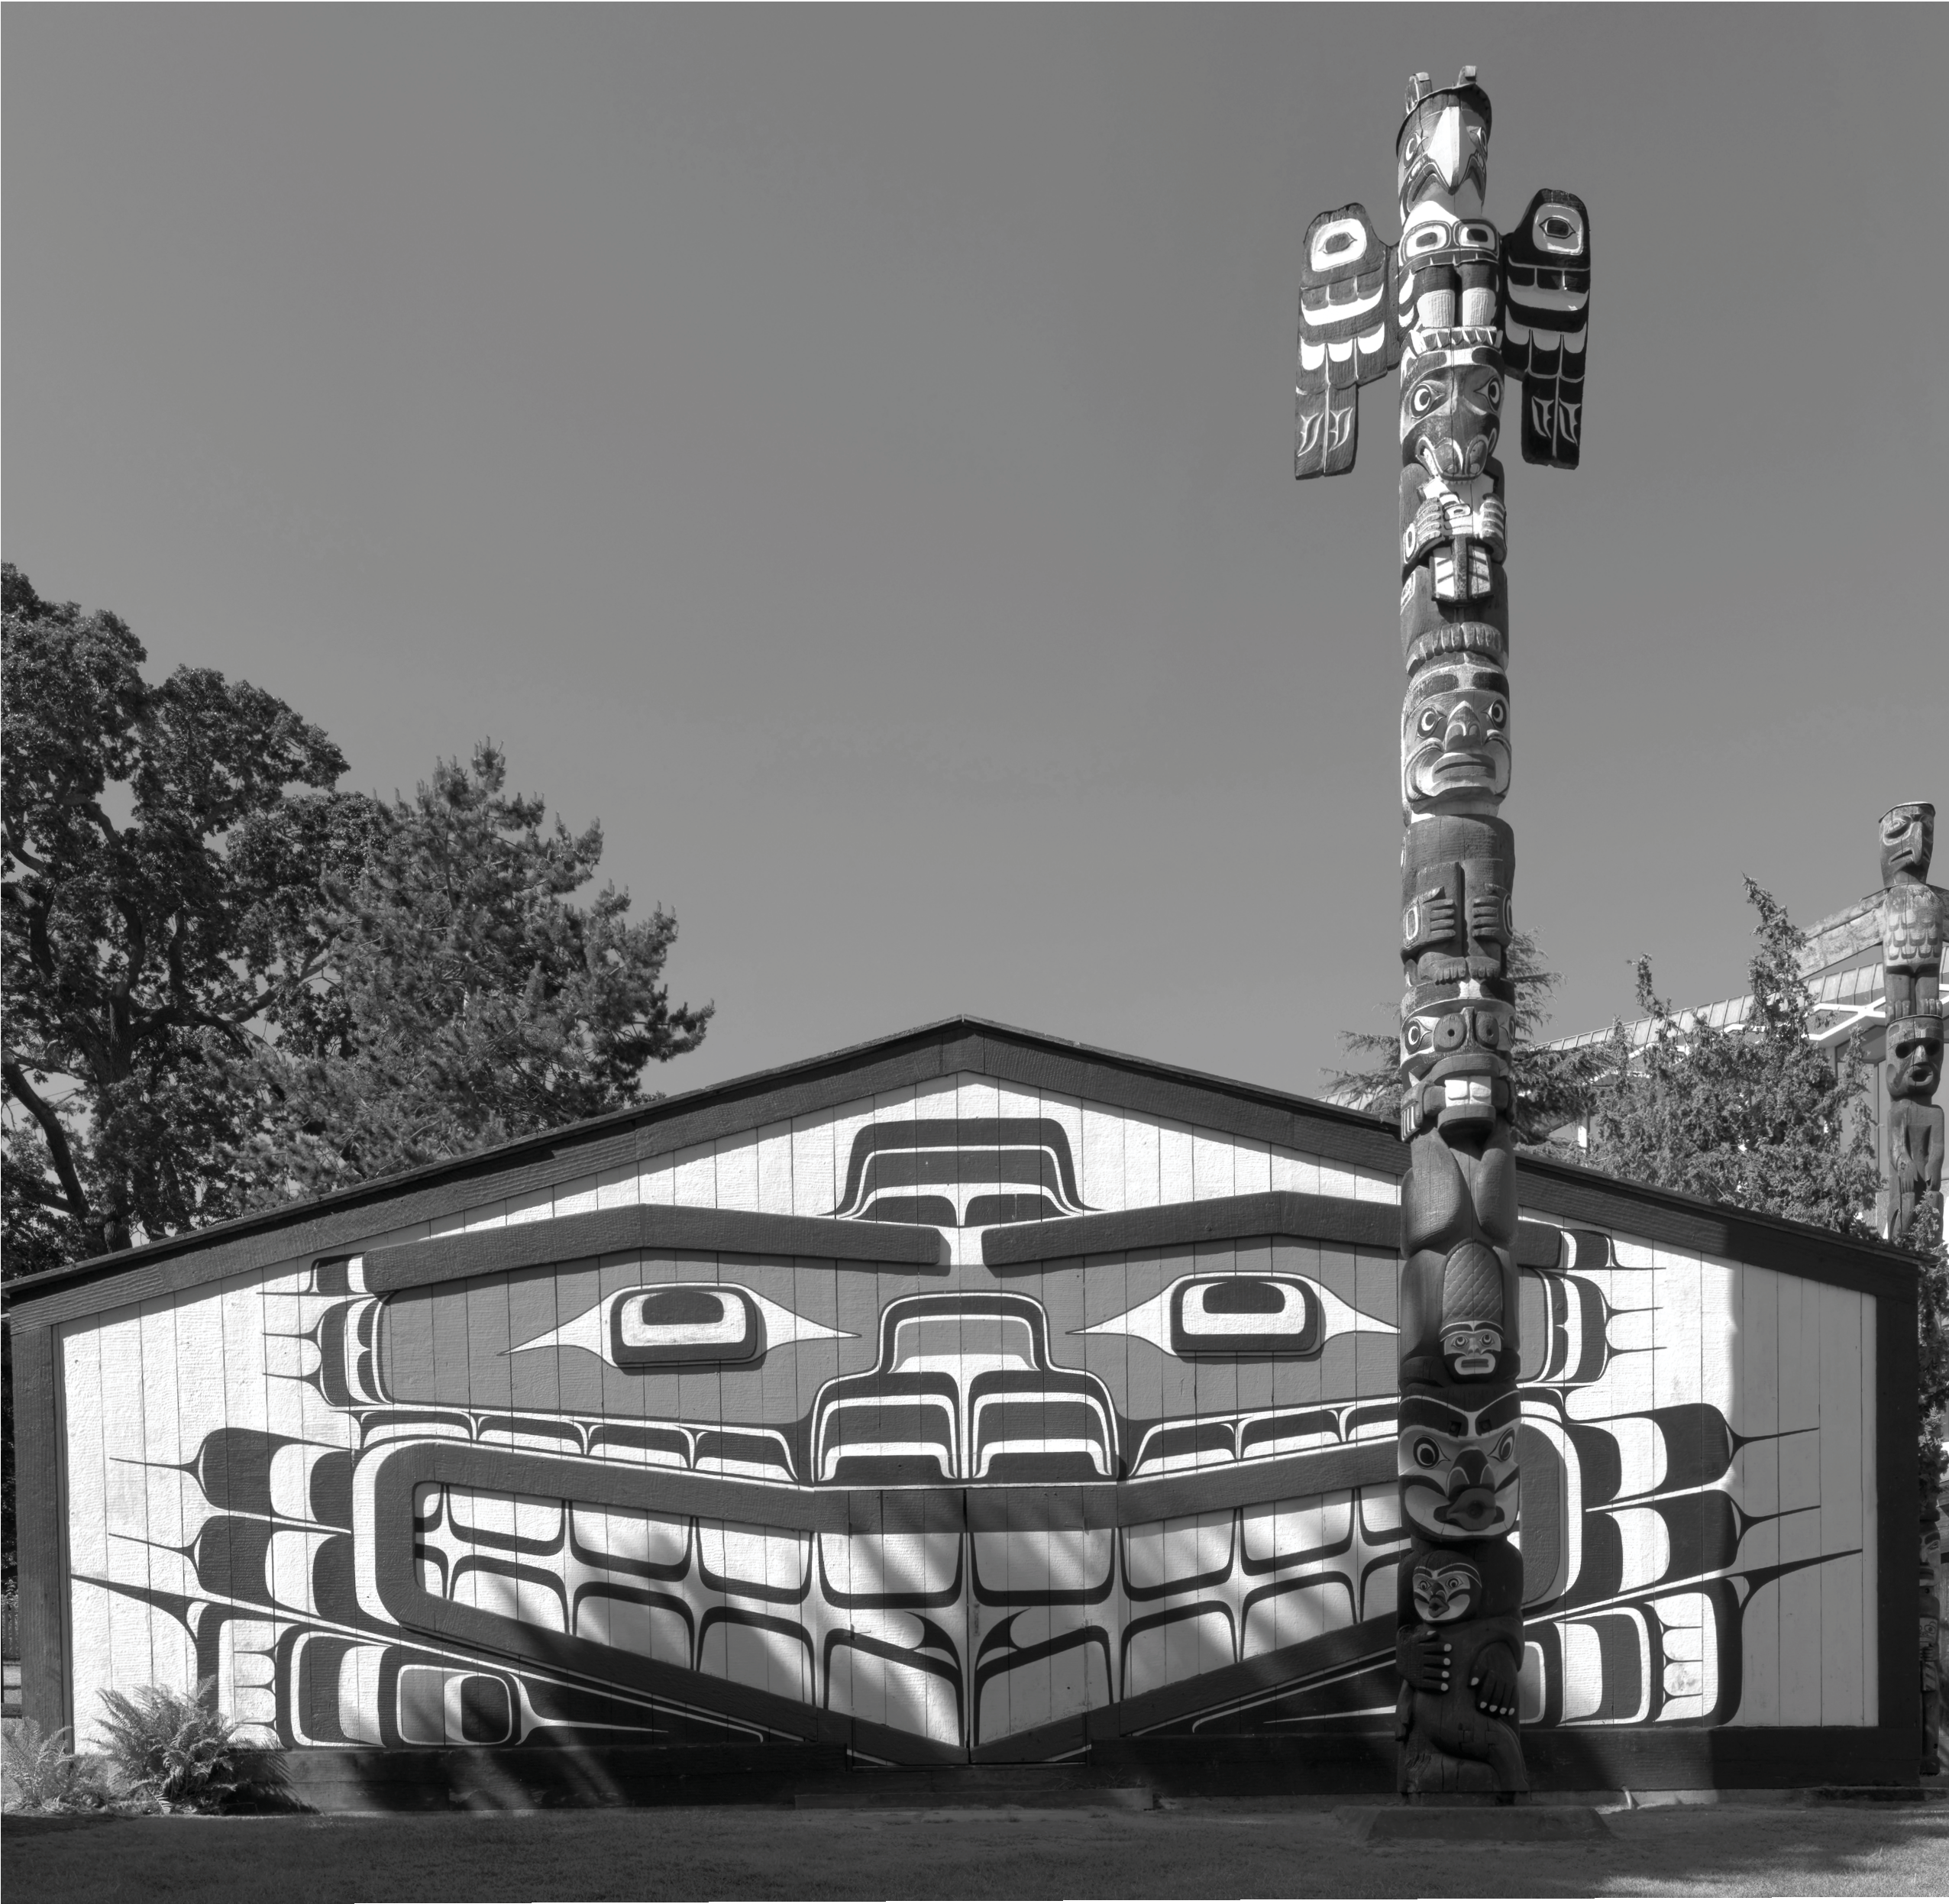

Great Bear Rainforest

Traditional First Nations Houses

Traditional First Nations Houses
The land we now know as British Columbia encompasses a wide range of climates and geographies. This diversity has affected First Nations cultures to a great extent and has resulted in numerous distinct First Nations cultures in British Columbia.
Within those cultural groups, there is diversity among tribes and at times even between families within those tribes. On the West Coast, First Nations peoples harvested many resources from the sea, the rivers, and the forests. In the north they hunted mountain goats. Even further north they hunted caribou. Up the Fraser River, First Nations people fished for sturgeon. On the coast it rains a great deal. The geography, combined with the climate and flora results in a temperate rainforest; winters are mild. In the north, the winter is cold and the trees are much smaller. In the interior, the winters are cold and the summers are hot and dry. Each distinct set of factors, associated with a geographic area and climate, helped to determine how First Nations people within that area lived. Many different aspects of life were influenced by climate and geography: the food that was available and when it was available, the transportation that was used, the art First Nations people were inspired to create, and the governance they instituted. The result is that within British Columbia, there are many different cultural perspectives and many cultural expressions amongst First Nations peoples.
This section will examine how house construction techniques demonstrate geographic and cultural diversity.
First Nations gather for many of the same reasons as other groups of Canadians.

The West Coast House
The use of the canoe all along the Pacific coast meant a high degree of interaction between cultural groups. There was intertribal trade, warfare, social interaction, and intermarriage. There were also common and shared characteristics in art forms. In ancient art, coastal First Nations people expressed themselves through rock paintings (pictographs) and rock carvings (petroglyphs). Later, wood became the common medium used by coastal peoples for canoes, houses, house posts, bentwood boxes, tools, and masks. Cedar bark and spruce roots were used for basketry. Cedar bark was used for clothing, including hats. Houses were made of cedar. Houses up and down the coast showed common construction techniques and characteristics: massive posts and beams, generally of red cedar, created a sturdy frame; houses had low doors for safety reasons—enemies had to stoop down to enter the house, putting themselves in a vulnerable position.
In 1984 the Museum of Civilization in Hull, Québec undertook the development of the Grand Hall exhibit. They called on British Columbia carvers to create houses for

the exhibit that were representative of their nations’ houses. These houses were constructed at various locations in British Columbia and then shipped to Quebec to be situated in the Grand Hall. The museum showcases houses from several different nations: the Tsimshian, the Haida, the Nuxalk, the Kwakwaka’wakw, the Nuu-chah-nulth, and the Coast Salish.
Traditionally, many First Nations groups had a summer camp and a winter settlement. In the summer, berry picking, hunting, and harvesting sea mammals and fish were common activities. Due to the milder climate in the summer, shelters were often little more than simple huts. Winter houses were more substantial— big houses or longhouses were generally between 12 and 20 metres long, though among the Coast Salish they could be twice this length. Planks from winter houses were sometimes used in summer house construction as well.
Though the structural framework for traditional coastal First Nations houses was for the most part similar, tremendous diversity existed in the variety of exterior and interior house paintings found in different villages, as well as among carved interior house posts, painted screens, house frontal poles, and free-standing memorial poles. Houses expressed the rank and ancestral heritage of their inhabitants.
Designs incorporated into winter houses expressed family histories and a family’s relationship to supernatural ancestors. Family crest carvings and inherited treasures were stored in the houses. In addition, ceremonial dances, dramas, and potlatches were all conducted in winter houses. Houses were given names, and among many groups once the houses were constructed, they were honoured with potlatch ceremonies.

Tsimshian House
The Tsimshian house at the Museum of Civilization represents a house style of Tsimshian villages in the mid 1800s. The house is constructed of massive cedar posts and beams. The walls are constructed of vertical wallboards, which are set into grooved timbers at the top and bottom. These boards can be removed. On the house front, a bear figure is painted at the centre and is flanked by a split wolf design—one side of the wolf on one side of the bear and the other side of the wolf on the other side. The design is painted in black and red and uses both negative and positive space. The house panels have been left in their natural colour. The painting is the reconstruction of a painted screen from a house interior from Port Simpson in mid-1800s.
Some chiefs had steps leading down from the main floor to the central fire pits. These steps were wide enough for use as surfaces for meal preparation and other domestic activities. Two very tall totem poles are beside and in front of the house. One pole is a memorial to a chief with the hat that shows how many potlatches he held and a box representing the chief’s burial.

Northern Coast Houses
Houses in the northern coast were among the most sophisticated found in coastal First Nations villages. It was important for them to withstand the extreme weather conditions of the north. The planks of the houses of the Haida, Tsimshian, Nisga’a, and Gitxsan were snugly and exactingly fitted.
The house below represents one of two styles of Haida houses. The northern houses of Haida Gwaii were similar to other northern coastal houses, built with gabled roofs and were covered with planks.
Houses in southern Haida Gwaii were built with an external frame. In the house featured below, adzed poles hold up each of the six beams, the ends of which extend beyond the roofline to the exterior of the house. Planks fit tightly between each beam. This style of house was popular in the 19th century. Its roof is pitched. The wall planks are also vertical with framing planks set at the top and bottom, parallel to the ground and to the roof. This surface is unpainted. A totem pole stands outside at the centre of the house, its bottom figure forming the house entrance. This pole is called, “House Waiting for Property.” One account says the original pole on which this one was modeled was the entrance to a Raven clan house in a village named Haina. The main figures on the pole seem to be the eagle and killer whale. The central figures may relate to an ancestor story about a man who travelled to the home of the killer whales to rescue his wife’s soul. At the top of the pole are the Haida watchmen —three small human figures wearing the dance hats that chiefs wore at potlatches. The central watchman on this pole wears a killer whale fin instead of a potlatch hat. They watch for the arrival of guests or the arrival of enemies, and alert the chief.
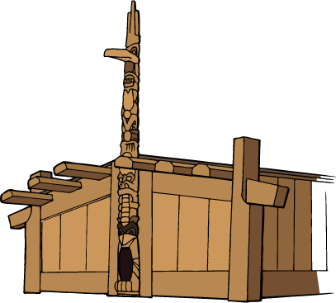

Nuxalk House
Traditional Nuxalk houses were of a shed-roof and plank construction, and some early Nuxalk houses were elevated on pilings. Nuxalk house frames were sometimes built with three structurally distinct “bays,” which delineated three
separate areas in the house’s interior, all of which shared a common hearth. Gabled houses were also build by the Nuxalk.
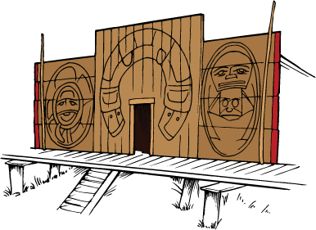
The Nuxalk house represented below is based on a house in the village of Qwemqtc in the late 1800s. The original house was built to represent a supernatural ancestor of the chief, Chief Clellamin, who built it. The story is that Nusq’alst came to earth from Nusmat’a, the land above, at the beginning of the world. This was a time when supernatural ancestors of many Nuxalk families came down and established homes and family lines on earth. Nusq’alst settled in the valley and became a mountain.
This house is also built of cedar posts and beams. The wallboards are set vertically with a framing row set parallel to the ground; the wallboards are unpainted. This house has a European influence, with a rectangular door at the centre and multi- paned windows on each side. The roof of the house is styled to represent mountain peaks—its peaks and gables are painted blue and white to represent streaks of snow. On each peak sits a carved wooden ball, which represents the rocks to which the Nuxalk people tied their canoes during a flood of the world. Above the door
is the figure of a man with a hammer in his hand that was used to pound a maple plank into the ground, welcoming guests to his house when there was a feast. A rectangular painted sign hangs above the man, commemorating Chief Clellamin’s life.

This house is also built of cedar posts and beams. The wallboards are set vertically with a framing row set parallel to the ground; the wallboards are unpainted. This house has a European influence with a rectangular door at the centre and multi- paned windows on each side. The roof of the house is styled to represent mountain peaks—its peaks and gables are painted blue and white to represent streaks of snow. On each peak sits a carved wooden ball, which represents the rocks to which the Nuxalk people tied their canoes during a flood of the world. Above the door
is the figure of a man with a hammer in his hand that was used to pound a maple plank into the ground, welcoming guests to his house when there was a feast. A rectangular painted sign hangs above the man, commemorating Chief Clellamin’s life. This house incorporated European architectural influences and techniques in addition to the traditional characteristics that are a living representation of a family history.
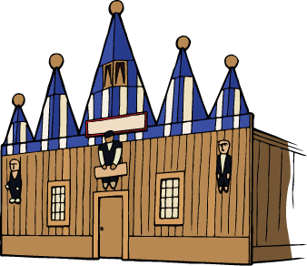

Central Coast House
This house is different from the other four houses. Its façade is clapboard. Its planks are set horizontally, and it is painted white and trimmed in red. This house is a representation of an original house that stood at Alert Bay from the 1890s to
the 1930s. The house belonged to Chief Wakas, a 19th century chief who descended from the Owikeno and Nimpkish peoples. The chief commissioned the entrance pole; he had the carver recreate the figures from a speaker’s staff that he had inherited. The pole’s figures are emblems of the chief’s family history. At the top
of the pole is the thunderbird, lord of the upper world. Below the thunderbird is the killer whale, lord of the undersea world and below killer whale is wolf, a human figure—the Wise One, the mythical cannibal bird, and bear, with raven at the base. The figures tell the story of how humans acquired dance, songs, and masks of the winter ceremonial.
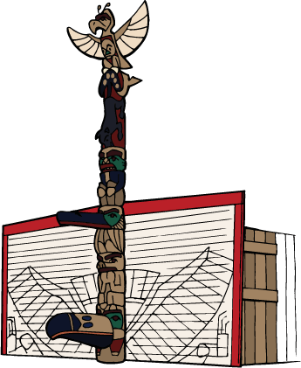

This house evolved over time. In the 1890s the archway through the bottom figure was the house entrance. Shortly after that, a beak was added to the figure by artist Dick Price. The top of the beak was the prow of a canoe. The lower part was made specially to complement it. Once the beak was added, the pole became a ceremonial entrance. A rectangular doorway was cut through the façade beside the pole for everyday use. In 1899 and 1900, the raven figure at the base of the pole was finished when tail feathers, wings, and claws were painted to stretch
across the façade to unify the façade, the pole, and the house together into a single representation of the history of Wakas’s family.

There was usually only one entrance to a house. Inside, open partitions contained sleeping platforms that faced one another on either side of a
corridor running through the centre of the structure. The size of these structures permitted several families to live under one roof. A fire pit was located in the centre of the house. Roof planks above the fire could be moved by using a pole, providing an opening for smoke to escape.

