Great Bear Rainforest Activity Plan

Inquiry:
Where is the Great Bear Rainforest?

Students discuss the features of a temperate rainforest and locate geographical features of the Great Bear Rainforest (GBR).

Learning Objectives
Students will:
- Identify the geographical regions of BC
- Identify key geographical features of the Great Bear Rainforest region on a map

Preparing for the Activity Plan
You may wish to view the short videos in the Materials section below, and choose one or two to show your class. Also read the teacher backgrounders listed in the Backgrounder section.
For the mapping activity, printing out copies of the blank map on 11” x 17” paper for students is strongly recommended.

Materials
- computer and projector
- student computers / tablets / devices
- library books
- chart paper / white board
- large poster paper, felt pens
- Great Bear Rainforest website

Blackline masters
- Map of the Great Bear Rainforest

Backgrounders
- From the “Relationships to the Land” Backgrounder (also found at the end of this Activity Plan):
- Relationships to the Land (pages 2-3)
- The Shape of the Land (pages 3-4)
- The Coast (page 6)

Videos
Enter the Great Bear Rainforest (4:35) https://www.youtube.com/watch?v=js1rnKPAnE0
Speechless—Episode 10: Great Bear Rainforest (3:27) (Great footage of the Kermode bear) https://vimeo.com/239028899
Welcome to the Great Bear Rainforest (2:59) https://www.youtube.com/watch?v=jAHNqN_8p2k

Delivering the Activity Plan

Activity 1: Geography of BC and the Coast Region Access Prior Knowledge
- Tell students that the Great Bear Rainforest is a temperate rainforest. Ask, What is a temperate rainforest? Have students look up the definition on their devices, or on a classroom device, and report to the class. Write down the characteristics on chart paper (annual precipitation of over 140 cm, and annual temperature between 4 and 12 °C, etc.)
- Project the Map of BC’s regions, found on page five of this Activity Plan.
- Ask students to name any geographical features they know of in their own BC region (names of mountains, rivers, lakes, etc.). Ask if they know any geographical features in other BC regions and identify in which region those features are found. Write answers on the board or flipchart paper.
- Share the backgrounder: “Relationships to the Land” either by projecting it to the whole class or by printing off copies for small groups to read aloud to one another.

Inquire
- Project one or more of the videos listed in the resource section.
- Based on the videos, what questions do students have about the geography of the Great Bear Rainforest? Write questions down on chart paper.
- Have students research the answer to at least one of the questions.

Experience
- This activity can be done individually, in pairs, in small groups, or as a whole class. Some of the locations that students are asked to identify on the map may be difficult to find. Project the “Great Bear Rainforest Region” interactive map from the Great Bear Rainforest educational website and zoom in to specific locations to help students find them on their own maps. Alternately, project the map answer key on-screen. Due to the number of items students are asked to identify, it’s probably better to have them mark down the associated number for each item on the map, rather than the name.
- Hand out the map of the Great Bear Rainforest to students.
Option: Project a map of the GBR on a wall and have students draw the map using large newsprint paper.

Explore
Direct students to the Great Bear Rainforest educational website for further information on the geography of the Great Bear Rainforest.

Read
The Coast” (on page 6 of the “Relationships to the Land” Backgrounder), and page 8 of this Activity Plan.

Watch and Listen

BC creates a sanctuary for the Spirit Bear (2:26)
CBC news clip (CBC Archives) from April 4, 2001 detailing the protection of a large part of the Kermode bear’s habitat.
http://www.cbc.ca/archives/entry/bc-creates-a-sanctuary-for-the-spirit-bear

Kayaking the Great Bear: A Search for Wilderness (8:14)
Video footage of three outdoor enthusiasts kayaking through the Great Bear region and exploring the wilderness.
https://vimeo.com/61707379

Reflect and Connect
Divide students into small groups, and have them discuss the following question: Knowing the geographical features of the Great Bear Rainforest, what can you infer about the people who live in that region? (i.e., connected to the water, remote, tough weather conditions, lots of large mammals to hunt and view). Come back as a class and discuss.

Assess
- Are the maps accurately labelled?
- Did students participate in class discussions?

Go Beyond
- Using Old Maps Online: www.oldmapsonline.org have students overlay historical maps onto a modern digitized equivalent. Discuss how accurate the early explorers were when creating maps.
- See example: https://davidrumsey.georeferencer.com/maps/824076507081/view#
- Students come up with a 3D representation of the Great Bear Rainforest using cardboard (topography), or create a large-scale wooden map using a CNC machine.

Map of BC’s Regions
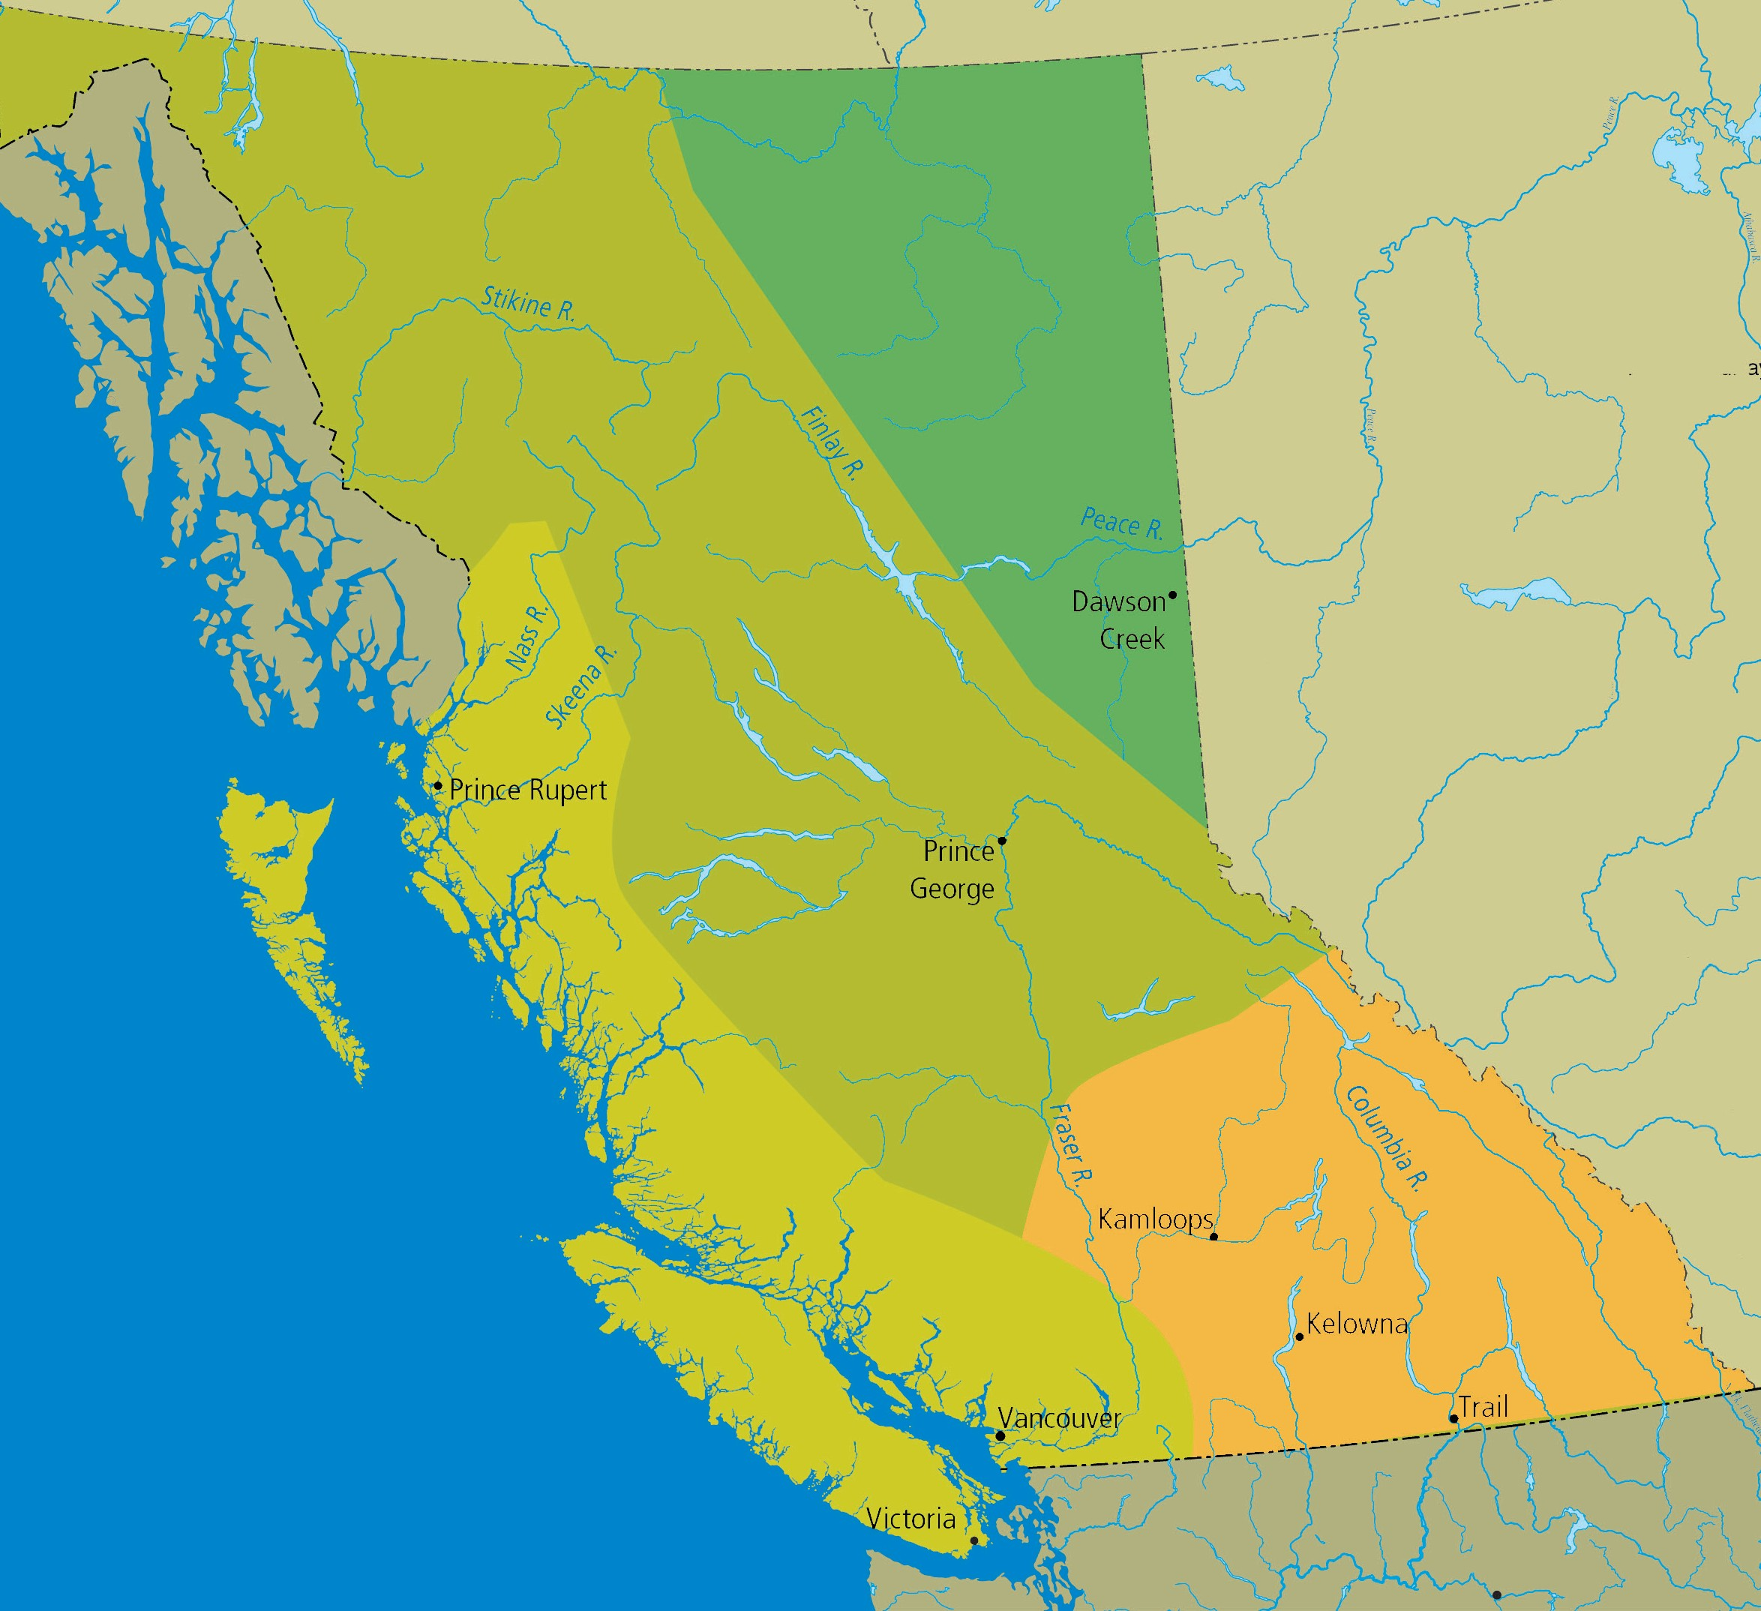
Northern Interior
Northeast
ALBERTA
Coast
Southern Interior
Pacific Ocean
0
200 km
0
200 miles
United States
Geographic Regions o

The Regions of B.C.
Many factors influence how people adapt to living in their chosen territories. The latitude, physical geography, climate, and altitude all affect the types of animal and plant resources found in a specific area. They also determine how people will harvest and use these resources. The relationship of the people with their natural world determines where they choose to live and affects how they organize their societies. B.C. can be divided into four broad geographical regions: the coast, the southern interior, the northeast, and the northern interior.

The Shape of the Land
The place that today we call British Columbia is a land of many different climates and habitats, but there is one constant: this is a province of mountains. The land is dominated by a series of mountain chains running roughly north-south, from the Coast Mountains in the west to the Rocky Mountains in the east. Between the
mountain ranges lie valleys and plateau regions such as the Cariboo, the Okanagan Valley, and the Rocky Mountain trench. On the coast, the would-be valleys are flooded by the sea, forming islands and fjords.
If British Columbia is a place of mountains, it is also a place of water—of rivers, lakes, channels, and inlets. These waterways, formed by the mountains, define the land and its people. A large part of B.C. is drained by four major river systems: the Fraser, Skeena, Columbia, and Peace. These rivers and their valleys provide living space, transportation routes, and habitat for fish.
Many of the abundant resources found in the province come from the mountains, including forests, food plants, minerals, game, and fur-bearing animals. The waters are equally rich, especially with fish like the Pacific salmon and oolichan. The ocean provides a wide array of food sources, from large sea mammals to small molluscs. Rivers and lakes, too, offer a variety of foods, including fish.
This land and its resources shape the lives of the people who have lived here for thousands of years. The mountains create barriers for people, but they also act as landmarks and natural boundaries. Their peaks and ranges enclose many river systems, both large and small, and these watersheds are a logical way of defining
territories. The territories of many First Nations of B.C. are based on the boundaries formed by watersheds.
For thousands of years, First Nations people have inhabited the valleys, plateaus, and coastline of this mountainous land, and they have adapted to the variations in climate, topography, and resources in different ways, resulting in a wide variety of societies. Distinct groups speak separate First Nations languages. Of the sixty First Nations languages in Canada, half are found in British Columbia.
The people of the coast have many different characteristics, but they share some common features which people who study cultures call the Northwest Coast culture. These societies had strict social codes to follow, with a rigid hierarchy whereby chiefs were ranked in importance, and a class system was made up of chiefs, nobles, commoners, and slaves.

Relationships to the Land
In the First Nations world view, people are integrated with the natural world, not separate from it. The land has great variety, and so the people are very diverse, for the land has shaped the people. It determines where and how they live.
The history of the First Nations people in British Columbia is as rooted in the land as are the great trees of the forests. Although the First Nations of the province are many and diverse, they have at least one thing in common: they have an enduring relationship with the land, a bond so strong that it defines who they are.
In general, Western society views the ownership of land and resources as an individual right. Property or land ownership is based on the right to purchase land, holding it in what is termed fee simple, that is, owning land that can be sold or passed on to inheritors. In practice, some individuals or corporations own land, while others who are landless pay land owners for the right to live on or use the land. In the traditional First Nations view, ownership of land is interpreted in a very different way. It is the extended family, the group, or the community that holds rights to the land, not individuals. There are no landless people in this system, as every member of the community shares in the rights and responsibilities of using and taking care of the land.
Through more than two hundred years of European contact and colonization, the differences in these two views have caused tension and conflict between First Nations people and colonists from other lands. The forces of colonization have threatened the integrated relationship the First Nations have with the land.
The First Nations of British Columbia have seen their people marginalized and discriminated against; they have seen oppressive laws attempt to assimilate them; and they have seen their land taken away from them without battle or treaty.
Together they have worked to have their title to the land recognized and the loss of the lands compensated for.
Today there are more than two hundred First Nations bands in British Columbia. The continuity of their relationship with their traditional territories has not been broken, despite the pressures put on them. Their oral traditions—the important narratives passed on from generation to generation—reinforce and remind
First Nations people of their connection with the land. Today, this connection is still strong, and all across the province, First Nations people return to the land to harvest the same resources as did their ancestors. Of course, some of these resources no longer exist or have been depleted, some of the technologies of production have changed, and now people may travel by speedboat or skidoo to
reach their territories. What have not changed are the ties to the land expressed in the oral tradition and verified by modern experiences.

1 First Nation
A community of Aboriginal people who identify themselves as a distinct cultural group and who are the descendants of the original inhabitants of the land that is now known as British Columbia. Each First Nation has a name for itself, such as the Stó:lō Nation.

The Coast
The First Nations people who live on the coast of British Columbia have adapted to a wet, mild climate influenced by the Pacific Ocean. The temperature usually stays above freezing in the winter and below 20° C in the summer. The annual rainfall in some locations is more than 400 cm a year. This results in many cloudy days, and fog often blankets the mountains.
This climate creates ideal conditions for the temperate rainforests which cover the mountain slopes, providing lush vegetation dominated by coniferous trees. The greatest of these trees, the western red cedar, is considered a special gift from nature by First Nations. Its characteristics make it one of the most useful materials available. Bill Reid, the renowned Haida artist, once wrote about the cedar:
If mankind in his infancy had prayed for the perfect substance for all material and aesthetic needs, an indulgent God could have provided nothing better.
On most of the coast, the mountains rise out of the ocean, creating intricate waterways that form a maze of channels, bays, and inlets. Hundreds of islands, from tiny rock outcroppings to giant Vancouver Island, provide protection from the ocean winds.
As well, thousands of rivers and streams rush down the mountains, flowing into the ocean directly, or combining into major rivers such as the Nass, Skeena, Kitimat, Kitlope, Dean, Bella Coola, Klinaklini, Homathko, and Squamish. These and other rivers empty into the ocean at the heads of long, narrow inlets or fjords. Most of these fjords have steep sides with little shoreline, but the head of the inlet flattens out to a floodplain built up of silt carried by the river. The estuaries formed at the juncture of fjord and river create rich habitats for a great deal of wildlife as well as living space for people.
The southern coast, the region that surrounds Georgia Strait, has a different climate and therefore a unique environment. This area lies in the rain shadow of Vancouver Island, including southeast Vancouver Island, the Gulf Islands, and the Fraser
Valley. Generally it has flatter land and a drier climate, and, consequently, different vegetation.

2 William Reid, Out of the Silence. New York: Harper & Row, 1971, p. 55. Used with permission of Martine Reid of William Reid Ltd.

0 50
100 200

Kilometres

Geographical Features of the Great Bear Rainforest

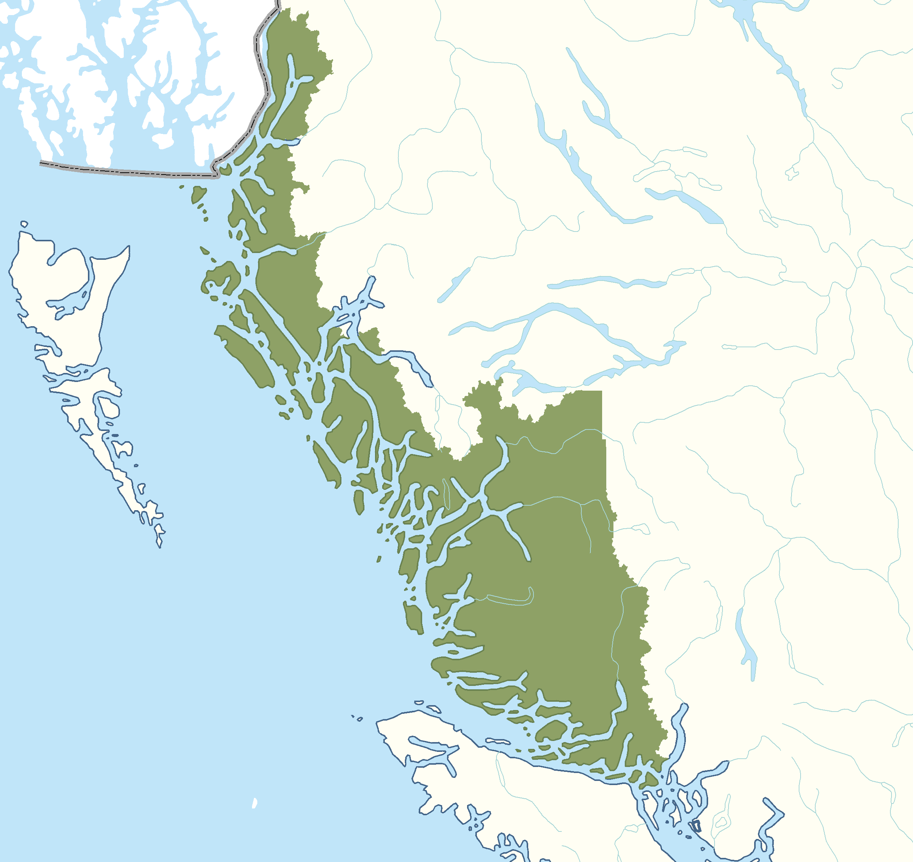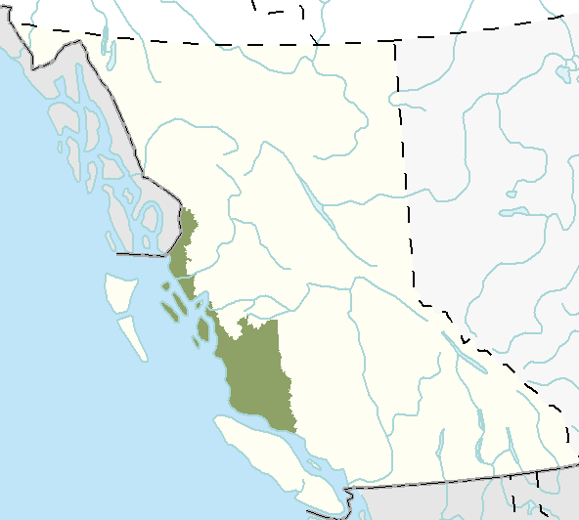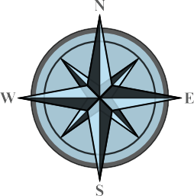Rivers
- Nass River
- Skeena River

Islands
- Graham Island (Haida Gwaii)
- Moresby Island (Haida Gwaii)
- Vancouver Island

Bodies of waters
- Hecate Strait
- Johnstone Strait
- Queen Charlotte Sound
Communities
- Bella Bella
- Bella Coola
- Campbell River
- Hartley Bay
- Kitimat
- Klemtu
- Metlakatla
- Ocean Falls
- Old Massett
- Oweekeno
- Port Hardy
- Prince Rupert
- Skidegate
Mountain Ranges
- Coast Mountains

Answer Key

1

22
2
17
15
13
20
3 21

12
4
6 14 10
10
16
9 18
8

19
7

0 50
100 200 5
Kilometres 11

Geographical Features of the Great Bear Rainforest

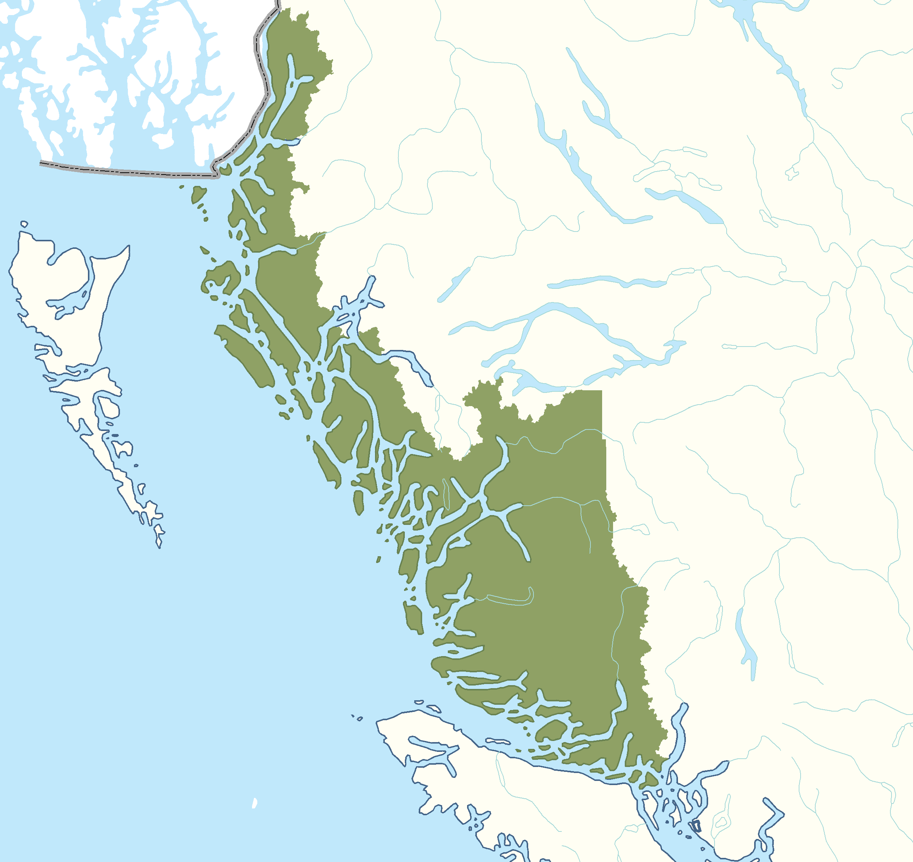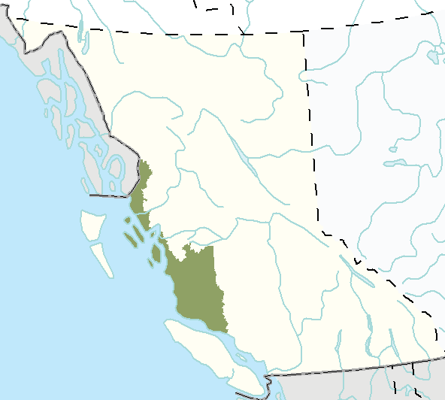Rivers
- Nass River
- Skeena River

Islands
- Graham Island (Haida Gwaii)
- Moresby Island (Haida Gwaii)
- Vancouver Island

Bodies of waters
- Hecate Strait
- Johnstone Strait
- Queen Charlotte Sound
Communities
- Bella Bella
- Bella Coola
- Campbell River
- Hartley Bay
- Kitimat
- Klemtu
- Metlakatla
- Ocean Falls
- Old Massett
- Oweekeno
- Port Hardy
- Prince Rupert
- Skidegate
Mountain Ranges
- Coast Mountains

