Great Bear Rainforest Activity Plan

Inquiry:

Why are spirit bears white?

Students hypothesize whether it is beneficial to be a white bear in the Great Bear Rainforest based on what they know about natural selection and selection pressures. After researching their position, students engage in a formal or informal class debate.

Learning Objectives
Students will:
- Discuss and debate the reasons for pigmentation of white bears, based upon their own research and understanding of natural selection
- Construct a deep understanding of natural selection and selection pressure
- Formulate a hypothesis and present evidence to support it
- Communicate their ideas and listen to the ideas of others
- Reflect on their learning

Preparing for the Activity Plan
- Review the concept of natural selection with the class by showing one or more of the following videos:

Myths and Misconceptions About Evolution (Ted-Ed) (4:22)
https://youtu.be/mZt1Gn0R22Q

Natural Selection (Amoeba Sisters) (7:22) https://youtu.be/7VM9YxmULuo

Natural Selection (Crash Course Biology #14) (12:43) https://www.youtube.com/watch?v=aTftyFboC_M

Materials
- computer / projector
- student computers / tablets / devices
- access to Internet

Blackline master
- Hypothesis Research

Background Information
Spirit bears are an alternate phenotype (set of observable characteristics and products of behaviour) of the black bear. They are found only in British Columbia and parts of southern Alaska, despite the range of the black bear extending right across Canada and south into Mexico. The white bears are not albinos, they are leucistic (possessing reduced pigmentation) and are white as a result of a recessive gene. There is debate among the scientific community as to whether the white pigmentation could be a benefit, a disadvantage, or neither. Since there is no right answer, exploration
of this question poses an opportunity for students to form their own opinion(s) and support their position(s) with research.
For additional bear-related lesson material, see the Great Bear Sea website:

Great Bear Sea > Elementary > Lesson 3: Collaborative Research –
Case Study on Bears
http://greatbearsea.net/elementary-curriculum/lesson-3/

Delivering the Activity Plan

Access Prior Knowledge
- Have the class brainstorm examples of “selection pressures” (i.e., predators; availability of resources such as food, habitat, and mates; disease; natural disasters; temperature and weather). Write the list on the board.
- What kinds of pressures would bears experience?
- Have students think-pair-share what they know about spirit bears.
- Before starting research, have students do a “Four Corners” exercise on the cost/benefit of being a (white) spirit bear. Label each of the four corners of the room:
» It’s a benefit to be a white bear.
» It’s a cost to be a white bear.
» It has both costs and benefits.
» It has neither costs nor benefits.
Students move to one of the corners of the classroom and provide explanations for the corner they selected.

Inquire
- Have students form a hypothesis about whether it is beneficial to be a white bear in the Great Bear Rainforest based on what they know about natural selection and selection pressures.
- Using credible sources, have students conduct research to support their hypothesis. (Keywords for Web research may include: “spirit bear natural selection,” “spirit bear selection pressures,” “what makes a spirit bear white,” etc.).
- Students come up with three to five points and provide the reference for each. (Have them cite the title of reference, author, source such as URL, magazine or book, and date retrieved.)

Experience
- Have students present their hypotheses in either a formal or informal debate. Students present the evidence they have to support their position and listen to the evidence of others that refute their position. Allow time for rebuttals.

Explore
- In a post-debate reflection, have students fill in the blackline master, “Hypothesis Research” stating their original hypothesis, their evidence points and sources, new information they gathered from listening to their classmates, and a summary reflection answering the following questions:
» Did you learn of more evidence that supported your hypothesis? If so, what?
» Did you learn of evidence that refuted your hypothesis? If so, what?
» Has your hypothesis changed? Why/why not?
- In addition, students could create an infographic stating their hypothesis and visually show the evidence to support it.

Assess
- How well did the student debate their hypothesis?
» Did the student’s statements clearly support their position in the debate?
» Was the position well researched and documented?
» Were arguments presented with clarity?
» Were rebuttals specific to the opposing arguments compelling and expressed with clarity?
- Does the post-debate reflection demonstrate understanding, and did they gather new information from what they learned from their classmates?

Go Beyond
- Students could design a comic strip that follows the life of an organism that adapts to an environmental change over time to become highly fit. Have students include a narrative that explains their organism.
- The comic strip could illustrate:
» the organism’s potential to increase in number
» adaptation through mutation and sexual reproduction
» how the organism became fit through competition for limited resources
- Use the letter to Francis Kermode, Director of the BC Museum in 1924, from the New York Zoological Society as a jumping off point to discuss:
» the history and future of zoos
» taking historical perspective (you may wish to show students the TC2 video:
https://tc2.ca/uploads/critical-thinking-files/videos/take2- historicalPerspective.html

After reading the letter, encourage students to make inferences about the author of the letter, as well as tone, mood, location, etc. Have students study, examine, describe, analyze, and reflect on the letter.

Hypothesis Research

Student:

What was your original hypothesis?

What sources did you use in your research?

Include title of reference; author; source such as URL, magazine, or book; and date retrieved.

1)

2)

3)

What new information did you gather from your classmates?

Did you learn of more evidence that supported your hypothesis? If so, what?

Did you learn of evidence that refuted your hypothesis? If so, what?

Has your hypothesis changed? Why/why not?

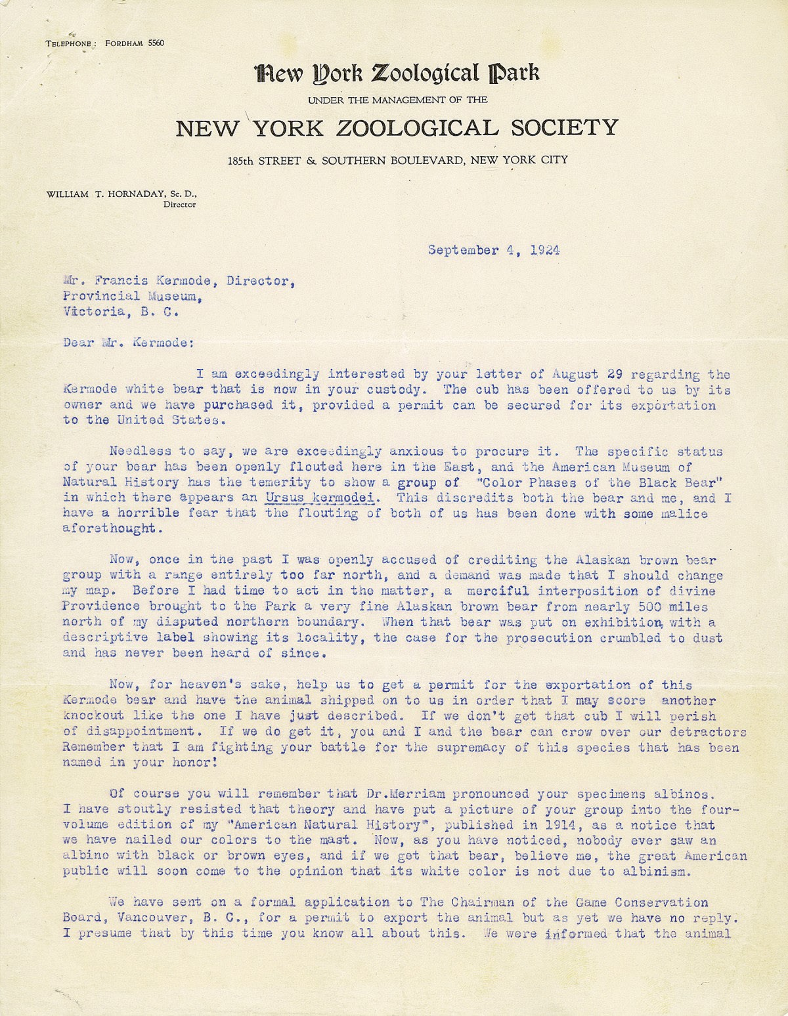

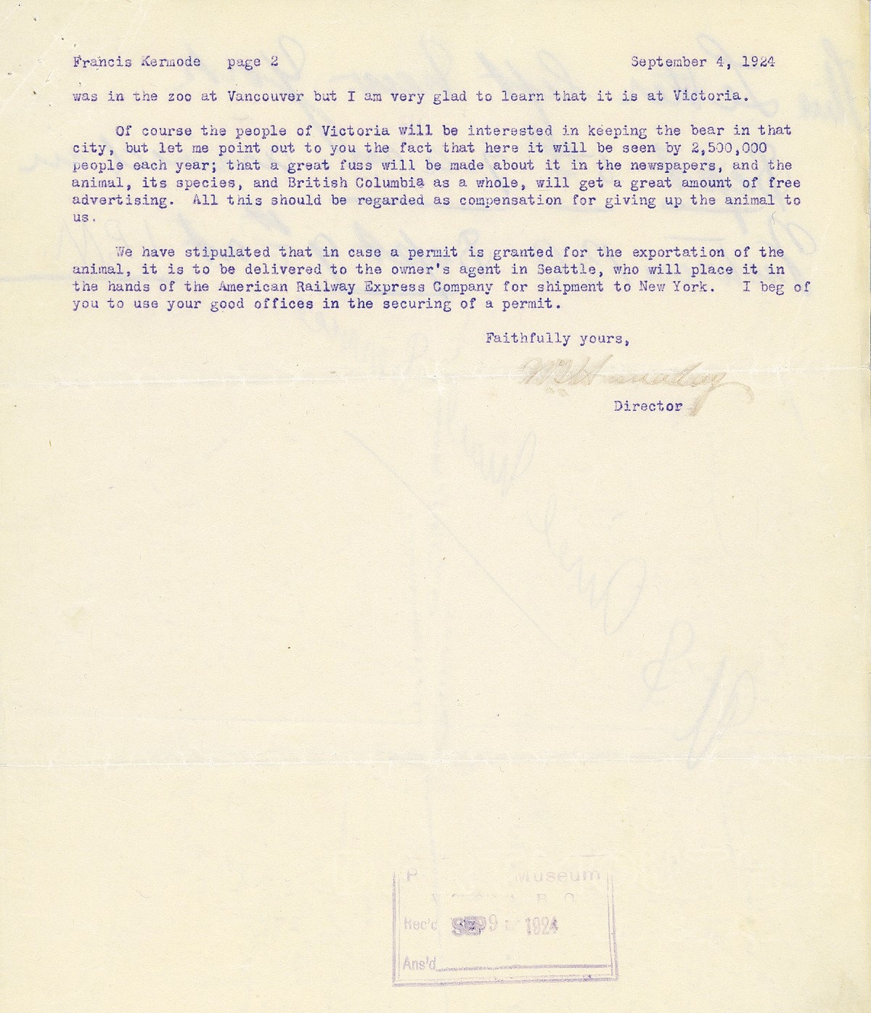
This work is licensed under a Creative Commons Attribution-NonCommercial-ShareAlike 4.0 International License unless otherwise indicated.

