Great Bear Rainforest Activity Plan

Given an environmental data set from the Great Bear Rainforest, what questions could you ask?

In this activity, students will learn the definition of “correlation” and use graphing technology to determine whether two variables are correlated. Students will apply their understanding of correlation to environmental factors in the Great Bear Rainforest.

Learning Objectives
Students will:
- Explore, analyze, and apply mathematical ideas using reason, technology, and other tools
- Model with mathematics in situational contexts
- Visualize to explore and illustrate mathematical concepts and relationships
- Explain and justify mathematical ideas and decisions in many ways
- Reflect on mathematical thinking
- Create, interpret, and critique graphs
- Interpret graphs in society
- Use technology to graph
- Connect data, graphs, and situations

Preparing for the Activity Plan
- Preview the videos and websites.
- Familiarize yourself with the use of spreadsheet software (e.g., Microsoft Excel or Google Sheets) to create graphs and determine correlation.

Materials
- laptops or other devices
- access to spreadsheet software (e.g., Microsoft Excel or Google Sheets)
- access to the Internet
- Blackline Master 1: Correlation of Variables in the Great Bear Rainforest

Background Information and Resources

Videos

Great Bear Wild—Dispatches from a Northern Rainforest
In this video, Ian McAllister speaks about the amazing diversity in the oceans of the Great Bear Rainforest and why we need to protect it.
https://vimeo.com/108089318

The Story of the Great Bear Rainforest
This video relates the story of the successful campaign to protect Canada’s Great Bear Rainforest.
https://www.youtube.com/watch?v=OgN2PFAEtGM

Informational Websites

NANOOS Visualization System
This website provides access to the Hakai KC Buoy data, collected to monitor changes the oceans and estuaries of the Pacific Northwest.
http://nvs.nanoos.org/Explorer

Delivering the Activity Plan

Access Prior Knowledge

What does “correlation” mean?
- Write “correlation” on the board or on a piece of chart paper.
- Have students discuss in small groups what correlation means.
- Each group should come up with a definition of “correlation,” write it on a piece of paper, and tape it to the board.
- Share the definitions with the class and, as a large group, decide on a final definition.
- Discuss examples of correlation. Have the students think about some examples of things that could be correlated (e.g., height and shoe size), and some examples of things that are most likely not correlated (e.g., favorite sport and hair colour).

Inquire

What is the Great Bear Rainforest?
- Share the videos Great Bear Wild—Dispatches from a Northern Rainforest and The Story of the Great Bear Rainforest to provide students with background information on the Great Bear Rainforest and its history.

Correlation in the Great Bear Rainforest
- Provide students with copies of Blackline Master 1: Correlation of Variables in the Great Bear Rainforest to record their work.
- Give students a list of variables (see suggestions below) relating to the Great Bear Rainforest. Possibilities include the following:
» sunlight
» activity of organisms
» logging
» presence of animal species
» season
» climate
» presence of Spirit bears
» temperature
» presence of First Nations communities
» vegetation
» conservation
» diversity
» experience

- Have students discuss in small groups what variables they think may be correlated and why. They can share out with the class or another small group.

Choose variables
- Have students go to the NANOOS website and find the Hakai KC Buoy in the Great Bear Rainforest.
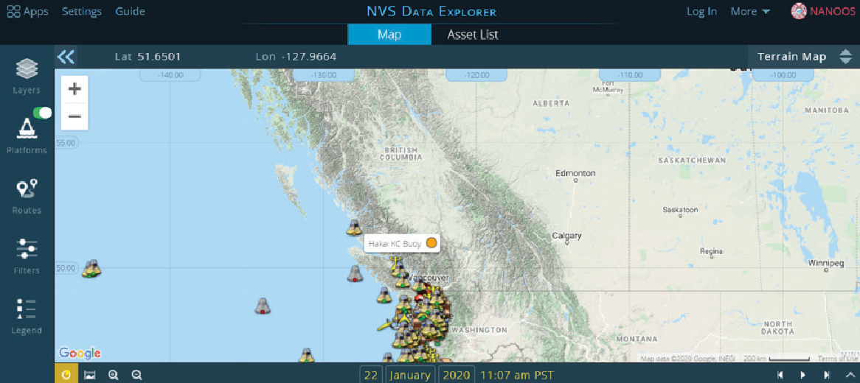

Location of the Hakai KC buoy
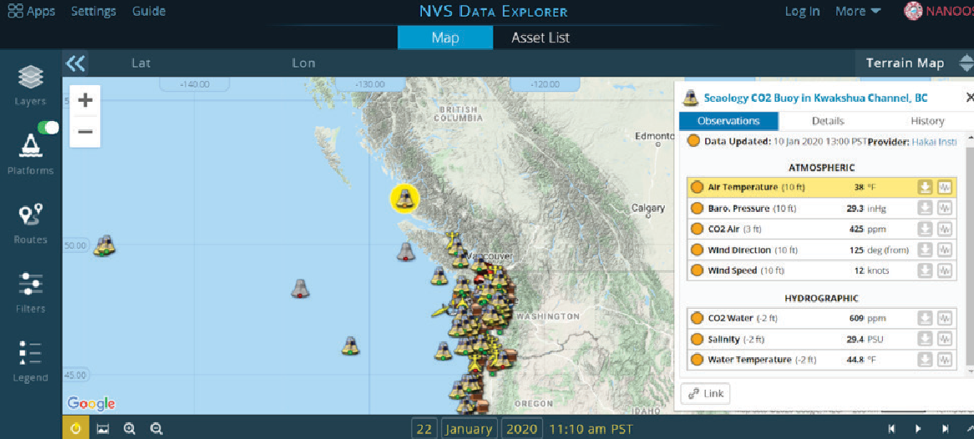

Data display for the Hakai KC buoy
- Give students time to explore the different variables measured at the Hakai buoy.

Choosing variables
- Have students pick two variables they think will be correlated, and two variables that they think will not be correlated.
- Have students give reasons for why they think so.

Create a double-line graph
- Provide students with copies of the BLM “Correlation of Variables in the Great Bear Rainforest” (below).Have students use the two variables they think will be correlated to complete Part 1 of the activity.
- Have students download the data on their chosen variables to a spreadsheet. Students will need to copy and paste the data from the two variables they are comparing into the same file to complete the rest of the activity.
- Have students create a double-line graph from the data. Instructions to create a double-line graph will vary depending on the application and software version. Be sure to know how to support students based on available software. Have students look at their graphs and predict whether the two variables are correlated.

Correlation function
- After using their graphs to predict whether a correlation exists, have students use the correlation function in their spreadsheets to confirm their findings. If
students are using Excel, they will use enter the formula =CORREL(first highlighted
array:second highlighted array).

Explore

Do Are the variables correlated?
- Have students use the correlation coefficient they calculated to determine how closely correlated their variables are. They may need to research what their correlation coefficient means.
- Have students assess whether it makes sense that their variables are correlated (or not correlated). For example, it might make sense that air temperature and water temperature be correlated, but not that water salinity and wind direction be correlated.
- Have students repeat this process with the variables they think will not be correlated to complete Part 2 of the activity.

Assess
- Do students show understanding of correlation?
- Are students able to use spreadsheets to create graphs?
- Are students able to successfully interpret their graphs?

Go Beyond
- Have students continue with other combinations of variables.
- Have students make single-line graphs of one variable and assess why the data values change the way they do (e.g., air temperature changes with the seasons).
- You could continue with a discussion of the difference between correlation and causation. If students have found two variables that are correlated, they can critically analyze whether changes in one actually causes changes in the other.

Part 1
Blackline Master 1
Correlation of Variables in the Great Bear Rainforest

Go to NANOOS and find the Hakai KC Buoy. Choose two variables that you think will be correlated and answer the questions below.
List two variables you think are correlated:
1.
2.

Why do you think they are correlated?

Create a double-line graph of your variables and answer the question below.
After looking at the double-line graph, do you still think they are correlated? Explain.

Calculate the correlation coefficient between your two variables and answer the questions below.

What is the correlation coefficient for your two variables? What does this mean? Final conclusions:

Part 2
Go to NANOOS and find the Hakai KC Buoy. Choose two variables that you think will NOT be correlated and answer the questions below.
List two variables you think are not correlated:
1.
2.

Why do you think they are not correlated?

Create a double-line graph of your variables and answer the question below.
After looking at the double-line graph, do you think they are correlated or not? Explain.

Calculate the correlation coefficient between your two variables and answer the questions below.
What is the correlation coefficient for your two variables?

What does this mean? Final conclusions:

This work is licensed under a Creative Commons Attribution-NonCommercial-ShareAlike 4.0 International License unless otherwise indicated.

