Great Bear Rainforest Activity Plan

What makes the establishment of the
Great Bear Rainforest such a powerful story?

In this activity, students learn that the profound significance of a place like the Great Bear Rainforest can be a powerful catalyst to bringing competing stakeholders together to collaboratively negotiate a means to protect it. According to the United Nations Education and Science and Cultural Organization (UNESCO), The World Heritage Convention recognises that some properties should be acknowledged for the great value the biodiversity in the region provides. UNESCO uses two primary criteria when determining whether they consider sites
to be worthy of protecting.

The sites must:
- [be] outstanding examples representing significant on-going ecological and biological processes in the evolution and development of terrestrial, fresh water, coastal and marine ecosystems and communities of plants and animals” (criteria ix),
or
- [include the] conservation of biological diversity, including those containing threatened species of outstanding universal value from the point of view of science or conservation (criteria x).
(UNESCO, 2020, para. 2)
Students will learn how industry, First Nations rightsholders, environmentalists, the British Columbia government, and other stakeholders came to a mutual agreement to protect the Great Bear Rainforest. In the end, they saved a priceless gem–the Great Bear Rainforest.
Canadian scientist David Suzuki (2012) states,
If we pollute the air, water and soil that keep us alive and well, and destroy the biodiversity that allows natural systems to function, no amount of money will save us. (para. 3)
Suzuki’s sentiments are mirrored by historical Indigenous leader Chief Seattle:
The Earth does not belong to man, man belongs to the Earth. All things are connected like the blood that unites us all. Man did not weave the web of life, he is merely a strand in it. Whatever he does to the web, he does to himself.

Learning Objectives

Students may determine various reasons why the Great Bear Rainforest story is so powerful, but ultimately, in the process, they will learn about a very powerful Canadian story—one which will live on forever. What makes this story so powerful? There are many answers.
Many believe it is how so many competing groups came together to preserve the area. Perhaps from a less human-centered perspective, the story is that this profoundly beautiful ecosystem always spoke for itself, and we humans finally listened. The fun in the activity is the inquiry—it’s a time to explore!
Students will:
- Brainstorm a list of special places, especially ecological areas that are protected via governments or institutionalized organizations (e.g., provincial parks, national parks, UNESCO sites) and explain why they think these areas were protected
- Identify a currently unprotected area they think should be protected (e.g., Jumbo Wild in the Kootenays) and explain why they think it should be protected
- Identify aspects of the Great Bear Rainforest that make it profoundly significant.
- Explore, research, and explain what they think makes the Great Bear Rainforest so amazing.
- Explain what they think makes the story of the Great bear Rainforest so powerful.
- Research another site that has been—or that they feel should be—protected and present this information to the class.

Preparing for the Activity Plan
- Read the background information and preview the videos and websites.
- Students may not be familiar with the Great Bear Rainforest. If so, introduce them to the location of the area; some of the terrestrial and marine life of the region;
a very brief history of how the area came to be a protected region; First Nations in the region; and the famous Kermode bear (also called the spirit bear). There is some helpful information in the Learning Objectives (above) and the Background Information (below).
- Depending on the depth of study you want to engage in, you can carry out this activity over one or two classes, or extend it over three to five classes.
- You may want to refer to the “Where is the Great Bear Rainforest?” Activity Plan at https://greatbearrainforesttrust.org/activity-plans/
- You may want to check the map and timeline at British Columbia’s Great Bear Rainforest.

- If students are not familiar with the Great Bear Rainforest, show these introductory videos:
» Enter the Great Bear Rainforest
» The Secrets of Great Bear Rainforest—National Geographic Documentary

Materials
- computer and projector
- student computer / tablet / devices
- access to the Internet
- Blackline Master 1: Twelve Reasons to Conserve the Great Bear Rainforest
- Blackline Master 2: What made the establishment of the Great Bear Rainforest such a powerful story?
- Blackline Master 3: What story do you want to tell about the Great Bear Rainforest?

Background Information and Resources
The Great Bear Rainforest is an area larger than Vancouver Island, which extends north along British Columbia’s central coast to the Alaska border and westward towards Haida Gwaii in the Pacific Ocean. It was officially declared a permanently protected area in February 2016. The Great Bear Rainforest landscape is comprised of the largest coastal temperate rainforest in the world along with coastal and open water areas, and it is teeming with wildlife (e.g., whales, dolphins, salmon, bears, eagles, and wolves). It is most noted for the white-fur Kermode bear. Situated on the unceded territories of more than twenty First Nations, the area is rich in biodiversity, history, and culture. Collaboration among First Nations rightsholders, timber firms, environmental groups, British Columbia’s government, and other interest groups produced an unprecedented win for the world— the Great Bear Rainforest is now a protected area. This achievement is a monumental testimony to what can be accomplished when people work together towards a common goal.

Videos

Enter the Great Bear Rainforest (4:36)
This video is a great introduction to the Great Bear Rainforest and its inhabitants. https://www.youtube.com/watch?v=js1rnKPAnE0
The Secrets of Great Bear Rainforest—National Geographic Documentary (45:54) This video beautifully depicts the Great Bear Rainforest. It stresses the importance of protecting this area from fossil fuel exploration and transport. https://www.youtube.com/watch?v=ldMotRW9bcE

Great Bear Rainforest in 4K—Exploring British Columbia, Canada (3:26)
This short video shows the Great Bear Rainforest and some of its many habitats. https://www.youtube.com/watch?v=7wWQ-0CKv1M
Great Bear Rainforest (3:02)
This video from Greenpeace International tells the story of the campaign to protect Canada’s Great Bear Rainforest.
https://www.youtube.com/watch?v=qhLRn3fU31w

The Story of the Great Bear Rainforest (3:02)
This video from Greenpeace International tells the story of the campaign to protect Canada’s Great Bear Rainforest. https://www.youtube.com/watch?v=OgN2PFAEtGM

Articles:

From Conflict to Collaboration: The Story of the Great Bear Rainforest
You may want to photocopy the first three sections of the article for your students. https://coastfunds.ca/wp-content/uploads/2016/02/StoryoftheGBR.pdf
Great Bear Rainforest agreement creates ‘a gift to the world. https://www.cbc.ca/news/canada/british-columbia/great-bear-rainforest-bc- agreement-1.3426034

Other Resources
British Columbia’s Great Bear Rainforest https://www.cbc.ca/news/canada/british-columbia/great-bear-rainforest-bc- agreement-1.3426034

Delivering the Activity Plan

Access Prior Knowledge
- Introduce a protected site, such as a provincial park, national park, or a UNESCO site.
- Have the students discuss why they think the site was significant enough to be protected.
- Have students list one currently unprotected area they think should be protected.
- Discuss why they think this site should be protected.
- Discuss what obstacles people might encounter when trying to protect a site.
- Ask students if they are familiar with British Columbia’s Pacific coastline. If they are, have the students describe the forests, coasts, and/or shorelines of the area.
- Determine if any students are familiar with the Great Bear Rainforest, the Kermode or Spirit Bear, or with the orcas that reside up and down the Pacific coast.

Inquire
- Show the students one or more of the following videos: Great Bear Rainforest in 4K—Exploring British Columbia, Canada (to introduce or re-introduce the region), Great Bear Rainforest/National Geographic, and/or The Story of the Great Bear Rainforest.
- Ask students what they found to be most fascinating about the region?

Experience
- Have students come up with three to five other reasons to conserve the Great Bear Rainforest.
- Distribute Blackline Master 1: Twelve Reasons to Conserve the Great Bear Rainforest (below). Compare and discuss.

Explore
- Once students are familiar with the Great Bear Rainforest and its unique features, lead them into the next phase of the activity. Ask them what other elements, besides its beauty, biodiversity and historical/cultural significance, makes the Great Bear Rainforest story so powerful.
- Read aloud read to the class (or have them read) the first four sections of the article From Conflict to Collaboration: The Story of the Great Bear Rainforest. English language learners or students requiring additional supports may benefit from using this alternative reading: Great Bear Rainforest agreement creates ‘a gift to the world.’
- Discuss the article.
- Have students complete Blackline Master 2: What made the establishment of the Great Bear Rainforest such a powerful story?
- Have students share their answers to Blackline Master 2.
- Have students consider what they personally think makes the Great Bear Rainforest so powerful. Have them submit their responses on Blackline Master 3: What story do you want to tell about the Great Bear Rainforest?
- For students requiring additional support, you may want to simplify the question to “What makes the Great Bear Rainforest so important?”.
- Have students display and share their reflections on what makes the story of the establishment of the Great Bear Rainforest so powerful.
- Instead or as well, you might have students create a PowerPoint, Prezzi, poster, or video entitled, “What makes the establishment of the Great Bear Rainforest such a powerful story?”.

Assess
- The activity using Blackline Master 2 focuses on comprehension, analysis, and synthesis. The activity using Blackline Master 3 is more research-driven and requires the student to do a more in-depth inquiry into what they think makes the story of the Great Bear Rainforest so powerful. The supplied rubric (below) can be used for one or both of the activities, either independently or as an overall assessment. The emerging, developing, proficient and extending categories are used, and the main criteria for the activity have been highlighted.
- The inquiry is designed to focus on analysis, but you may emphasize other criteria.
It is at your discretion to decide what, if any, criteria should be emphasized. The assessment rubric is designed for both teacher and student use.

Go Beyond
- Have students explore another ecological site that is currently under conflict because of opposing views about how the area best be used. Present a PowerPoint, Prezzi, or audiovisual to the class.
- Have students debate whether it is the ecological value of the Great Bear Rainforest, its preservation, and/or the collaborative negotiations that brought it into being that makes the Great Bear Rainforest story so powerful.
- Have students search for another powerful story about how a protected area came to be.

References
Smith, M. & Sterritt, A. (2016). From Conflict to Collaboration: The Story of the Great Bear Rainforest. Coast Funds. Retrieved from https://coastfunds.ca/wp-content/ uploads/2016/02/StoryoftheGBR.pdf
Dobell, (2016, April 8). A relationship with whales in the Great Bear Sea. National Observer. Retrieved from https://www.nationalobserver.com/2016/04/08/news/relationship- whales-great-bear-sea
Mackenzie, D. (2018). Great Bear Rainforest. Outdoor Photographer [Online Journal].
Retrieved from https://www.outdoorphotographer.com/on-location/travel/great- bear-rainforest/
McSheffrey (2016). Thunder in the Air. National Observer. Retrieved from https://www. nationalobserver.com/2016/02/25/canadas-coastal-indigenous-people-gain-power- through-great-bear-rainforest-agreement
Morrow, Fiona. Great Bear Rainforest agreement creates ‘a gift to the world.’ CBC News. Retrieved from https://www.cbc.ca/news/canada/british-columbia/great-bear- rainforest-bc-agreement-1.3426034
Tol, R.S.J. (2009). Economics of Sea Level Rise. In J.H. Steel, S.A. Thorpe, & K.K. Turekian (Eds.), Elements of Physical Oceanography: A derivative of the Encyclopedia of Ocean Science (p. 544). North York, Ontario, Canada: Elsevier.
Wood, Linda Solomon and Chris Hatch. Great Bear Rainforest: Canada’s gift to the world. National Observer. Retrieved from https://www.nationalobserver.com/2016/01/27/ news/great-bear-rainforest-canadas-gift-world

Blackline Master 1
Twelve Reasons to Conserve the Great Bear Rainforest
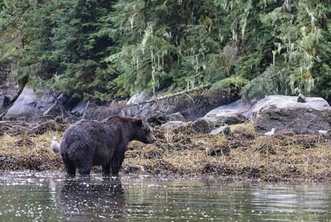
- The Great Bear Rainforest possesses immense biodiversity. It is:
  - the largest coastal temperate rainforest in the world;
  - the largest kelp bed forest in the world;
  - the largest biomass in the world;
  - home to as many as six million migratory birds;
  - home to a diverse range of black bears and grizzly bears;
  - home to the endangered orca whales;
  - home to dolphins, otters, sea otters, porpoises, sea lions and more;
  - home to coastal wolves;
  - home to twenty percent of the world’s salmon; and
  - home to many other animals, plants, and marine life.
- The Great Bear Rainforest is home to the unique Kermode bear, also known as the spirit bear.
- The Great Bear Rainforest is home to many First Nations who have lived and practiced their cultural traditions for a millennium or more. The Great Bear Rainforest agreement protects First Nations’ rights to the continuance of traditional cultural practices.

Participating First Nations rightsholders in the agreement include:

Da’naxda’xw awaetlala (Knight Inlet) Dzawada’enuxw Tsawataineuk (Kingcome Inlet) Gitanyow (Kitwanga River)
Gitga’at (Hartley Bay) Gitxaala (Kitkatla)
Gwa’sala-’nakwaxda’xw (Port Hardy) Gwawaenuk (Hopetown/Watson Island) Haida (Haida Gwaii)
Haisla (Kitimaat) Heiltsuk (Bella Bella) Kitasoo/Xai’xais (Klemtu) Kitselas (Terrace) K’ómoks (Comox)
Kwiakah (Phillips Arm/Frederick Arm) Nisga’a
Kitselas
Lax Kw’alaams
Kitsumkalum
Gwa’sala-‘Nakwaxda’xw Gitxaala
Gwawaenuk Dzawada’enuxw Tlowitsis Kwiakah
Kwikwasut’inuxw Haxwa’mis We Wai Kai (Cape Mudge) Metlakatla
Nuxalk Ulkatcho Wuikinuxv
Da’naxda’xw/Awaetlala Namgis
Xwémalhkwu (Homalco) Mamalilikulla-Qwe’Qwa’Sot’Em Wei Wai Kum (Campbell River)

- The size of the Great Bear Rainforest region is enormous.
  - The protected area encompasses over 21 000 kilometers (Smith and Sterritt, 2016, p. 8).
  - 3.1 million hectares of forested wilderness is included (Morrow, CBC, 2016, n.p.).
  - The area is larger than Vancouver Island and Ireland.
- The composition of the terrestrial and marine areas is significant. Terrestrial areas consist of:
  - 55% of the estuaries in the central and north coast of BC (Smith and Sterritt, 2016, p.
8),
  - 54% of the wetlands in the central and north coast of BC (Smith and Sterritt, 2016, p.8),
  - 34% of old growth forests and 39% of mature forest in the central and north coast (Smith and Sterritt, 2016, p. 8),
  - old growth trees that can be over 1000 years old, and
  - spectacular fjords along the coastline.

Marine life consists of:
  - Beautiful coastal underwater landscapes:
“Beneath the surface [referring to the waters of the GBR], the dark greys and greens of the rainforest briefly give way to an explosion of colour: seaweeds in bronze, burgundy, and iridescent blue; sea stars in violet, pink, ochre and vermillion; ghostly nudibranchs competing for space with scarlet-and-yellow striped anemones; rock surfaces encrusted with white, pink, and orange sponges and dotted by the living pincushions of purple or green sea urchins. Then the steep rock faces drop away into darkness, reaching depths of dozens of metres just a few boat-lengths from shore. Somewhere down there the whale forages with her calf” (Dobell, 2016, n.p.).
- Whale populations are returning to the Douglas Channel, which runs through the heart of the Great Bear Rainforest.
“Through the late 1800s and into the mid-1900s, worldwide commercial whaling drove most of the planet’s large whale species to the verge of extinction. Of a population of 50 000 humpback whales that once travelled the western coast of North America, a scant 1500 remained by the time the whale hunt ended in 1966. A unique non-migratory humpback population in Georgia Strait had disappeared entirely, and sightings along the BC coast were rare. Fin whales – the second largest animal on Earth, next to the blue whale – were even scarcer. In 2003
and 2004, Cetacea Lab identified about 40 individual humpback whales around Caamano Sound and spotted just a handful of fin whales. Then the numbers suddenly started to climb” (Dobell, 2016, n.p.).
- The Pacific waterways adjacent to the Great Bear Rainforest are of great significance.
The Pacific waterways provide an “underwater soundscape” (Dobell, 2016, n.p.), for whales and dolphins, a “healthy marine ecosystem” that benefits the larger Great Bear Rainforest ecosystem, and resources for a “thriving coastal economy” (Dobell, 2016, para. 29).
- The “War in the Woods” story on the development of the Great Bear Rainforest is significant in and of itself. Wood and Hatch state, “The story behind the deal is as fascinating as the place is powerful” (Wood and Hatch, 2016).
- The Great Bear Rainforest is known historically for its logging, sawmills, canneries, whaling, mining, and hunting. There are still sectors within or near the GBR that allow some of these activities to continue, but within strict ecological guidelines.
- The Great Bear Rainforest contributes to the planet’s climate stability.
- The results of scientific studies related to the Great Bear Rainforest are important, as they help prove the significance of the area based on UNESCO criteria.
- An Ecosystem Based Management (EBM) was developed that can serve as a model for other areas.

Blackline Master 2

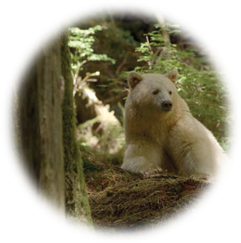
What made the establishment of the Great Bear Rainforest such a powerful story?
THE PLACE: What makes it so significant?

Photo credit: Jon Rawlinson. Wikimedia Commons. CC-BY-2.0 https://creativecommons.org/licenses/by/2.0/deed.en
THE AGREEMENT: What makes it so significant?
The LASTING LEGACY: What makes it so significant?

Blackline Master 2

Possible answers: What made the establishment of the Great Bear Rainforest such a powerful story?

THE PLACE:
“The Great Bear Rainforest is home to a vast array of wildlife, including brown bears, black bears, wolves, mink and other land mammals, birds and marine animals like orcas, humpbacked whales, seals, sea lions, sea otters, dolphins and many more. It is a large, pristine wilderness” (Mackenzie, 2018, June 3, n.p.).
THE AGREEMENT:
“The story behind the deal is as fascinating as the place is powerful. National Observer will bring it to you through the eyes of its participants: coastal First Nations, the international pulp and paper customers stigmatized by environmental boycotts, the loggers suddenly caught up in the ‘War in the Woods,’ the environmentalists learning to respect and ultimately learn from their erstwhile enemies, politicians from across the political spectrum, philanthropists, lawyers, and many more. No screenwriter could have put together a cast as eccentric and colourful as the one you will meet over the coming weeks” (Solomon & Hatch, 2016,
p. 4). “The story of its conservation is remarkable; loggers and activists were forced to resolve bitter, historical conflicts, while First Nations seized unprecedented power to create a sustainable future for their people and territory” (McSheffrey, 2016, n.p.).
THE LASTING LEGACY:
“The conservation of the rainforest and its human well-being provisions are now enshrined in legislation, leaving a permanent legacy for the Lungs of the Earth” (McSheffrey, 2016, n.p.). “Coastal wetlands provide many services. They are habitats for fish (also as nurseries), shellfish, and birds (including migratory birds). Wetlands purify water, and protect coast against storms” (Tol, R.S.J. 2009, p. 544).

Blackline Master 3

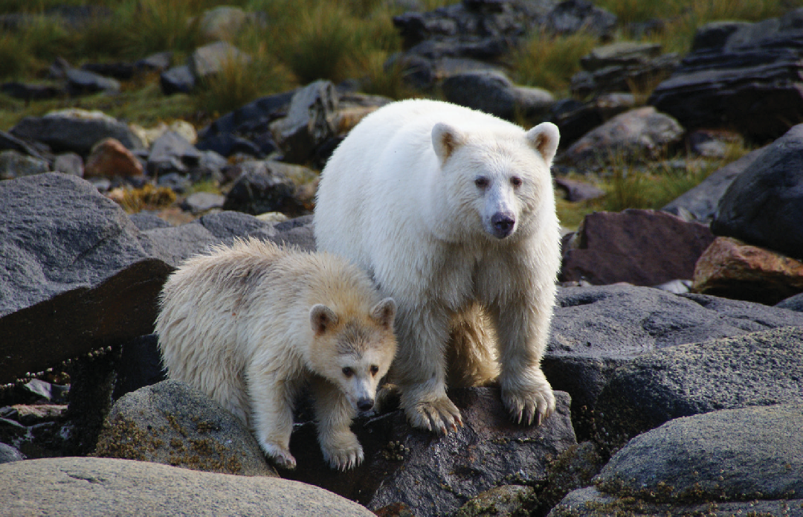
Possible answers: What made the establishment of the Great Bear Rainforest such a powerful story?

The Spirit Bear has become an iconic symbol of the Great Bear Rainforest, but there is so much more to the area than these precious bears. Write what you think makes the story of the Great Bear Rainforest so special. It may be the story of how so many groups came together to preserve the area or how magnificent the area is, or there may be specific aspects of the Great Bear Rainforest that intrigue you.

What is the story you want to tell about the Great Bear Rainforest?
Determine what aspect of the Great Bear Rainforest story is most powerful to you. Locate information you can use from the first part of the “What makes the establishment of
the Great Bear Rainforest such a powerful story?” activity, and then do more research if necessary. Create a title for your article (e.g., “The Great Bear Rainforest: The Greatest Outdoor Show on Earth”).
If your teacher has established a link to this Blackline Master, you can work directly on a computer to complete an online article. Otherwise, you can handwrite your article below or paste a typed version onto a hardcopy.

Photo credit: Originally posted to Flickr by My-mischievous-Max. CC-BY-2.0 https://creativecommons.org/licenses/by/2.0/deed.en

Blackline Master 4
Rubric: What makes the establishment of the Great Bear Rainforest such a powerful story?

Criteria | Emerging | Developing | Proficient | Extending
Communicates learning | - Limited understanding of GBR story  - Emerging ability to communicate | - Basic understanding of GBR story  - Basic ability to communicate | - Proficient understanding of GBR story  - Effective communication | - Sophisticated understanding of GBR story  - Sophisticated communication
Identifies main ideas— what events took place and where (GBR) | - Comprehension weak  - Unable to identify main ideas  - Needs to re-read materials or ask for explanations | - Comprehension adequate  - Able to partially identify some of the main ideas  - Needs assistance to enhance comprehension | - Comprehension good  - Able to identify the main idea(s)  - Good understanding of the material | - Comprehension very good  - Able to clearly identify main points and more  - Solid understanding of the material
Provides supporting details | - Unable to provide supporting details  - Supporting details inaccurate  - Needs help with identifying and differing main and supporting details | - Supporting details are adequate  - Supporting details are fairly accurate  - Needs help clarifying and grouping supporting details | - Supporting details good  - Supporting details are accurate  - Supporting details are matched with main ideas | - Supporting details are very good  - Supporting details are accurate  - Able to differentiate main and supporting details and match them accurately
Draws reasonable inferences/logical connections | - Unable to draw inferences  - Unable to draw connections  - Needs help making connections and drawing inferences | - Adequately draws some inferences  - Adequately draws some connections  - Needs help drawing more inferences and connections | - Draws inferences well  - Makes connections well  - Good ability to make reasonable connections | - Draws inferences very well  - Makes connections very well  - Very good ability to make reasonable connections
Synthesizes ideas  (student explores the power of the GBR story or another like it) | - Struggles to synthesize different ideas  - Struggles to synthesize a variety of sources  - Needs help synthesizing ideas and resources | - Can adequately synthesize some ideas  - Can adequately synthesize some resources  - Needs help to synthesize more ideas and resources | - Synthesizes ideas well  - Synthesizes resources well  - Beginning to synthesize ideas to create novel associations | - Synthesizes very well  - Synthesizes resources very well  - Synthesizes new ideas and resources to create novel conclusions
Draws coherent conclusions | - Struggles to draw conclusions  - Makes incorrect conclusions  - Needs help drawing conclusions | - Can adequately draw some conclusions  - Needs to help draw more conclusions | - Can draw conclusions well  - Can make generalizations  - Can summarize of outcomes | - Can draw conclusions very well  - Can make generalizations  - Can summarize conclusions
Note: The assignments may differ significantly, so flexibility in assessment emphasis will be important (e.g., students may present some very diverse creative works). Students may communicate their ideas by focusing on analysis, while others may create a reflective synthesis. Marking will be holistic, to adjust for the ways that students choose to communicate their learning about the Great Bear Rainforest. Inform students that the rubric is designed to inform their writing, provide a framework for them to self-assess, and to provide a corresponding achievement gradient.
This work is licensed under a Creative Commons Attribution-NonCommercial-ShareAlike 4.0 International License unless otherwise indicated.

