Great Bear Rainforest Activity Plan

How can we learn about the Great Bear Rainforest through writing?

Learning Objectives
Students will:
- Identify ways that d writers share reflections on what they have learned or experienced (e.g., photojournalists, poets, and novelists)
- Analyze and write about aspects of the Great Bear Rainforest that inspire them (story, landscapes, animals, cultural history, significance)
- Reflect on how different authors have written about the Great Bear Rainforest

Preparing for the Activity Plan
- Read the background information and preview the videos and websites.
- Make photocopies of Blackline Master 1: Interesting Highlights about the Great Bear Rainforest (available below).
- Before starting this Activity Plan, you may want to complete the plan “What makes the establishment of the Great Bear Rainforest such a powerful story?”
- You will want to show students a video about the GBR so they can relate to this majestic, pristine sanctuary; some online videos are recommended in various sections below.
The following videos can be used as an introduction to the Great Bear Rainforest:
Great Bear Rainforest in 4K—Exploring British Columbia, Canada (3:26) https://www.youtube.com/watch?v=7wWQ-0CKv1M
Enter the Great Bear Rainforest (4:36) https://www.youtube.com/watch?v=js1rnKPAnE0
The Secrets of Great Bear Rainforest—National Geographic Documentary (45:54) https://www.youtube.com/watch?v=ldMotRW9bcE

Materials
- computer and projector
- student computers / tablets/ devices
- access to the Internet
- Blackline Master 1: Interesting Highlights about the Great Bear Rainforest
- Blackline Master 2: Writing Samples
- Blackline Master 3: Planning for Writing
- Blackline Master 4: Writing Rubric
- Blackline Master 5: Writing about the Great Bear Rainforest

Background Information and Resources
A significant amount of background information has been provided in Blackline Master 1: Interesting Highlights about the Great Bear Rainforest.

Videos:
Great Bear Rainforest in 4K—Exploring British Columbia, Canada (3:26) https://www.youtube.com/watch?v=7wWQ-0CKv1M
Enter the Great Bear Rainforest (4:36) https://www.youtube.com/watch?v=js1rnKPAnE0
The Secrets of Great Bear Rainforest—National Geographic Documentary (45:54) https://www.youtube.com/watch?v=ldMotRW9bcE

Welcome to the Great Bear Rainforest (2:59)
This video gives an artistic look at the Great Bear Rainforest, with guitar music. https://www.youtube.com/watch?v=jAHNqN_8p2k

Great Bear Rainforest Spirit Bear (20:58)
This video shows outstanding footage of a tourist trek in the Great Bear Rainforest. https://www.youtube.com/watch?v=3N_clSgNgHw

Articles

The inside story of how the Great Bear Rainforest went from a ‘War In The Woods’ to an unprecedented environmental and human rights agreement
In this 2016 article, Mike Gaworecki describes how the agreement that resulted in the Great Bear Rainforest was reached.
https://news.mongabay.com/2016/02/the-inside-story-of-how-great-bear-rainforest- went-from-a-war-in-the-woods-to-an-unprecedented-environmental-and-human-rights- agreement/

Why You Should Explore Canada’s Great Bear Rainforest
This blog entry by Hayley Simpson describes the Great Bear Rainforest from a tourist’s viewpoint.
https://theculturetrip.com/north-america/canada/articles/why-you-should-explore- canadas-great-bear-rainforest/

The Great Bear Rainforest
David Du Chemin, a professional photographer, includes beautiful images of Spirit Bears in this engaging article.
https://davidduchemin.com/2015/09/the-great-bear-rainforest/

Image Banks

Wikimedia Commons
This site is a good source for Creative Commons and public domain images. https://commons.wikimedia.org/wiki/Main_Page

Pixabay
This website has some images that are commercially available and others that are freely available in the public domain.
https://pixabay.com/

Delivering the Activity Plan

Access Prior Knowledge
- Ask students if they are familiar with British Columbia’s Pacific waters, shorelines, or forests. Establish whether they are familiar with the Great Bear Rainforest, the Kermode or spirit bear, or some of the whales in the area.
- Ask students if they are aware of any wilderness areas that have been protected.
- Ask students if they know about any instances of activists fighting to protect a wilderness site (e.g., Jumbo Valley, the Amazon Rainforest, a local site). Ask, “What were the activists trying to protect, and how did they proceed?” (e.g., boycotts, marches, rallies, letters)
- Ask students if there are any local, national, or global wilderness areas that they think need to be protected.

Inquire
- Introduce the main inquiry question: How can learn about the Great Bear Rainforest writing?
- Share one of the following videos to introduce the Great Bear Rainforest:
» Welcome to the Great Bear Rainforest
» Great Bear Rainforest Spirit Bear
- Ask students to discuss what features of the Great Bear Rainforest they liked the most.
- Distribute Blackline Master 1: Highlights of the Great Bear Rainforest.
- Read Blackline Master 1 aloud or have students read it silently. Students will learn important details about the Great Bear Rainforest (e.g., about the spirit bear, the old- growth forests, the fjords, the whales, and so forth).
- Ask students to share the three details they found to be most interesting.

Experience
- Distribute Blackline Master 2: Writing Samples, and work through it together, discussing along the way.
- Discuss the five questions at the end of Blackline Master 2:
» Would you like to be a photojournalist like David Mackenzie?
» Would you like to write travel guides for a company such as Lonely Planet?
» Would you like to investigate a particular Great Bear Rainforest animal and write about it?
» Would you like to be a biologist or marine biologist writing about your research?
» Would you like to write about your travel adventures for family and/or friends to read?
- Alternatively, instead of working through Blackline Master 2, project and read aloud the short photo essay by David Du Chemin at The Great Bear Rainforest. Have students focus on the author’s use of description and the feelings he expresses.
- Tell students that now that they’ve learned about the Great Bear Rainforest, they’re going think about how they might describe it in a written composition. Have them complete Blackline Master 3: Planning for Writing to begin the process.
- Have students share their completed Blackline Master 3 with other students, either as a whole class or in small groups.
- For student self-assessment, at this point you might distribute the Blackline Master 4: Writing Rubric. You could also use it for your assessment of the assignment.

Explore
- The Great Bear Rainforest is a beautiful place, but it also has a history with many stories, including stories about how the area came to be protected. To provide an overview of this process, read aloud (or have students read) the 2016 article by Mike Gaworecki at The inside story of how the Great Bear Rainforest went from a ‘War In The Woods’ to an unprecedented environmental and human rights agreement.
- For weaker readers, you might instead share the 2017 article by Hayley Simpon, Why You Should Explore Canada’s Great Bear Rainforest. Show the article on a screen as you read it aloud, as it incorporates a number of photographs.
- Have students discuss what they learned from the article about the history behind the Great Bear Rainforest.
- Invite students to consider the following questions:
» In what format would you would like to present your knowledge of the Great Bear Rainforest (e.g., poem, PowerPoint, newspaper article)?

» What genre of composition are you going to complete (e.g., personal travel journey, tourist brochure, travel article)?
» What topic do you want to write about the Great Bear Rainforest (e.g., its grandeur; the story of its preservation; a specific aspect such as the Spirit Bear, the fjords; or its significance to the planet’s thrivability)?
- Have students complete Blackline Master 5: Writing About the Great Bear Rainforest to create some form of written composition related to the topic of the Great Bear Rainforest. Provide students with Blackline Master 4: Writing Rubric so they can self- assess, and/or use the rubric yourself to assess the assignment.

Read
- Have students work together in pairs to read and edit each other’s work.

Watch and Listen
- Have students display their work and present it to the class. If some students are reluctant, assist them or allow them to present their work to a very small audience.

Assess
- Use Blackline Master 4: Writing Rubric for summative, self-, and formative assessments. The rubric provided uses the emerging, developing, proficient, and extending categories. The rubric can be used to assess Blackline Masters 3 and/ or 5, as well as any extension activities. The teacher may want to focus instruction on criteria found in the Content and Development and Organization and Structure categories. As students may choose a diverse number of ways to communicate their ideas, the rubric can be used flexibly. Some students may want to research a topic (e.g., emphasis on analysis) while others may want to reflect (e.g., synthesize) and present a more creative piece (e.g., a poem). The new curriculum encourages communication in various formats.
- If you have struggling readers (e.g., ELL, modified students, IEP students), you may specify a specific format, (e.g., tourist poster) and provide scaffolding steps for your students to use (e.g., catchy heading, graphics, and enticing descriptions). Otherwise, give students some freedom to communicate what they have learned.

Go Beyond
- Have students create a photo essay about the Great Bear Rainforest (e.g., the highlights) using PowerPoint, Prezi, or Word. They can use Creative Commons and public domain images from Wikimedia Commons. Pixabay has some images that are commercially available and others that are freely available in the public domain. If students do use either of these sites, students can also learn about Creative Commons licensing and the public domain, if they are not already familiar.
- Have students learn and write about Indigenous stories from the region
- Have students learn and write about future issues the Great Bear Rainforest region might face (e.g., climate change).

References
Dobell, Darcy. (2016, April 8). A relationship with whales in the Great Bear Sea.
National Observer. Retrieved from https://www.nationalobserver.com/2016/04/08/ news/relationship-whales-great-bear-sea
Fischer, G. (2016, July 31). First Nations man leads tours to sacred Bella Coola petroglyphs to share Indigenous culture. CBC News. Retrieved from https://www.cbc.ca/news/ canada/british-columbia/first-nations-man-leads-tours-to-sacred-bella-coola- petroglyphs-to-share-indigenous-culture-1.3702121
Government of BC. (2016) Learn about the GBR: Agreement Highlights [Website]. Retrieved from: https://greatbearrainforest.gov.bc.ca/tile/gbr-agreement-highlights/
Mackenzie, D. (2018). Great Bear Rainforest. Outdoor Photographer [Online Journal].
Retrieved from https://www.outdoorphotographer.com/on-location/travel/great- bear-rainforest/
McSheffrey (2016). Thunder in the Air. National Observer. Retrieved from https://www. nationalobserver.com/2016/02/25/canadas-coastal-indigenous-people-gain-power- through-great-bear-rainforest-agreement
Smith, M. & Sterritt, A. (2016). From Conflict to Collaboration: The Story of the Great Bear Rainforest. Coast Funds. Retrieved from https://coastfunds.ca/wp-content/ uploads/2016/02/StoryoftheGBR.pdf
Smy, O. (2016, August 26). 9 things you probably did not know about the Great Bear Rainforest. Outer Shores. Retrieved from https://outershores.ca/9-things-probably- didnt-know-great-bear-rainforest/
Stand.earth (2020). Protecting the Great Bear Rainforest. Retrieved from https://www. stand.earth/about/achievements/protecting-great-bear-rainforest
Terra Foundation for American Art (2020). Picturing the Americas: Inside A Forest II. Retrieved from https://picturingtheamericas.org/painting/inside-a-forest-ii/
Uechi, J. and Hatch, C. (2016, June 24). The visionary philanthropy of Vancouver’s Rudy North. National Observer. Retrieved from https://www.nationalobserver. com/2016/06/24/news/visionary-philanthropy-vancouvers-rudy-north
Ver Berkmoes, R. (2014). Canada’s Wild Side: the Great Bear Rainforest. Lonely Planet.
Retrieved from https://www.lonelyplanet.com/articles/canadas-wild-side-the-great- bear-rainforest

Blackline Master 1
Interesting Highlights about the Great Bear Rainforest
- The Great Bear Rainforest is the largest coastal temperate rainforest in the world. (Smy, 2016)
- The Great Bear Rainforest is home to the largest biomass on earth. (Smy, 2016)
- The Great Bear Rainforest is larger than the size of Ireland. (Government of BC, 2016)
- The Great Bear Rainforest is larger than America’s largest National Park, St. Alias National Park in Alaska (Smy, 2016)
- The Great Bear Rainforest is home to the rare Kermode bear, also known as the Spirit Bear.
- The Great Bear Rainforest is home to a distinct type of coastal grey wolf.
- The Great Bear Rainforest is home to some of the largest kelp forest in the world. (Smy, 2016)
- Bull kelp in the Great Bear Sea can grow to 120 feet long (Smy, 2016)
- Trees in the Great Bear Rainforest can be upwards of 1000 years old. (Smy, 2016)
- Trees in the Great Bear Rainforest can tower as high as some skyscrapers.
- Over six million birds return to the area every year. (Smith & Sterritt, 2016)
- The Great Bear Rainforest streams are home to 20% of the world’s salmon. (Smith & Sterritt, 2016)
- The area has been inhabited by First Nations for a millennium or more. (Government of Canada, 2016)
- Where once there were over 50,000 humpback whales now there are 1500 but one region has noted an increase from 40 to 60 during the years 2006 – 2010 – the GBR. (Dobell, 2016)
- The Great Bear Rainforest is the only place in the world where fin whales can be sighted from shore.
- The second largest mass arrest in Canada took place in the Clayoquot region of BC: they were protesting the cutting of first growth trees, as did protesters in the Great Bear Rainforest
- The Pacific Northwest orca population is declining putting them at an increasing risk.
- A number of sea otters were reintroduced to the Pacific Northwest and their populations are rising again. (Smy, 2016)
- Emily Carr’s famous, In a Forest II, painting focuses on trees in the Great Bear Rainforest. (Terra Foundation for American Art, 2020)

- The Nuxalk Nation’s ancient petroglyphs, estimated to be over 5000 years old, are located in the Great Bear Rainforest. (Fischer, 2016)
- One can find many totems in the Great Bear Rainforest; each has a story to tell.
- Many cedar long houses can be found in the Great Bear Rainforest; each has a story to tell.
- Many Pacific Northwest First Nations annually paddle large cedar canoes that represent their clans and communities.
- Simon Jackson, a young boy, founded the Spirit Bear Youth Coalition that became very influential in the movement to protect the bear.
- Canadian philanthropist, Rudy North, spurred himself and others to raise $120 million dollars to help protect the Great Bear Rainforest. (Uechi & Hatch, 2016)
- 26 First Nations live in the Great Bear Rainforest area and were involved in negotiations. (Government of Canada, 2016)
- Several logging companies (e.g., Canadian Forest Products, Catalyst Paper, International Forest Products and Western Forest Products) were willing to meet with environmental groups (ForestEthics), First Nations leaders, and government leaders to make a deal to protect much of the region.
- Many of the environmental groups allied as the Rainforest Solutions Project and this expanded into the Joint Solutions Project—“a structure that facilitated a broader dialogue with First Nations, the BC government, labour groups, and local communities” (Smith & Sterritt, 2016, p. 5).

The Agreement
According the Government of British Columbia (2016) the highlights of the agreement are as follows:
- The Great Bear Rainforest Announcement outlines the forest practices for the area and increases the amount of protected old-growth forest from 50% to 70%.
- The agreement also addresses First Nations’ cultural heritage resources, freshwater ecosystems, and wildlife habitat.
- The amount of habitat protected for marbled murrelet, northern goshawk, grizzly bear, mountain goat, and tailed frog will increase as each new reserve is developed.
- The Province signed agreements with the aligned Coastal First Nations, Nanwakolas Council and other individual First Nations to address specific concerns identified by First Nations communities. Most notably, many First Nations will have an increased stake in the region’s forestry sector.
- The Province has also updated agreements with Coastal First Nations, Nanwakolas Council and other first individual First Nations to increase their allocation of forest carbon credits to sell and utilize for development projects of importance to them.
- In 2015, working with many of the same First Nations and employing the same ecosystem-based management approach, four Marine Plans for the areas next to the Great Bear Rainforest were completed through the Marine Plan Partnership.
- With the Great Bear Rainforest and Marine Plan Partnership combined, the largest land and marine ecosystem in the world will be managed using EBM (p. 1).

Regulating and Protecting the Great Bear Rainforest
There are strict regulations that control activities in the GBR:
- 85% of the Great Bear Rainforest is now legally off limits to logging.
- First Nations are now co-decision makers, along with the provincial government of British Columbia. Agreements between the government and First Nations will promote the vitality of native communities and their culture.
- Logging is restricted to 15% of the Great Bear Rainforest and it will be subject to the most stringent standards in North America.
- Every year, logging companies are required to report how they are achieving their conservation targets” (STAND.earth, 2020, para. 3).

Blackline Master 2

Writing Samples
Read the following three excerpts from articles about the Great Bear Rainforest.
- Consider the following excerpt by McSheffrey (2016):
For many years, First Nations had mostly operated community by community, often in isolation from one another. Facing the enormous political and financial power of industry in the late 1990s however, they realized they were stronger together.
The nations formed two governing bodies to represent them in negotiation: Coastal First Nations for those in Haida Gwaii and the Northern and Central Coast, and the Nanwakolas Council for nations on northern Vancouver Island and the South-Central Coast.
They became an irresistible force, using their combined power directly in negotiation with government and industry, and indirectly by leveraging effective environmental campaigns. It forced the timber companies to the table to talk.
“First Nations came together at a time in their history when they knew if they did not save the region at this point in time, that all that was precious to them would be gone,” said Sterritt. “That really is the story from the First Nations side.” (para. 18)
We all encapsulate our experiences into story, and it is natural to want to creatively share that narrative. Some authors encapsulate, to the best of their ability, another person’s or group’s story. This is what McSheffrey did in the article excerpt above.
- In a Lonely Planet travel guide article entitled “Canada’s wild side: the Great Bear Rainforest,” author Ryan Ver Berkmoes (2014) seeks to entice wildlife-lovers to visit the Great Bear Rainforest:
With huge stands of ancient old-growth timber, the Great Bear Rainforest is a wonderland of wildlife. Deer, cougars, mountain goats, wolves, elk and more prowl the forests. Bald eagles and countless other species fly across the skies and perch in the enormous trees. In the cold, clear waters of the craggy coasts and myriad inlets, orcas, humpback whales, sea lions and sea otters are just some of the sea-going mammals that feast on the rich bounty of the Great Bear (para. 3).
The author is drawing the reader into a serene nature experience that they could also have if they visited the Great Bear Rainforest.

- Photographer and writer David Mackenzie (2018) presents a night at Spirit Bear Lodge as an epiphany—a time when an experience or an encounter challenges a person to reconsider life and its significance:
“You have to ask yourself why you care.” In the still calm of a clear twilight evening at the Spirit Bear Lodge, Mike Forsberg offered that suggestion to me to answer the question, “How can we make a difference?” It is so easy to come up with a glib, superficial answer to that question. “Oh, I want the next generation to see what I saw. I want to give voice to creatures who can’t speak for themselves.” Yes, I want those things, but is that enough? I do care, fervently. My passion emanates from a deep spiritual connection to nature and wild places and a desire to capture images of these special places to help others engage in a subject that is becoming remote from our increasingly urbanized society.
(para. 12)
Writers often become inspired by unique, intriguing, and distinct phenomena. The Great Bear Rainforest is beautiful and pristine, but it also has an incredible history and is unique for numerous reasons. Discuss and complete Blackline Master 1.

Explore what type of writer you would like to be when writing about the Great Bear Rainforest.
To help you decide, consider these questions:
Would you like to:
- be a photojournalist like David Mackenzie?
- write travel guides for a company such as Lonely Planet?
- explore a specific Great Bear Rainforest animal and write about it?
- assume the point of view of an animal in the Great Bear Rainforest and describe your experiences?
- be a biologist or marine biologist writing about their research?
- explain the history of the Great Bear Rainforest?

Blackline Master 3

Planning for Writing
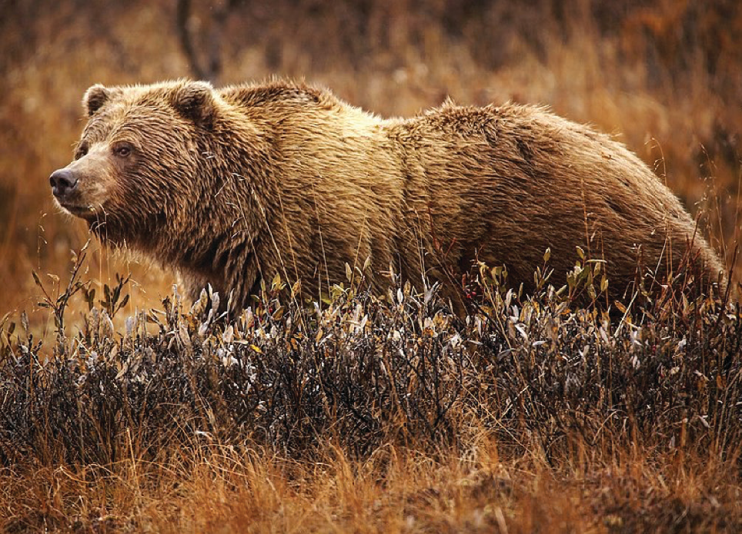
Grizzly Bear
Image in the public domain by Jean Beaufort. Wikimedia Commons.Creative Commons CC0 1.0 Universal Public Domain Dedication

What identity do you want to assume as the writer (yourself, a poet, a travel journalist, a photojournalist, a social-activist writer, a reporter, a nature writer, a blogger, a biologist, a fisherman, a First Nations writer, or another identity)?

What story do you want to share? Do you want to write about the diverse array of flora, fauna, and marine life that can be found in the Great Bear Rainforest? Do you want to write about a specific animal? Do you want to write about the First Nations in the area?
Do you want to talk about an event such as the return of the whales, migratory birds, herring season, feeding bears before hibernation?

What words might you consider using in your composition? Do you want to talk about the towering walls of the fjords, the pristine waters, the cathedral-like forests, the
distinctive black-and-white orcas, the playful sea otters, the remarkable achievement
of groups to pull together the GBR agreement, or some other descriptors?

What will you title your composition? What will be the narrative hook that will draw readers in (e.g., something at the start of the article that entices the reader to keep reading)?

You may want to handwrite your composition or complete it on the computer. You can use free images to accompany your composition. See https://pixabay.com/ or https://commons.wikimedia.org.

Blackline Master 4
Writing Rubric

Criteria | Emerging | Developing | Proficient | Extending
Content and Development (creative writing about the Great Bear Rainforest) | - Inadequate or incomplete content  - Major points missing  - Incomplete development of ideas | - Adequate content  - Adequate details provided  - Satisfactory development of ideas | - Significant content  - Relevant details provided  - Ideas well-developed | - Significant and important information included  - Many significant details provided  - Ideas very well-developed
Organization and  Structure (organized writing about the GBR) | - Requires more organization  - Structure weak  - Disjointed information  - Weak transitions between sections | - Satisfactory organization  - Satisfactory structure  - Information connects together  - Weak transitions between ideas  - Adequately stayed on topic | - Well-organized  - Good structure  - Logically ordered  - Good transitions  - Coherent | - Very well-organized  - Very good structure  - Very logically ordered  - Very good transitions  - Logistical and coherent
Inquiry, Analysis, and Synthesis  (some may do a more formal writing about the GBR) | - Inquiry not completed  - Analysis weak or absent  - Synthesis of ideas weak or absent | - Inquiry adequate  - Analysis adequate  - Synthesis of ideas adequate | - Inquiry in-depth  - Analysis good  - Synthesis of ideas good | - Inquiry well researched and in- depth  - Analysis very strong  - Synthesis of ideas very strong
Grammar, Spelling, and Vocabulary | - Frequent errors in spelling, punctuation, and/or grammar  - Very limited vocabulary  - Weak sentence and/or paragraph structure | - Spelling, punctuation, and/or grammar not consistently good  - Sufficient vocabulary  - Adequate sentence and/or paragraph structure | - Good spelling, grammar, and punctuation  - Good vocabulary  - Good sentence and/or paragraph structure | - Very good spelling, grammar, and punctuation  - Very good vocabulary  - Very good sentence and/or paragraph structure

NOTE 1: The assignments may differ significantly, so flexibility in marking emphasis will be important (i.e., students may present some very diverse creative works). Students may communicate their ideas differently, with some focussing on analysis while others may submit a more reflective piece. Marking should be holistic to adjust for the ways that students choose to communicate their learning about the Great Bear Rainforest. Inform students that the rubric is designed to inform their writing, provide a framework for them to self-assess, and to provide a corresponding achievement gradient.

Blackline Master 5

Writing about the Great Bear Rainforest
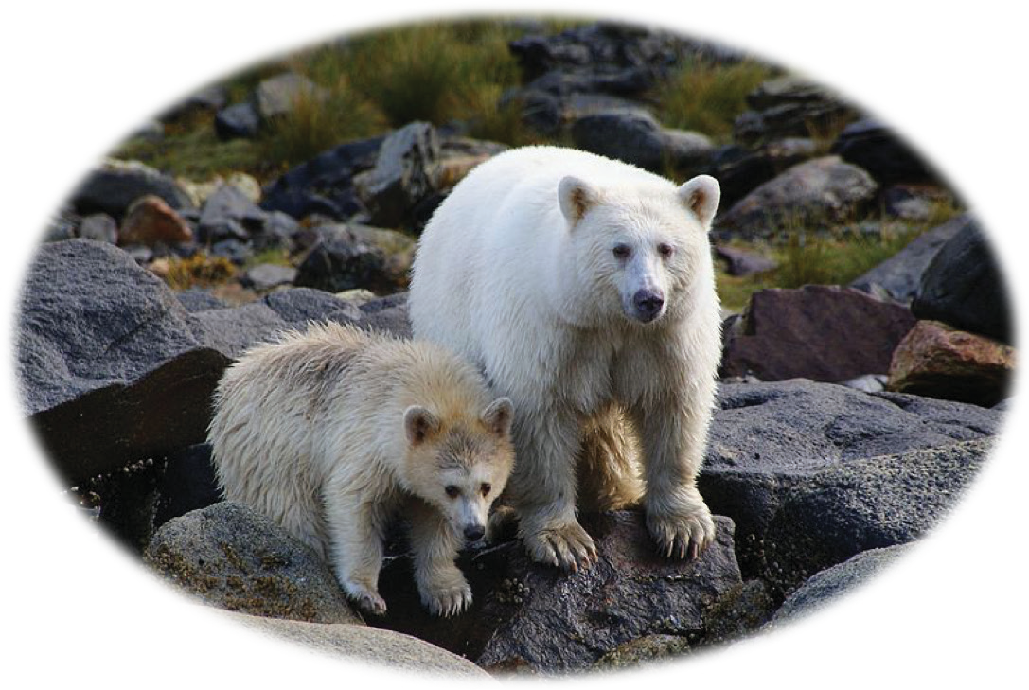
Great Bear Rainforest Spirit Bears
Photo by Maximilian Helm. Licensed under a Creative Commons Attribution 2.0 Generic License. https://creativecommons.org/licenses/by/2.0/deed.en

Write your own Great Bear Rainforest composition. Determine what identity you want to assume as a writer (e.g., photojournalist, poet, or travel writer), your target audience, and what aspect of the Great Bear Rainforest that you are going to write about (e.g., Spirit Bear, the return of the Salmon, the ancient trees).
If your teacher posts this Blackline Master online, you can complete your assignment on the computer. Otherwise, if you have a printed copy, you can hand write the assignment directly below or you can print it out and affix it to this paper. You could present your poster to the class.

This work is licensed under a Creative Commons Attribution-NonCommercial-ShareAlike 4.0 International License unless otherwise indicated.

How can we learn about the Great Bear Rainforest through writing? 16

