Students explore black bear variations such as the spirit bear and investigate why these variations occur in specific locations.
Why are spirit bears primarily in the Great Bear Rainforest?
Great Bear Rainforest Activity Plan

Learning Objectives
Students will:
- Formulate multiple hypotheses and predict multiple outcomes
- Use knowledge of scientific concepts to draw conclusions that are consistent with evidence
- Analyze cause-and-effect relationships
- Apply First Peoples perspectives and knowledge, other ways of knowing, and local knowledge as sources of information
- Understand, over the course of this activity:
» the mechanisms for the diversity of life:
» mutation and its impact on evolution
» natural selection and artificial selection
» microevolution:
» adaptation to changing environments
» changes in DNA
» natural selection

Preparing for the Activity Plan
- Read the background information and preview the videos and websites.
- This activity plan assumes that learners have a basic understanding of natural selection. The video Natural Selection—Crash Course Biology #14 would be a good place to start this discussion.

Materials
- computer and projector
- student computers / tablets/ devices
- access to the Internet
- Blackline Master 1: Why is the spirit bear primarily in the Great Bear Rainforest?
- Blackline Master 2: Why does your bear live in its specific environment?

Background Information and Resources
The spirit bear is found mainly in the Great Bear Rainforest; we see other unique variations in black bear living in other areas. During this activity, students make connections between these black bear variations and their environments. In the process, the theory of natural selection is reinforced; that is, that organisms better suited for their environment will preferentially survive and produce more offspring than those that are not.

Videos
Bear Witness (22:38)
In this video, BC’s Coastal First Nations discuss protecting all bears in the Great Bear Rainforest from trophy hunters. https://www.youtube.com/watch?time_continue=1319&v=NDg24d8fF1Q&feature=emb_ logo

Enter the Great Bear Rainforest (4:35)
This video is a great introduction to the Great Bear Rainforest and its inhabitants. It provides footage of black bears that identifies colour variants. https://www.youtube.com/watch?time_continue=267&v=js1rnKPAnE0&feature=emb_logo

Great Bear Rainforest in 4K—Exploring British Columbia, Canada (Devin Graham)
(3:26)
This short video shows the Great Bear Rainforest and some of its many habitats. https://www.youtube.com/watch?time_continue=13&v=7wWQ-0CKv1M&feature=emb_logo

Great Bear (18:06)
This video explores study and stewardship of bears in which traditional ecological knowledge and science complement one another.
https://vimeo.com/105569648

Natural Selection—Crash Course Biology #14 (12:43)
This video is an overview of Charles Darwin, natural selection, and selective pressure. https://www.youtube.com/watch?time_continue=1&v=aTftyFboC_M&feature=emb_logo

Welcome to the Great Bear Rainforest (2:59)
This video is an excellent introduction to the Great Bear Rainforest and can be used to identify bear phenotypes. https://www.youtube.com/watch?time_continue=7&v=jAHNqN_8p2k&feature=emb_logo

Informational Websites:

Geographic Regions of BC (BC Ministry of Education)
This link goes to a map of western Canada.
https://greatbearrainforesttrust.org/wp-content/uploads/2018/06/GBR-Map-13.pdf

North American Bear Center: Northwoods Ecology Hall
This website gives a succinct overview of the black bear colour variants and where they are located.
https://bear.org/black-bear-color-phases/

Untamed Science
This website has a lot of general bear information, including a list of 12 subspecies of Ursus americanus and where they live.
https://untamedscience.com/biodiversity/american-black-bear/

Delivering the Activity Plan

Access Prior Knowledge
- Introduce students to the habitat and location of the Great Bear Rainforest to ensure an understanding of the environment.
- Introduce the activity by asking students to share what they know about the Great Bear Rainforest and the spirit bear.
- For activities to aid student understanding, see the Grades 7−9 Great Bear Rainforest Activity Plans Where is the Great Bear Rainforest? and What is a rainforest?.
- You might show one of these useful videos:
» Enter the Great Bear Rainforest,
» Welcome to the Great Bear Rainforest, or
» Great Bear Rainforest in 4K – Exploring British Columbia Canada (Devin Graham).

Inquire
- This activity can be delivered in either of the following two ways:
» Have students focus specifically on the spirit bear and its location.
» Have students explore other variations of the black bear, including the spirit bear (black, brown, cinnamon, blond, blue-grey, white).
- Tell students that they are going to research whether there is a connection between the black bear environment and the colour of the bears’ fur.
- The student blackline master provides students with Blackline Master 1: Why is the spirit bear primarily in the Great Bear Rainforest? to guide their work.

Experience
- Have students research colour variations of the black bear and record them on a map of North America on Blackline Master 1.
- The North American Bear Center Northwoods Ecology Hall is a good place to direct students. (Possible variations students may find include black, brown, cinnamon, blond, blue-grey, white).
- If your class is focussing on just the spirit bear variation, omit this part of the activity.

Explore
- Have students research the environment where each variation of the bear occurs. They should be able to discuss how the given environment allows for preferential survival of the given bear. This activity can be done individually, in small groups, or as a jigsaw in which each group researches one type of bear variant.
- If the jigsaw approach is used, allow each group to share its findings.
- As a class, discuss why each variation is found in its primary environment.
- Ask students if the black bear populations demonstrate natural selection.
- Provide students with Blackline Master 2: Why does your bear live in its specific environment?, which gives guiding questions to make connections between the genetic variation and its environment.

Assess
- Throughout their research, were students able to find reliable sources of information?
- Were students able to make inferences based on the information they found?
- Were students able to formulate multiple hypotheses and predict multiple outcomes?
- Did students use knowledge of scientific concepts to draw conclusions that are consistent with evidence?
- How did students analyze cause-and-effect relationships?
- How did students apply First Peoples perspectives and knowledge, other ways of knowing, and local knowledge as sources of information?
- Did students demonstrate an understanding of mutation and how it impacts evolution using the black bear variations in the Great Bear Rainforest? Did students demonstrate an understanding of natural selection and artificial selection in the black bear populations in the Great Bear Rainforest?
- Did students demonstrate an understanding of microevolution in the Great Bear Rainforest (e.g., adaptation to changing environments, changes in DNA, and natural selection)?

Go Beyond
- Have students explore these questions: Is it possible for the spirit bear to eventually form its own species? What would be necessary for this to happen? Students can create an ideal environment in which speciation may occur.
- Have students research how traditional ecological knowledge could be used to explain why spirit bears live where they live.
- Show the documentary Bear Witness and discuss the sport hunting of bears.

Blackline Master 1
Why is the spirit bear primarily in the Great Bear Rainforest?

Name:

Use the map below to locate variations of the black bear (Ursus americanus).

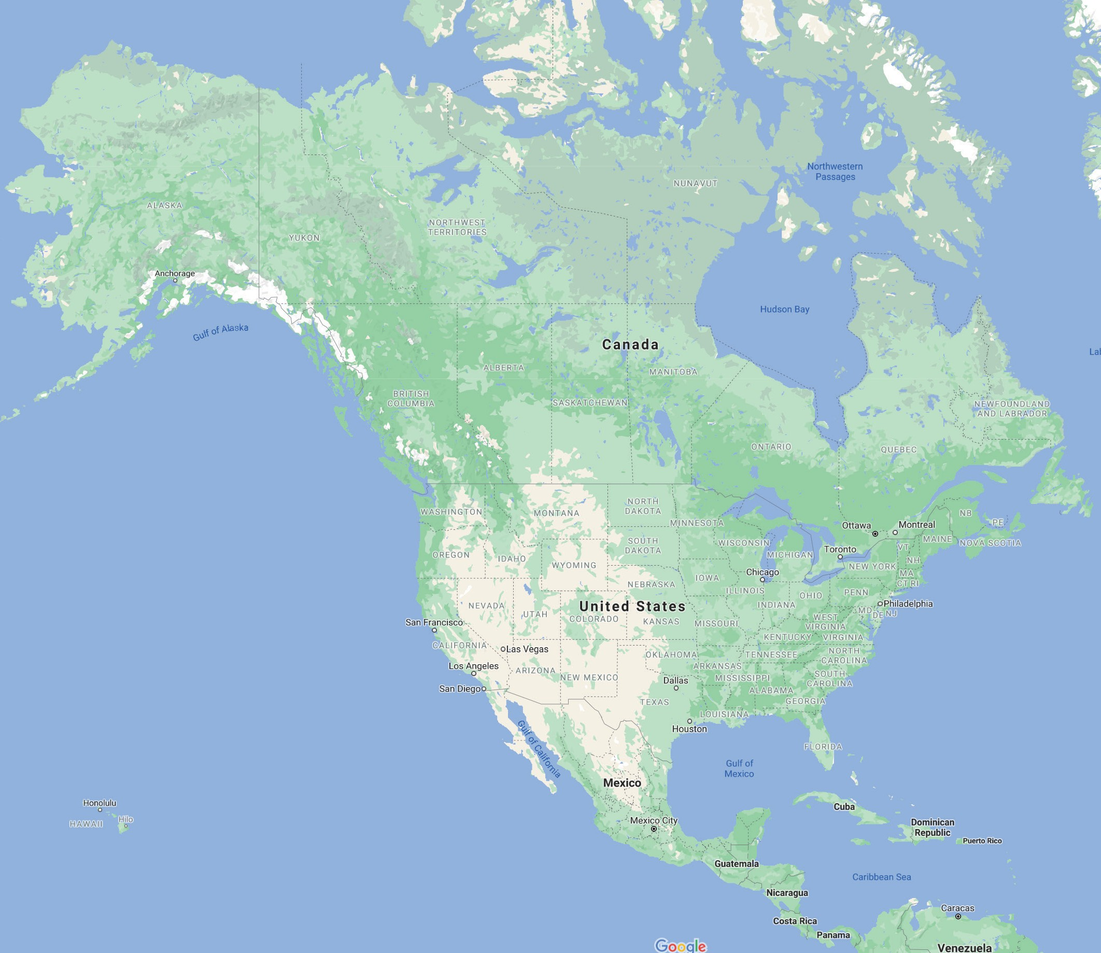

Courtesy of Google Maps

Blackline Master 2

Why does your bear live in its specific environment?

Name:

Select one variation of the black bear (species Ursus americanus). Research your black bear variation and its habitat. Why does your bear live in its specific environment?
Be sure to select reliable resources if using the internet and document them in the “Sources” section below.

- Which black bear variation are you researching?

- How is your bear variation suited for its environment? Or conversely, how is your bear not suited to its environment?

- If you were to travel in time 500 years into the future, would you expect the frequency of your bear to be higher or lower than it is now? Explain.

- Sources:

This work is licensed under a Creative Commons Attribution-NonCommercial-ShareAlike 4.0 International License unless otherwise indicated.

