Great Bear Rainforest Activity Plan
Where in the world do we live?

Using maps, students will explore where they live in British Columbia, traditional homelands, and geographic features in the province.

Learning Intentions
- What are maps used for?
- How are maps created?
- Where do I live in British Columbia?
- Whose traditional lands do I live on?
- Investigate the geographical features of British Columbia
- Where do I live in the world?
- Where is the Great Bear Rainforest?
- Understanding Indigenous Homelands and Waters and Comparing Map Naming

Blackline Masters
  - Learning Intention 1: Four Directions
  - Learning Intention 2: Heart Map
  - Learning Intention 6: Our Family Stories (World: separate file on GBREAT website)
  - Learning Intention 6: Our Family Stories (Canada)

Curricular Connections
Refer to the “Curriculum” drop-down option under the “Learn” tab of the Great Bear Rainforest Education and Awareness website.
Curriculum Alignment: Great Bear Rainforest Education and Awareness Trust https://greatbearrainforesttrust.org/curriculum/

Learning Intention 1

What are maps used for?
Students will explore the different purposes and perspectives of maps. They will also learn about the four directions as a way of orienting and grounding ourselves, as well as their importance in some Indigenous cultures in Canada.

Experiences and Observations

Part 1: What are maps?
Gallery walk with the question: What are maps? What do you notice? Where do we find maps?
  - Place a variety of maps around the classroom at different tables.
  - In groups, assign students to a table. Together or individually, they can make observations about what they notice.
  - Give students a signal to move to the next table to explore the next set of maps.
  - Students can document their thinking by drawing or writing on sticky notes and either bring them with them or leave them at the map station for the next group.

Group Discussion
  - After students have been through all the stations, have a group discussion about what they noticed. Possible observations: names, words, directions, symbols, legends, compass rose.
  - How were all the maps the same or different from each other? What were they highlighting? Some were all about waterways, some were large places, smaller places, some were 3-D globes, biking trail maps, ski area maps, etc. The more types of maps, the better.

Make a Map
  - Spend a few minutes letting students create their own map with their favourite features. This is a way to creatively incorporate new concepts that they have learned, so it doesn’t need to have everything.
  - For students who would benefit from more direction, suggest they map their classroom or their school.

Part 2: The Four Directions and the Medicine Wheel
Note: Some Indigenous groups use the terms “medicine circle” or “sacred circle” instead of “medicine wheel.” The medicine wheel is not traditionally part of all Indigenous groups’ worldview and spirituality in North America (Turtle Island).

The Four Directions in our Classroom
On maps, students may have noticed the compass rose with the cardinal directions: north, east, south, and west.
As a class, put the direction names up on each respective classroom wall. These can be typed or handwritten in large letters so the words can be read from anywhere in the room. If necessary, you can find your school online to determine where you should place the directions on your walls.
  - Each direction has many important associated symbolic elements. These elements may vary, depending on your sources.
  - Research (if necessary) and share the significance and importance of the Four Directions in Indigenous cultures. Suggested resources:

We Greet the Four Animals
https://www.strongnations.com/store/item_display.php?i=4392&f=

The Sacred Tree: Reflections on Native American Spirituality
Four Worlds Development Project, 1988. Out of Print.
All Creation Represented: A Child’s Guide to the Medicine Wheel https://focusedresources.ca/en/k-12-evaluated-resource-collection/all-creation- represented-childs-guide-medicine-wheel

Reflecting on the Four Directions
Students draw and write in a medicine wheel to reflect on the teachings they have learned about. You may choose to use the Four Directions blackline master for this purpose.

Possible Topics/Key Vocabulary
  - Compass rose
  - Four Directions – East, South, West, North
  - Legend
  - Symbols
  - The medicine wheel, medicine circle or sacred circle
  - The Four Directions in Indigenous culture

Reflections on Learning

Part 1:
  - Students will draw a map and include some features that stuck out to them.
  - Including at least three items on their map, students create a legend with the name of the item, and the compass rose (four directions).

Part 2:
  - Students draw and write about what they have heard and read about the medicine wheel, including the four directions, including at least three features, such as directions, seasons, and colours

Suggested Resources

We Greet the Four Animals
https://www.strongnations.com/store/item_display.php?i=4392&f=

The Sacred Tree: Reflections on Native American Spirituality
Four Worlds Development Project, 1988. Out of Print.
All Creation Represented: A Child’s Guide to the Medicine Wheel https://focusedresources.ca/en/k-12-evaluated-resource-collection/all-creation- represented-childs-guide-medicine-wheel

Extensions
  - Learning a song from the Indigenous First Nations in your community. For example, the Coast Salish Nation anthem. This song is repeated four times for the four directions. This version of the song has Chief Dan George’s prayer song and features Gordon Dick (Tchilaqs7tchila) of the Tsleil-Waututh Nation drumming.
  - Use a compass to find north in the school yard.

Four Directions
Spring
Autumn
The Four Directions are important to many Indigenous communities.
Draw and write your learning about the four directions.
Winter
Summer

Learning Intention 2

How are Maps Created?
Students will create maps with different intentions to show different perspectives and experiences.

Experiences and Observations

Read

My Map Book
Children’s book by Sara Finelli.
https://www.harpercollins.ca/9780062898876/my-map-book/

Activity: Map of My Heart
  - Have students draw a symbolic map of their heart. This is a map of what is important to us.
  - Explain that the first map will be a heart map. Maps share information and ideas that sometimes can’t be seen or compared. Today we are mapping what is in our heart. A blackline master for this purpose can be found at the end of this Learning Intention.
  - Students start by brainstorming things that are important to them. Collect these ideas on a board, chart paper, or computer so that students can reference them.
  - Then either with using the graphic organizer or drawing their own hearts, students start to segment the heart and add things that are important to them. Examples: family, friends, pets, hobbies, memories, favourite things, and so on.

Discussion
  - What information do maps show? Is the person who creates the map important? Whose perspectives do the maps show? We are the mapmakers of our hearts. Who are the mapmakers of other maps we see?

Mapping Extensions

Activity: Draw a Map of Our Classroom
  - This is a map of something students can see in front of them. How can they represent the class? What symbols will they use? What will they include?

Activity: Draw a Map of How You Got to School Today
  - Students create a map of their route to school. This is a map from the students’ memories. Did they walk or drive? What special landmarks did they pass by?

Activity: Map your Favourite Places at School (Playground)
  - Students create a map of their favourite places. This is a map of things that are special to students at school. Where do they have the most fun? Where do they feel safe? Where do they have special memories?
  - Teachers can keep note of these places. They will connect well to Learning Intention 8.
  - Be sure students add a compass rose to their maps.

Activity: Sound Mapping
  - Have students find a special place and map the sounds they hear (for example, birds chirping, trucks driving by, children laughing, and so on. Have them draw those spaces where they are sitting.

Activity: Light Mapping
  - This activity connects especially well with planning a school garden. Students visit a spot three times during the day noticing the areas covered with sunlight and the areas that are shaded. Students use a pencil or pencil crayon to colour the sun. They can determine how much sunlight a space gets.
  - Alternative light mapping is using a concrete surface that you can use sidewalk chalk to map the shadows and their changing throughout the day.

Possible Topics/Key Vocabulary
  - Perspectives
  - Mapping

Reflections on Learning

Project-based Learning
Students make one or more maps as a way of expressing information, ideas, and/or feelings.

Reflections
Students and teachers together consider the intentions of maps, their authors, and the perspectives they convey.

Suggested Resources

My Map Book
Children’s book by Sara Finelli.
https://www.harpercollins.ca/9780062898876/my-map-book/

Extensions

Writing Extension
  - Have students refer to their heart maps as an inspiration to write during writer’s workshop or story workshop.

’s Heart Map

Learning Intention 3

Where do I live in British Columbia?
Using maps, students learn about the area where they live in British Columbia.

Experiences and Observations

Wonder Together
Where do we live in British Columbia?

Explore
Use a mapping application on a phone or computer to identify your location. If possible, enlarge this on a projector.
  - Zoom out to show your town/city
  - Zoom out to show your province
  - Wonder: Ask students what features they notice
Document student answers to highlight vocabulary and place names.

Brainstorm
What is special about our community and province?
  - Brainstorm things students love to do in their community and province, and have them find special places on the interactive map.
  - Consider together how where you live impacts how you live. For example, if you live near mountains, you might have an opportunity to go skiing. If you near the ocean, you might have opportunities to go to the beach.
  - Add these ideas to the list or mind map you have already started

Activity: How Does a Compass Help Orient Ourselves?
Maps are used to understand our relationship with other places. There are tools and clues we can use to help us navigate maps.
A simple compass plan is linked below, which uses a large sewing needle, strong magnets, cork, and a bowl of water.

How to Make a Compass
https://www.steampoweredfamily.com/how-to-make-a-compass/

Activity: Create a Treasure Map
  - Students bring their compass outside to create a treasure map to a special place or object.
  - Students can use directions such as:
    - Start at the Cedar tree
    - Take 10 steps north
    - Turn west and take 5 steps.
    - Turn north and take 20 more steps!
    - Who did you find?

Note: This activity has connections to ADST and coding.

Possible Topics/Key Vocabulary
  - Compass
  - Location
  - Special places in my community

Learning Reflections
  - What makes our place special? Students can draw and write to reflect on their favourite places.

Project-based Learning
  - Students will create a compass and a treasure map.

Suggested Resources

How to Make a Compass
https://www.steampoweredfamily.com/how-to-make-a-compass/

Extensions
  - Examine how satellites triangulate coordinates.
  - Go geo-caching as a class.

Learning Intention 4

Whose traditional homelands do I live on?
Students explore how Indigenous people have lived on the land where they live for time immemorial.

Experiences and Observations

Wonder
Who lived on these lands and waterways since time immemorial?
Define “time immemorial” for the students—meaning for a very long time, since before people can remember.
Students might come up with First Nations, Métis, and Inuit Peoples. In B.C., First Nations people were here since time immemorial.
Note: Inuit were up north, and Métis came after contact. Métis and Inuit live in B.C. today, but generally do not have “lands or territories” so are not recognized in a land acknowledgement unless it is in Inuit territories or there is a Métis settlement, and even then it can get political. Métis have quite a few chartered communities in BC which are associations.

Examine
First Nations maps to see the host nations of the land we live and learn on

First Nations of British Columbia - UBC Museum of Anthropology
https://greatbearrainforesttrust.org/wp-content/uploads/2018/06/GBR-Map-7.pdf

First Nations Language Maps - UBC Museum of Anthropology
https://greatbearrainforesttrust.org/wp-content/uploads/2018/09/GBR-Map-3.pdf

First Nations Peoples of British Columbia - Ministry of Education
https://greatbearrainforesttrust.org/wp-content/uploads/2018/06/GBR-Map-8.pdf

Have students explore First Nations maps through gallery walk (placing maps around the room and inviting students to explore them in small groups - rotating at intervals)
  - Possible questions to consider: How many languages do you see? Comparing these maps to each other and maps we have previously explored. How are areas defined?
Understand the names of the First Nations who live here today and have lived here since time immemorial. Try to play sound clips of the names in their Indigenous languages to learn the proper pronunciation.

Create a Personalized Land Acknowledgment
Have students create their own land acknowledgements. Have them include details such as:
  - On whose unceded land and waterways they live and learn
  - Connections to the land: What about the land are we grateful for? How can we care for the land?
  - Land acknowledgements can mention:
    - The fact the First Nations of the land were subject to attempts at colonization
    - That First Nations cultures remain strong and resilient
    - What actions are being done as part of Reconciliation (learning more, reading books, and so on).
    - Expressions of gratitude and caring for the land as an act of Reconciliation to the land and its people.
  - If possible, bring your class outside for this portion of the lesson, and return to continue adding to and revising your acknowledgments throughout the year.
  - Consider reframing the colonial word “territory” with other words such as land and waterways.

Possible Topics/Key Vocabulary
  - Colonization
  - First Nations
  - Gratitude
  - Indigenous
  - Inuit
  - Métis
  - Time immemorial
  - Traditional and unceded territory

Reflections on Learning

Land Acknowledgments
Students create personalized land acknowledgments, including the host nations and their own connections to the land. They will know the names and the proper pronunciation of the local First Nations groups.

Suggested Resources

First Nations of British Columbia - UBC Museum of Anthropology
https://greatbearrainforesttrust.org/wp-content/uploads/2018/06/GBR-Map-7.pdf

First Nations Language Maps - UBC Museum of Anthropology
https://greatbearrainforesttrust.org/wp-content/uploads/2018/09/GBR-Map-3.pdf

First Nations Peoples of British Columbia - Ministry of Education
https://greatbearrainforesttrust.org/wp-content/uploads/2018/06/GBR-Map-8.pdf
Check with your school district to see if you have access to resources about the local Indigenous communities and languages.

Learning Intention 5

Investigate the geographical features of British Columbia
Students learn about the geographical landforms and features of British Columbia.

Experiences and Observations

Discuss
What is special about British Columbia? What are some favourite places?
  - Capture this brainstorm on the board, computer, or chart paper so you can refer to these places and the landforms they have. You might be building on ideas brainstormed from previous lessons.

Read or Listen
Read or listen to transformer stories of local First Nations related to geographical landmarks.
  - Recognize that First Nations territories in B.C. are often defined by physical geography.
  - Conduct a gallery walk of books that show diverse geographical features and natural resources to reinforce vocabulary
  - Place books around the room. In groups, students look through the books to notice the photos and vocabulary.
  - Engage students in a photo scavenger hunt around the school community for geographical features. What can you find in your local community?

Possible Topics/Key Vocabulary
  - Creeks
  - Estuaries
  - Hydrology
  - Lakes
  - Marshlands
  - Oceans
  - Rivers
  - Streams

Reflections on Learning

Making Learning Visible – Learning Stories
As you document your photo scavenger hunt, the students can reflect on their findings using their new vocabulary. This reflection can be labeling their photos or drawing and writing their ideas.

Project-based Learning
  - Students work in small groups to create papier-maché maps to represent geographical features such as mountains and landforms.
  - Invite families in to support you with this messy and exciting learning.

Suggested Resources
Transformer stories:

Transformer Rocks
Video on CBC Indigenous Facebook page
https://www.facebook.com/watch/?v=1624305037596916

Coyote the transformer, a Secwépemc story - Thompson Rivers University
https://www.youtube.com/watch?v=bMIZeT6S63Y

Extension
  - Field trips to local areas to visit mountains, lakes, ocean, river, marshlands, creeks, and more.
    - Have students bring field guides and notebooks to capture their observations
    - Students bring cameras or iPads to document their learning.
  - Create a papier-maché 3D map of B.C. in small groups.
    - Students create and add plasticine plants and animals to their map after they have created the topography.
    - Tip: Invite parents in to help with this messy project.
    - Alternative: Using clay or plasticine can be a less messy alternative.
  - Students choose one geographical feature or one region of B.C. to take their learning deeper. This can be done individually or in small groups. Students present their learning to the class to deepen everyone’s understanding of the topics.

Learning Intention 6

Where do I live in the world?
Students consider where they live and the places that influence their identities.

Experiences and Observations

Looking at a World Map (Digital or Paper)
  - Students plot where they live on a world map. (Consider finding a map that has accurate continent proportions; an example is provided as a separate file on the GBREAT website.)
  - Show students they live in the Northern Hemisphere, above the Equator.
  - Ask what places their family has special stories and connections to.

Family Story Connection
  - Send students home with a map of Canada (provided at the end of this Learning Intention) and a map of the world (provided as a separate file on the GBREAT website). Then invite them to add symbols to the map
and explain their stories in the legend.
    - This could be places their families and ancestors are from.
    - As you get responses, add them to the map to see all the places that shape who we are as people and as a class community.
    - Plot family places on the map.

Sharing our Family Story with Each Other
  - Students are invited to share the stories of their family maps in small groups or in large group presentations.
  - The teacher can add students’ special family places to the class map, if applicable. Students interview family members (recorded through their phone, computer, over Zoom) to share in class.

Literacy Connection

Where are you from?
Video of author Yamile Saied Mendez reading story.
https://www.youtube.com/watch?v=gqaIE1Skn6Y

Possible Topics/Key Vocabulary
  - Northern hemisphere
  - Southern hemisphere
  - Important family stories
  - Continents
  - Countries

Reflections on Learning

Story Maps
  - Students create a story map and write or explain the significance of their places and people.

Suggested Resources

Where are you from?
Video of author Yamile Saied Mendez reading story.
https://www.youtube.com/watch?v=gqaIE1Skn6Y

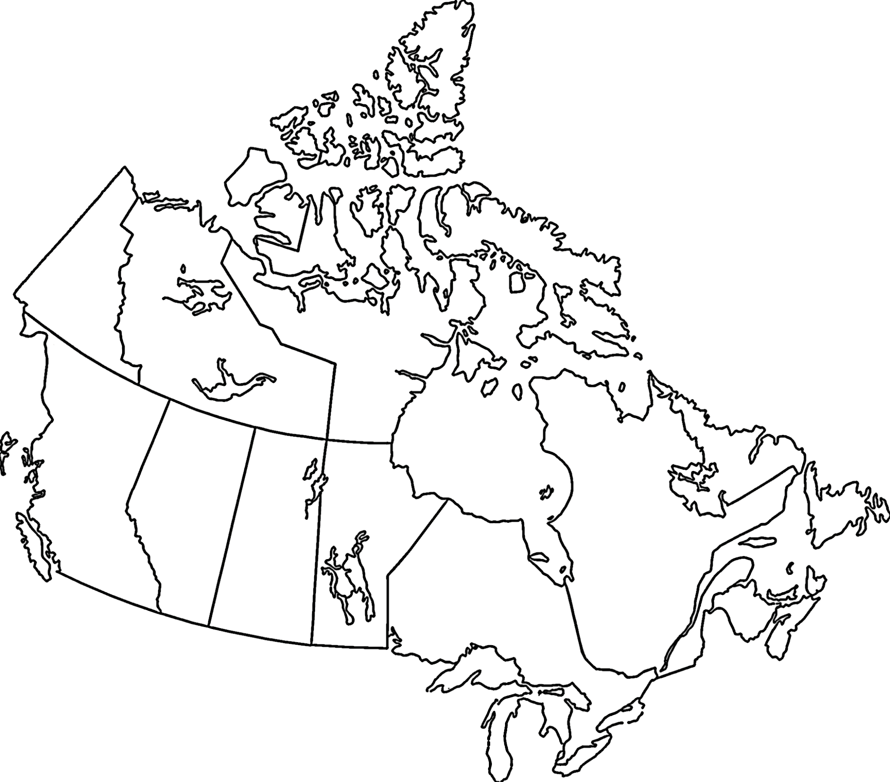
Our Family Stories of Canada
Four Directions
Legend
Where in the world do we live?
20

Learning Intention 7

Where is the Great Bear Rainforest?
The Great Bear Rainforest covers a large area of land. Understanding where it is in relation to where we live helps us understand our own region.

Experiences and Observations
Watch videos on the Explore > Video tab of the GBREAT website, or follow the links below:

Enter the Great Bear Rainforest
https://www.youtube.com/watch?v=js1rnKPAnE0&t=97s

Welcome to the Great Bear Rainforest
https://www.youtube.com/watch?v=jAHNqN_8p2k&t=3s
Explore the Great Bear Rainforest Interactive maps under Explore > Maps on the GBREAT Website.
- Have students calculate how far away they are from this region (unless they live in it). Is your community similar or different from the rainforest?
- Is it North, South, East, or West of their community?

Interactive Maps (GBREAT website)
https://greatbearrainforesttrust.org/map_downloads/

Possible Topics/Key Vocabulary
- Rainforest
- Conservation
- Protection

Reflections on Learning
- Have students map the Great Bear Rainforest and their own community on a map of B.C.

Suggested Resources

Enter the Great Bear Rainforest
https://www.youtube.com/watch?v=js1rnKPAnE0&t=97s

Welcome to the Great Bear Rainforest
https://www.youtube.com/watch?v=jAHNqN_8p2k&t=3s

Interactive Maps (GBREAT website)
https://greatbearrainforesttrust.org/map_downloads/

Learning Intention 8

Understanding Indigenous Homelands and Waters and Comparing Map Naming
Experiences and Observations

Indigenous Place-based Mapping
- Indigenous place-based mapping often involves naming places and landmarks around stories.
- Listen to stories of places in your local area and other regions around B.C.
- Have students share stories of those landmarks so they remember where they are.
- Compare this to naming places after people and places from another continent: for example, the Fraser River, Victoria, and New Westminster. Which approach has more of a connection to the place?
- Who names places?

Wonder
- Have students imagine what they would name some special places in the school to reflect their connections to—and the stories from—those places, and the land.
- Visit those places and think of names and stories.
- The class can work together to create a map.
- The place names can be used in your outdoor learning (for example, friendship rock, learning tree, hidden forest).

Possible Topics/Key Vocabulary
- Place-based mapping

Reflections on Learning

Creating Names and Maps for Special Places
- How are students sharing their own stories and ideas? Are they able to connect to places and recognize the importance of oral storytelling and intention of names?

Suggested Resources
Below is a collection of starting resources. Please preview them to see if they will fit for your place and your age group. Our hope is that this can be a starting place for you to find stories about the places where you live and learn.

Indigenous Heritage
Vancouver Heritage Foundation website https://www.vancouverheritagefoundation.org/discover-heritage/indigenous- heritage/

Musqueam Place Names Map
https://www.musqueam.bc.ca/our-story/our-territory/place-names-map/
Set in Stone: Stó:lō ancestors’ spirits live in Fraser Valley landmarks Stó:lō members face uphill battle to preserve sacred sites. CBC article. https://www.cbc.ca/news/indigenous/spirits-stolo-ancestors-live-fraser-valley-
landmarks-1.4074785?fbclid=IwAR1DqgWtDTfP84qMtQnJulWzviBAeHCsfSIq9WtJw D79rZ_eXUU8710RcNc

Stories from the Land: Indigenous Place Names in Canada
Geographical Names Board of Canada web page https://maps.canada.ca/journal/content-en.html?lang=en&appid=0e585399e9474c cf932104a239d90652&appidalt=11756f2e3c454acdb214f950cf1e2f7d

Transformer Rocks
Video on CBC Indigenous Facebook page
https://www.facebook.com/watch/?v=1624305037596916

VANCOUVER: The stories here | Te squélquel ikwe’elo
From the shores of skwtsa7s (Island of Dead Men), to the banks of the Sto:lo (Fraser River), Indigenous Cities Vancouver is a collection of stories revealing the land they are from. These stories hold the wisdom of sχʷəy̓ em̓ (ancient stories), historical knowledge, and personal experience long since obscured by the city landscape.
A National Arts Centre Indigenous Theatre and Savage Society co- presentation. Through music, sound, and storytelling, each unique offering, curated by Indigenous artists and memory holders, evokes connection, and invites interaction with the traditional landscapes of the xʷməθkwəy̓ əm (Musqueam), Skwxwú7mesh (Squamish) Səl̓ ílwətaʔ/Selilwitulh (Tsleil- Waututh), Qiqéyt (Qayqayt), kʷikʷəƛ̓ əm (Kwikwetlem), Katzie, Kwantlen,
sq̓ əc̓ iy̓ aɁɬ təməxʷ (Katzie) Nations.
https://nac-cna.ca/en/indigenouscities/city/vancouver?utm_source=vancouver is awesome&utm_campaign=vancouver is awesome outbound&utm_ medium=referral

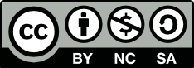

This work is licensed under a Creative Commons Attribution-NonCommercial-ShareAlike 4.0 International License unless otherwise indicated.

